**Handling Resource Requests & Limits In Kubernetes**

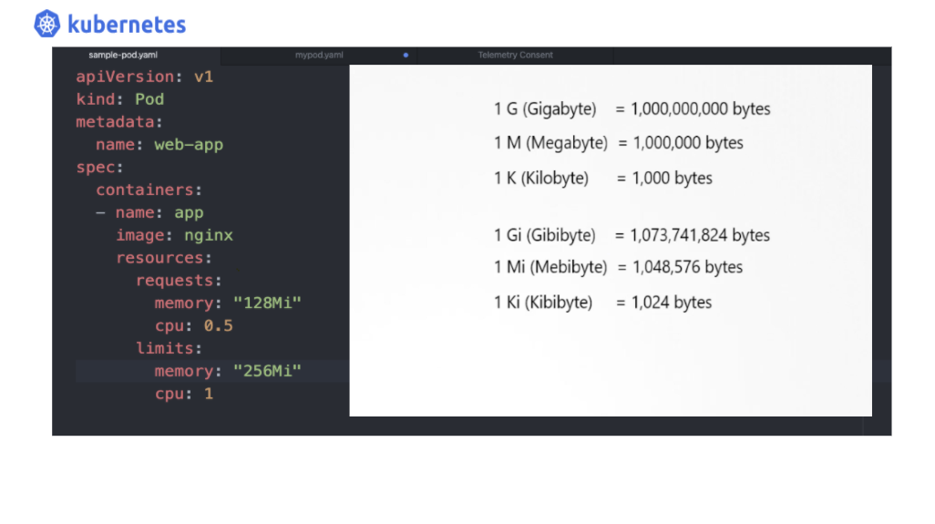

When it comes to architecting your system infrastructure requirements as a cloud architect or system architect, you need an efficient orchestrating tool to help you achieve the required flexibility and scalability. Kubernetes orchestration platform gives you this ability and simplifies your resource management process hassle-free.

# What are the Node level resources in a Kubernetes cluster?

In any given cluster with multiple nodes, there are a defined set of resources in the form of

* **CPU**
* **Memory**
* **Disk Spaces**

CPU and memory are collectively referred to as compute resources, or just resources. These resources are measurable quantities that can be requested, allocated, and consumed.

# Unit Of Resources Type:

Each of the above resource types has a base unit, let get into the details of each one by one

1. **CPU :**

CPU represents compute processing and is specified in units of Kubernetes **CPU’s.**

*1 cpu, in Kubernetes, is equivalent to****1 vCPU/Core****for cloud providers and****1 hyperthread****on bare-metal Intel processors.*

If not specified in resource request, by default, Kubernetes allocates 0.5 CPU to the pod or to the containers in the pod.

**Some examples to simplify unit economics for Kubernetes cpu.**

* 0.1 cpu = 100 m= 1 hundred milli cpu

We can also represent it as 0.2, 0.3, 0.4 but it cannot go below 1 m.

* 1 vCPU = 1 vCPU on AWS, I GCP core, 1 Azure core, 1 Hyper thread

## 2. Memory :

In Kubernetes requests for memory, resources are measured in **bytes**. The memory can be represented both as

* simple integer values
* Fixed point numbers

These both type of represented can use anyone the given: **E, P, T, G, M, K**

or,

One can also use the power-of-two equivalents: **Ei, Pi, Ti, Gi, Mi, Ki**

**Let’s understand by simple Example :**

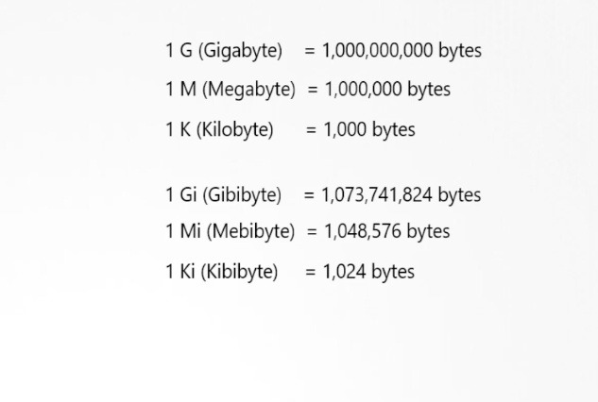

* **256 Mi** or it can also be represented as **26843546**
* 123 MI =129 M = 129e6=128974848

By default, Kubernetes assumes that any pod or container in the given pod will require 256 Mi of the node memory in which they are residing.

If you’re using Kubernetes v1.14 or newer, you can specify huge page resources. Huge pages are a Linux-specific feature where the node kernel allocates blocks of memory that are much larger than the default page size.

## How Does Kubernetes Manage The Resource Request?

Each pod deployed on the cluster node can be optionally allocated resources like CPU, RAM, etc either by default or based on the resource provisioning defined in the pod definition. Every such request coming from the newly created pod is handled by the node scheduler, so if you have opted to define the resources requirement yourself as an administrator or Kubernetes developer, the scheduler will act according to your pod’s resource request parameters and decides which node will this pod be placed.

If the administrator has defined any resource limit for the container in the pod, the kubelet lying in the node enforces those limits so that the running container is not allowed to use more of that resource than the limit you set.

## Example Pod Definition To understand how you can manage resources & limits :

Create your sample pod using the command

$ atom sample-pod.yaml

atom: here is the text editor, you can any text editor of your choice to create the file. After creating this file open this file in atom editor and type the YAML code specified below. Please feel free to make your own resource level provisioning as you want.

apiVersion: v1  
kind: Pod  
metadata:  
 name: web-app  
spec:  
 containers:  
 - name: app  
 image: nginx  
 resources:  
 requests:  
 memory: "128Mi"  
 cpu: 0.5  
 limits:  
 memory: "256Mi"  
 cpu: 1

**Resource specifications in the sample-pod.YAML file:**

As can be seen in the YAML file above, we have allocated the resource request parameter along with the limit, by defining in our pod container

**resources**:

resources:  
 requests:  
 memory: "128Mi"  
 cpu: 0.5

and by defining

**limits:**

limits:  
 memory: "256Mi"  
 cpu: 1

Let’s go ahead and create this pod.

## Create this pod :

* $ kubectl apply -f sample-pod.yaml

**Let’s View the created pod web-app using the describe command:**

* $ kubectl describe po web-app

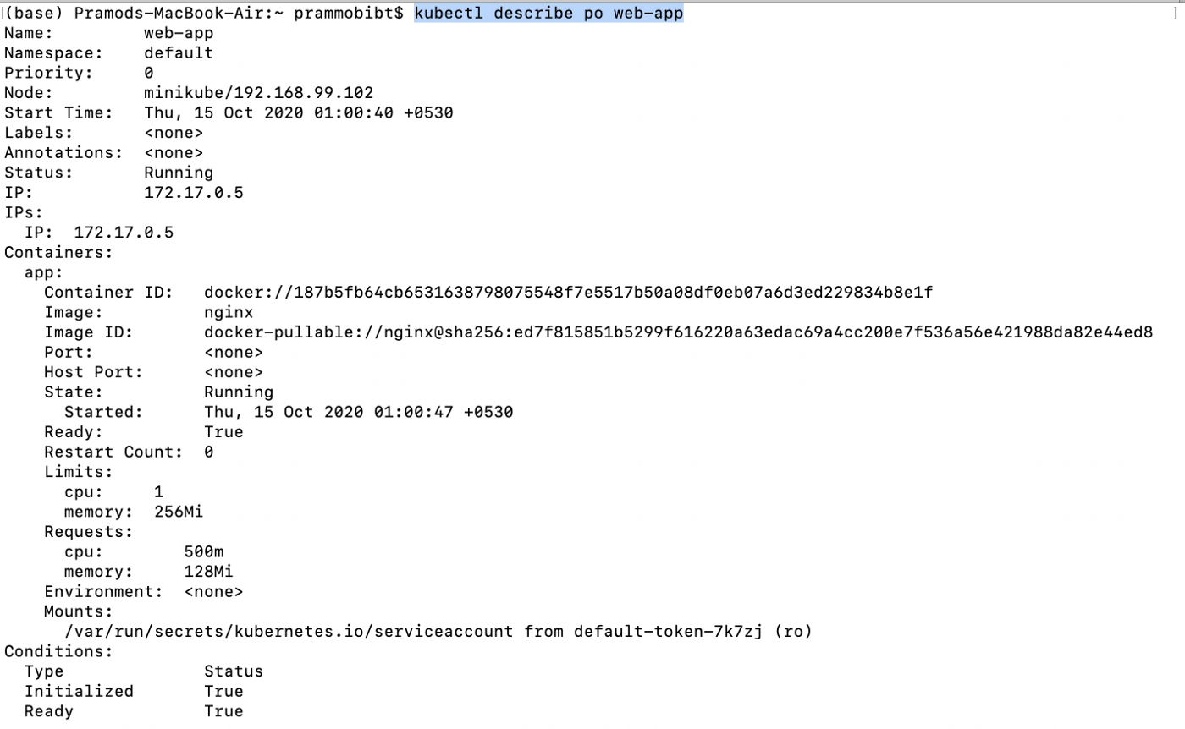

Fig-2

## Explanation :

As per our provisioned resources and limits, our container pod has been created as shown in fig-2

# So what goes behind when resource provisioning happens :

The moments any request to create Pod is received by the Kubernetes, the K8S scheduler takes the charge to assess the current capacity of the nodes lying in the given Kubernetes cluster, which helps the scheduler to decide the CPU and Memory available at the node’s disposal.

The scheduler has the responsibility to ensure that, for each resource type, the sum of the resource requests of the scheduled Containers is less than the capacity of the node. The scheduler refuses to place a Pod on a node if the capacity check on the available resources fails in that node fails.

This guard against a resource shortage on a node when resource usage later increases, for example, during a daily peak in request rate.

When the CPU & Memory limit is defined against the container, Kubernetes throttles the vCPU , so that container doesn’t go beyond the specified limit in the case of CPU. But when it comes to Memory, Kubernetes allows the container/pod to go beyond the set threshold memory limit, but if the pod continues to breach the limit Kubernetes eliminates the pods form the nodes

# Summary:

To summarize everything we learned

* How to manage resource provisioning of the container in Kubernetes?
* How to define resource requests?
* How to define resource limits?
* How does the scheduler handle the resource provisioning?
* What happens if some pods or containers try to go beyond the specified resource limit defined in the pod definition?

# Handling CPU Limits & CPU Requests In Kubernetes: Part 2

## **What happens if you exceed the resources request beyond what Nodes can handle in Kubernetes?**

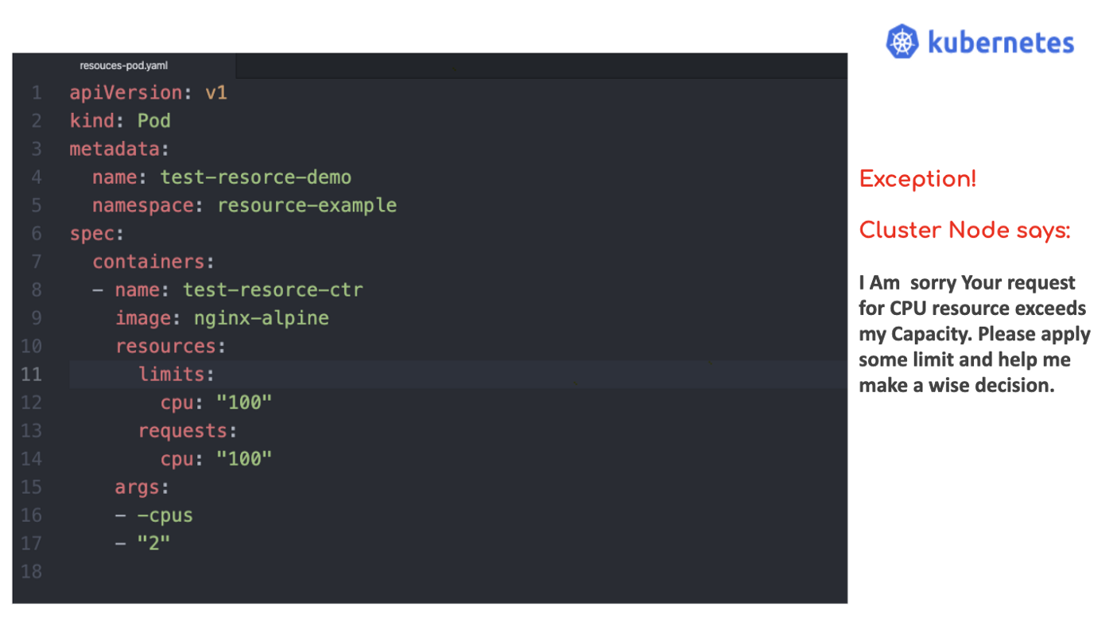

*“Choose your resources wisely else you will be thrown out ”*

This is true for Kubernetes clusters with multiple nodes too. In our part 1 of handling resources and limits in Kubernetes:

## [Handling Resource Requests & Limits In Kubernetes](https://medium.com/the-programmer/handling-resource-requests-limits-in-kubernetes-53ea8a68a550" \t "_blank)

### **[How does Kubernetes manage the resource requirements of Pods or Containers?](https://medium.com/the-programmer/handling-resource-requests-limits-in-kubernetes-53ea8a68a550" \t "_blank)**

[medium.com](https://medium.com/the-programmer/handling-resource-requests-limits-in-kubernetes-53ea8a68a550" \t "_blank)

**We learned**

* How to manage resource provisioning of the container in Kubernetes?
* How to define resource requests?
* How to define resource limits?
* How does the scheduler handle the resource provisioning?
* What happens if some pods or containers try to go beyond the specified resource limit defined in the pod definition?

**So today we will go further to understand the few resource management scenarios given below :**

* What happens when the CPU request exceeds the available CPU resource in the given cluster node?
* What happens when the CPU limit is not specified?
* What happens when you do specify a CPU limit but do not specify a CPU request?
* What is the main motivation for CPU requests and limits?

# Use Case 1: ****What happens when the CPU request exceeds the available resource in the given cluster Node?****

*No matter what CPU requests or limits you have assigned in your pod/container definition, if the****node,****accompanying the pod/containers has no more room it will not entertain any new pods asking for the room to be accommodated.*

When we specify our pod definition, we generally define, CPU requests and limits, with Containers, but it is more useful and wise to think of a Pod as having a CPU request and limit. The cumulative CPU request of the containers is what we call Pod's CPU requests, similarly, the cumulative CPU limit of all the containers is known to be the Pod’s CPU limit.

So if any new pod is required to be scheduled in the cluster Nodes, the resource requests are largely used to decide the same.

Any pod will only be scheduled to run on a Node if the Node has enough CPU resources available to satisfy the Pod's CPU request.

## Let’s understand this intuition by an example :

## Before We Begin:

Before we create a test pod, we need to have a Kubernetes cluster, and the **kubectl** command-line tool must be configured locally in your system. If you do not already have a cluster, you can create one by using **[minikube](https://kubernetes.io/docs/tasks/tools/" \l "minikube" \t "_blank)** or you can use one of these Kubernetes playgrounds:

* [Katacoda](https://www.katacoda.com/courses/kubernetes/playground)
* [Play with Kubernetes](http://labs.play-with-k8s.com/)

We will create a Pod that will ask for CPU requests from the Node exceeding the Node capacity in our cluster.

Let’s create a **Namespace** to ensure whatever resources we are creating create in this exercise are isolated from the rest of our local **minikube** cluster.

So, go ahead and type this command using your terminal

$ kubectl create namespace resource-example

**Output:**

once you have created the namespace, using the above command, you can view all the namespaces using the below-given command

Note! **ns can also be represented as namespace**

$ kubectl get ns

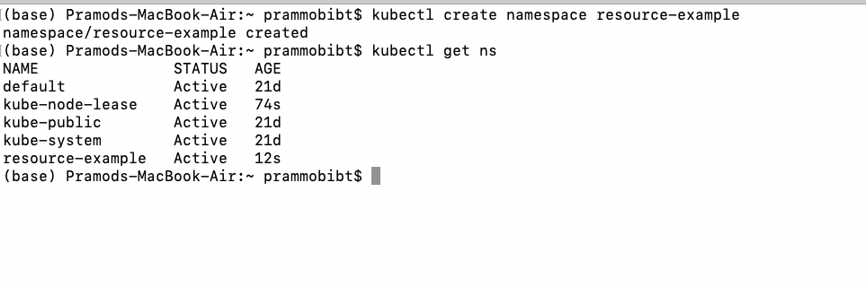

## **Time to create a pod:**

where the resource request being specified by the pod’s single container is exceeding the limit of what our local **minikube** cluster‘s **Node**can serve.

## Pod Definition resources-pod.yaml file :

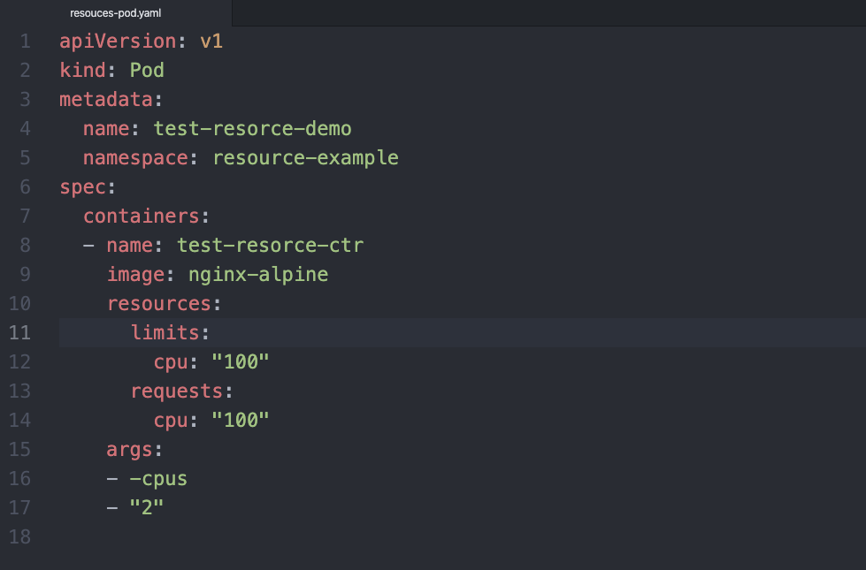

In the above pod definition

* We have requested for 100 CPU
* We have set the Limits to 100 CPU
* The args(argument)**-cpus "2"** tells the Container to attempt for 2 CPUs, usage

# Let’s create this Pod file: Using the namespace(resource-example) we defined at the start

$ kubectl apply -f /Users/prammobibt/resouces-pod.yaml --namespace=resource-example

our **test-resorce-demo** pod will be created in the cluster with the namespace resource-example

## Let’s see what is the status of the test-resorce-demo:

kubectl get pod test-resorce-demo --namespace=resource-example

**Output** : As can be seen below our pod, **test-resorce-demo, is showing pending as the status**

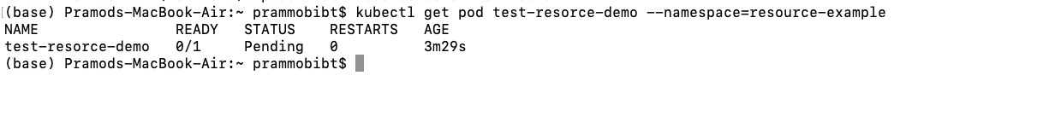

## Why this happening?

The output shows that the Pod status is Pending. That is, the Pod has not been scheduled to run on any Node, and it will remain in the Pending state indefinitely. To further diagnose the issue let’s use **describe command :**

$ kubectl describe pod test-resorce-demo --namespace=resource-example

## Outcome:

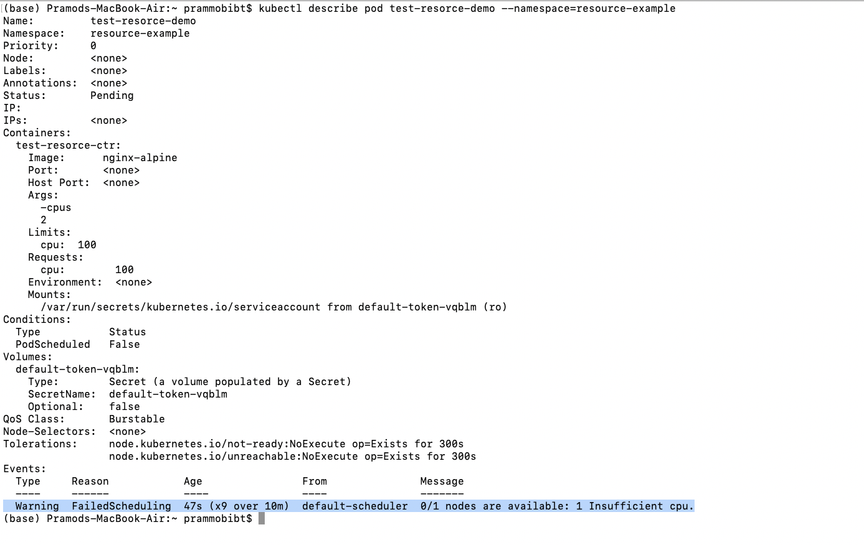

As highlighted in the result above, it is clearly showing that

**“The Container cannot be scheduled because of insufficient CPU resources on the Nodes.”**

# Use case 2: What happens when the CPU limits are not specified?

I have personally experienced that defining resource **limits** against CPU or memory is always better, but that is not the norm. When you are not doing so, it is imperative to understand what can be the possible implications of the same.

**So if you have ignored this step in your Pod definition, you can experience two below-mentioned situations, especially when the CPU resource being asked exceeds the Node’s resource availability.**

* As our pod’s container has not been given any upper threshold limit it could use all of the CPU resources available on the Node where it is running.
* There can also be a situation where our Pod’s container is running in some given **namespace**, which has some **default CPU limit. In this case, our container will**automatically be assigned the default limit.

*A****LimitRange****parameter can be used by our cluster administrator to specify a default value for the CPU limit.*

# Working with Service Account In Kubernetes

## **How to configure a service account in Kubernetes and manage it?**

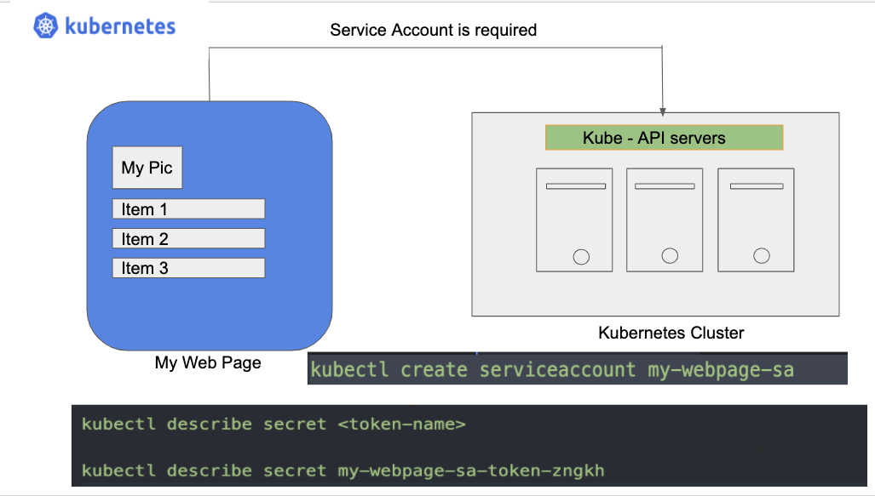

## What Is Service Account in Kubernetes?

There are two types of account in Kubernetes

* **User Account**: It is used to allow us, humans, to access the given Kubernetes cluster. Any user needs to get authenticated by the API server to do so. A user account can be an admin or a developer who is trying to access the cluster level resources.
* **Service Account**: It is used to authenticate machine level processes to get access to our Kubernetes cluster. The API server is responsible for such authentication to the processes running in the pod

## Service Account :

In the Kubernetes cluster, any processes or applications in the container which resides within the pod can access the cluster by getting authenticated by the API server, using a service account.

## For Example:

An application like **Prometheus** accessing the cluster to monitor it is a type of service account

So,

*A service account is an identity that is attached to the processes running within a pod.*

Note!

When you create a pod, if you do not specify a service account, it is automatically assigned the default service account in the same namespace.

# How Does Kubernetes Service Account Works?

**Case 1: When you have an external application trying to access Kubernetes cluster API servers.**

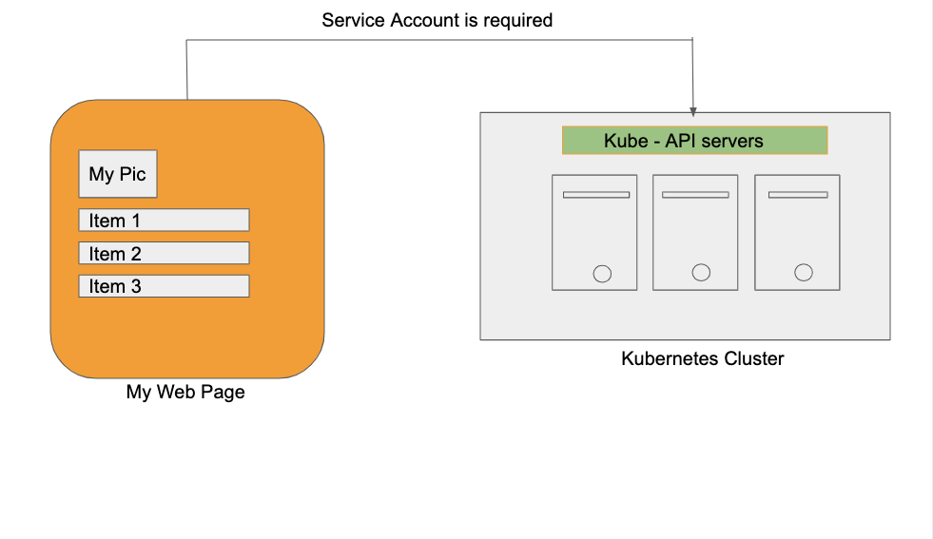

My Web Page is trying to access the Kubernetes cluster

Suppose there is a web page: **My Web Page** which has a list of items to be displayed, this data needs to be fetched from an API server hosted in the Kubernetes cluster as shown above in the figure. To do so, we need to a service account that will be enabled by cluster API servers to authenticate and access the data from the cluster servers.

## Install minikube and kubectl CLI : If not done yet

Before you begin: You need to have a Kubernetes cluster, and the **kubectl** command-line tool must be configured to communicate with your cluster. If you do not have **minikube** installed visit here: **[Minikube](https://kubernetes.io/docs/setup/learning-environment/minikube/" \t "_blank)**,

or you can use one of these Kubernetes playgrounds by clicking the given link below:

* [**Katacoda**](https://www.katacoda.com/courses/kubernetes/playground)
* [**Play with Kubernetes**](http://labs.play-with-k8s.com/)

## Creating a service account:

Now to access the kubernetes cluster as discussed above we need to create a service account, which we can do by using the following command :



This command will generate a service account with the name: **my-webpage-sa**

When you are done creating a service account, **a service account token** also gets generated, this token is what will be required by our My Web Page application to access the data via **apis**.

Let’s see how you can view the token and other attached details with the created service account.

## Describing the service account:

you have to type the following **kubectl** command:



**Output of the above describe command:**

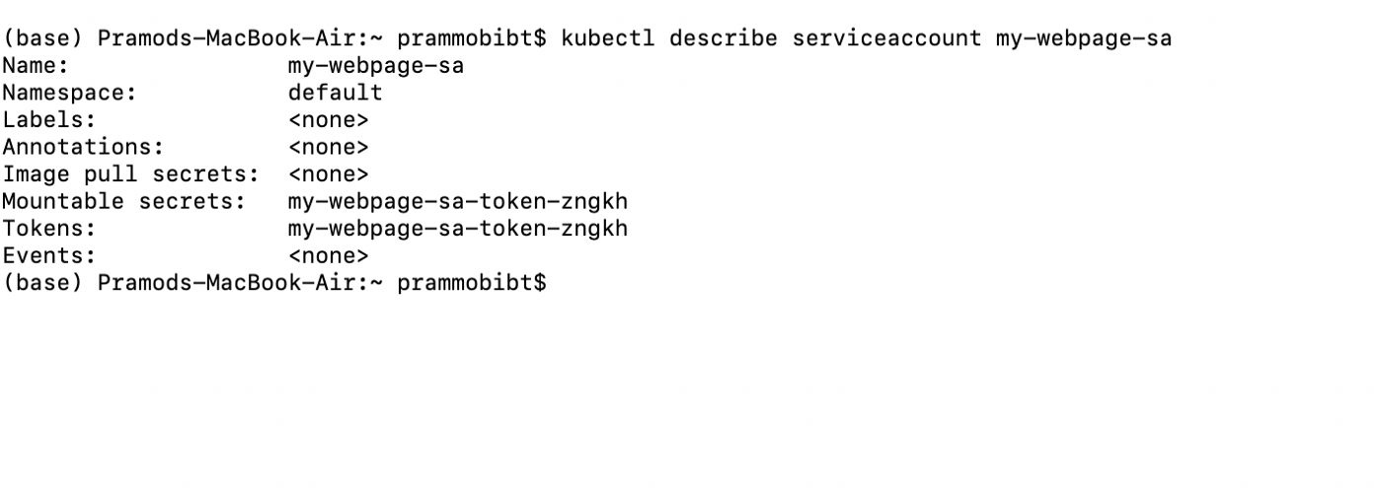

So if you carefully watch the output you will see that the **Tokens** attribute is created with the value: **my-webpage-sa-token-zngkh.**This token is stored as a secret object, this secret object is attached to the service account:**my-webpage-sa.**

## To view the secret object :

If you want to view whats the content of the secrte object we can type the following command

**$ kubectl describe secret <token-value>**

as shown below :

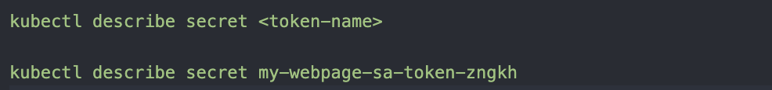

## output:

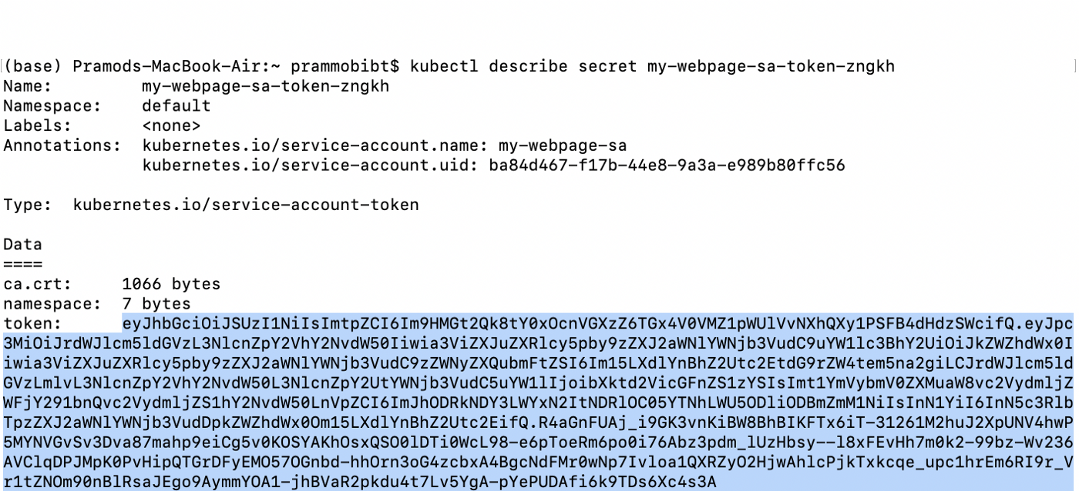

when you execute the above command, you can view the encoded hash-key value of the token as highlighted in the image above.

This is the key that can be exchanged as an authentication bearer token in your REST API call, to fetch the required data from the Kubernetes cluster API server.

## **Summary:**

**To summarize :**

* We need to first create a service account
* Then based on RBAC:(Role-based authentication control) we need to extract and export the token hash key be passed in our REST API header. This will allow access to the cluster API server as an authenticated service account.

But what if our application is an integral part of the cluster itself and lies into one of the PODs

## Case 2: When the application is hosted and running within the Cluster POD

In this scenario, when any pod is created in the Kubernetes cluster with any given **namespace**, these pods by default creates a service account with the name **default**. The default service account automatically creates the service token along with the required secret object.

So our application will be able to access the API server lying within the same namespace, by using this **default** service account mounted in the pod.

For instance, type the below-given command on your terminal:

**-$ kubectl get serviceaccount**

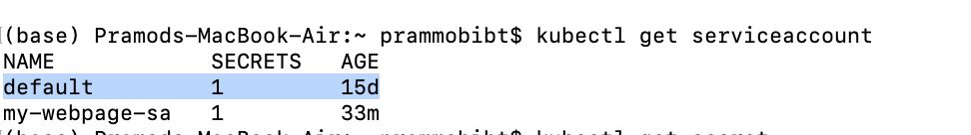

you will see the default secret as highlighted above, and if you go further to type the below set of commands to access the default secret attached with the **default** token



you will be able to get the name of default token value,**default-token-7k7zj(note this will vary in your case ),** this automatically gets created when any pod is created in the given node namespace**,**

## **To view the secret object detail against the default token,default-token-7k7z:**

Type the following command:

* **$ kubectl describe secret default-token-7k7zj**

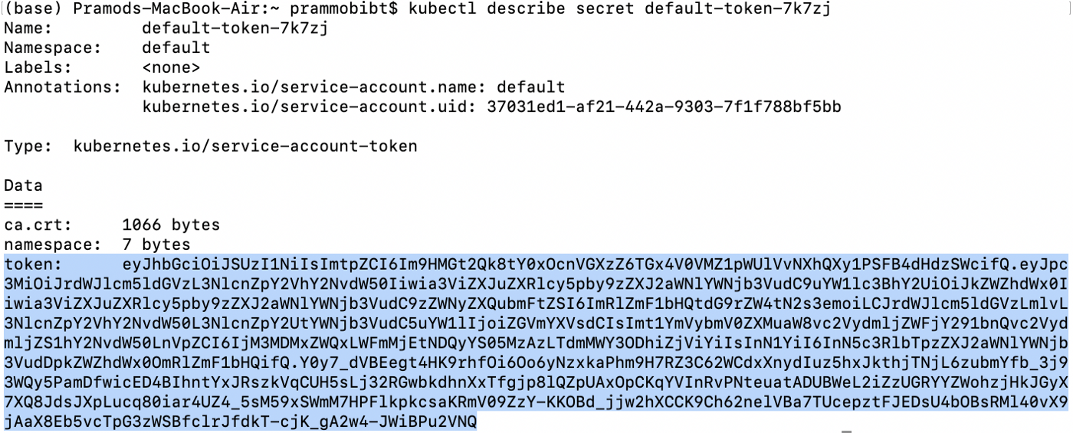

So for our application hosted in the pod with the same namespace, this default secret object can be used to give access to the API servers lying in the same cluster namespace.

# Working With Deployment In Kubernetes

## **What is Deployment in Kubernetes? How to maintain a rolling update of our application?**

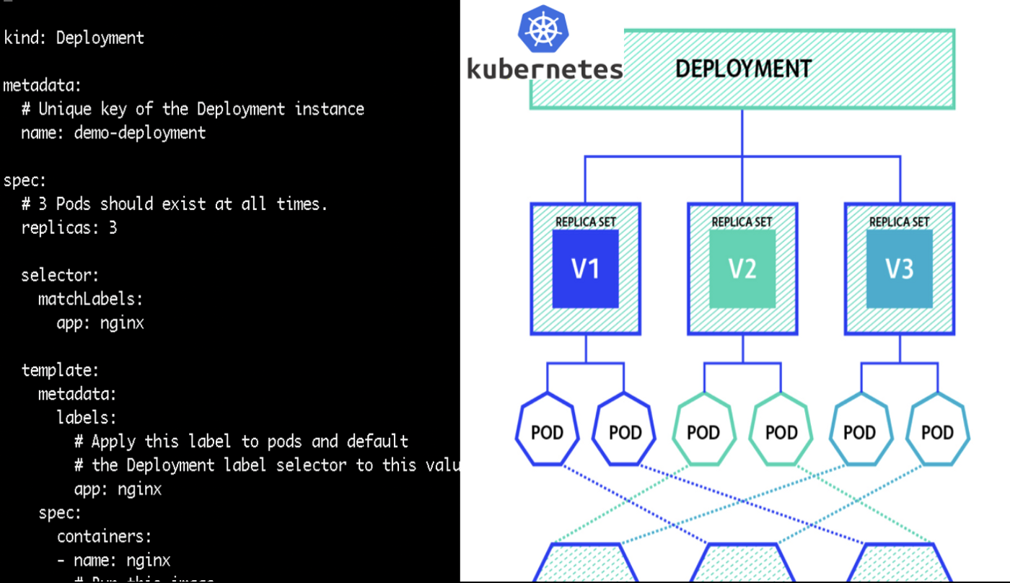

*Kubernetes****Deployment****(****controller****) is your buddy if you want to deploy, update , maintain your hosted application on the production server without any downtime with utmost efficiency and with the required scalability and availability*

Many times while working on your production server, you may encounter an instance where you would like to push a new update of your web application, while doing so it is desired not to break the running web app and to avoid any downtime. You may be required to deploy many instances of your web application to manage user workloads and to ensure the application is always available for the user to access.

Kubernetes **Deployment** here is your true mate which helps you to seamlessly perform your application rolling update. It also helps you to scale the web app horizontally by helping you create multiple replicas of the web application.

**So in the Kubernetes ecosystem,**

*A****Deployment****provides declarative updates for Pods and ReplicaSets without breaking the user side experience*

You can effortlessly **roll-out** application updates and also **rollback** the update if anything breaks using the deployment object in Kubernetes.

Deployment act as a controller in Kubernetes which helps Kubernetes developers and administrator achieve the desired state for pods, replica sets in the manner decided by the controller.

*One can create Deployments to create new ReplicaSets or to remove existing Deployments and adopt all their resources with new Deployments.*

# Defining Deployment:

## Using the imperative command:

Here we are making use of imperative command to create a deployment

named: test-deploy, with an docker image = nginx having 3 replicas, as using the Kubectl CLI as shown below:

kubectl create deployment test-deploy --image=nginx --replicas=3

When you run this command you will see the,

**Output:**

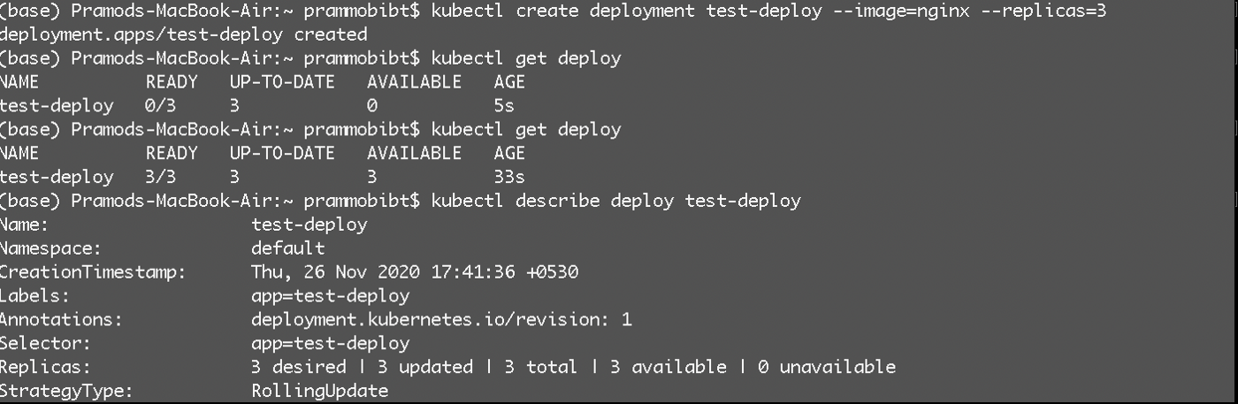

Fig: 1.0

As seen in Fig 1.0, our test-deploy deployment has been created successfully and is in a ready state. We have made use of :

**kubectl get deployment**

and,

**kubectl describe deployment test-deploy**

To view the details of the deployment, we have created

## Creating Deployment Using Yaml Definition:

**demo-deploy.yaml:**

We can create a deployment using a declarative way as shown below in our YAML file definition, here

* **kind** is of type **Deployment**
* **apiVersion**: apps/v1(These needs to be aways confirmed with Kubernetes API doc, as it may change in future Kubernetes API version updates. )

**apiVersion**: apps/v1  
**kind**: Deployment**metadata**:  
 # Unique key of the Deployment instance  
 name: demo-deployment**spec**:  
 # 3 Pods should exist at all times.  
 **replicas**: 3  
 **selector**:  
 **matchLabels**:  
 **app**: nginx  
 **template**:  
 **metadata**:  
 **labels**:  
 # Apply this label to pods and default  
 # the Deployment label selector to this value  
 app: nginx  
 **spec**:  
 **containers**:  
 - name: nginx  
 # Run this image  
 image: nginx:1.14

Here we are deploying the Pod using the pod definition under the template section as shown below:

**template**:  
 **metadata**:  
 **labels**:  
 # Apply this label to pods and default  
 # the Deployment label selector to this value  
 app: nginx  
 **spec**:  
 **containers**:  
 - name: nginx  
 # Run this image  
 image: nginx:1.14

Using the **selector** under the **spec, as shown below**

**selector**:  
 **matchLabels**:  
 **app**: nginx

Here label is matched with the given pod label, if the label is not matched or missing our deployment will fail

## Creating the deployment of the demo-deploy.yaml file:

**apiVersion**: apps/v1  
**kind**: Deployment**metadata**:  
 # Unique key of the Deployment instance  
 name: demo-deployment**spec**:  
 # 3 Pods should exist at all times.  
 **replicas**: 3  
 **selector**:  
 **matchLabels**:  
 **app**: nginx  
 **template**:  
 **metadata**:  
 **labels**:  
 # Apply this label to pods and default  
 # the Deployment label selector to this value  
 app: nginx  
 **spec**:  
 **containers**:  
 - name: nginx  
 # Run this image  
 image: nginx

**Use the below command to,**

## **Create Deployment:**

$ kubectl apply -f demo-deploy.yaml

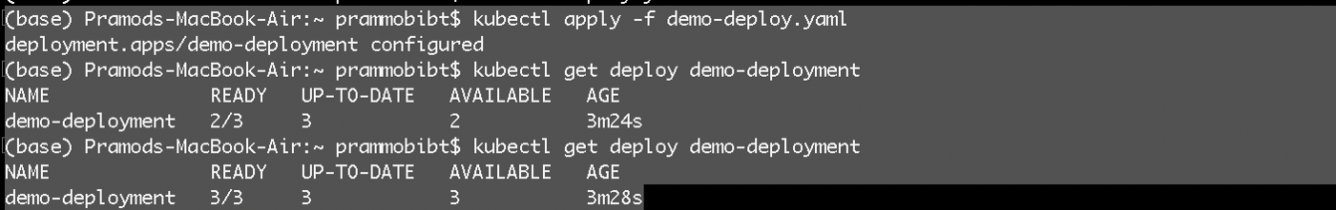

fig 2.0

We can see from fig 2.0, that our deployment has been created successfully and is in a ready state.

When you inspect the Deployments in your cluster using the command

$ kubectl get deploy demo-deployment

, the following fields are displayed:

You will see the following as output:

* **NAME** lists the names of the Deployments in the namespace.
* **READY** displays how many replicas of the application are available to your users. It follows the pattern ready/desired.
* **UP-TO-DATE** displays the number of replicas that have been updated to achieve the desired state.
* **AVAILABLE** displays how many replicas of the application are available to your users.
* **AGE** displays the amount of time that the application has been running.

The number of desired replicas is 3 according to the below field on our YAML definition.

**spec**:  
 # 3 Pods should exist at all times.  
 **replicas**: 3

# Updating the Deployment :

Now that we have successfully deployed our deployment : demo-deployment

let’s update the same with new **nginx**, image version, nginx:1.16.1.

One can do so by using the **set image**command, as shown below:

$ kubectl set image deployment/demo-deployment nginx=nginx:1.16.1 --record

If it succeeds you will see the output as shown below, where demo-deployment is updated successfully

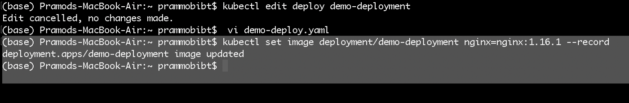

Fig 3.0

Let’s describe our deployment to get more details about our updated deployment

$ kubectl describe deploy demo-deployment

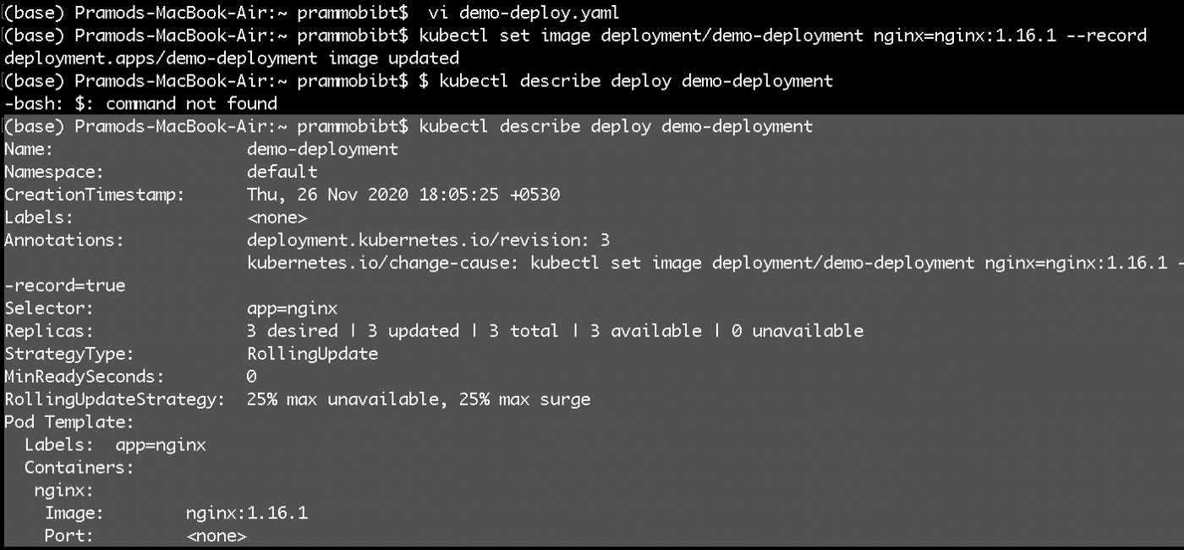

Fig 4.0

As can be seen in fig 4.0, we have updated the pod with the new image nginx:1.16.1, as a rolling update, with all the 3 desired replicas being created successfully.

One can also edit the deployment YAML file Alternatively, using the following edit command:

kubectl edit deployment.v1.apps/demo-deployment

and change the,.spec.template.spec.containers[0].image from nginx to nginx:1.16.1,

**spec**:  
 **containers**:  
 - name: nginx  
 # Run this image  
 image: nginx:1.16.1

save the file in the vim editor and your deployment will be updated with new, nginx:1.16.1, image version.

# What's Next?

We saw

* **What is the Deployment workload in Kubernetes?**
* **How to create deployment?**
* **How to edit and update the deployment?**

Next, we will continue to learn more about deployment where we will cover

* **How to rollback the update using deployment?**
* **How to check the rollback and rollout status?**

# Working with deployments in Kubernetes: Rollback and rolling updates

## **How to manage rolling updates using deployment in Kubernetes?**

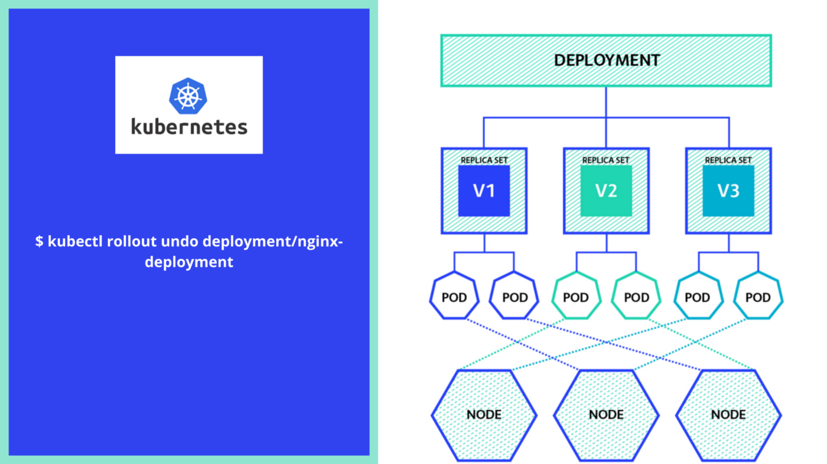

*A Kubernetes deployment is****a resource object in Kubernetes that provides declarative updates to applications. It****allows you to explain an application’s life cycle, such as which images to use for the app, the number of pods replicas for the app, and the mechanism in which the should be updated*

# Revisiting Updating Deployments in K8s:

When you want to make any changes to the deployment type workloads, you can do so by changing the specifications defined in **.spec.template.**

**Remember!**

A Deployment’s rollout is triggered if and only if the Deployment’s pod template (i.e, **.spec.template**) is modified. If you modify the scaling parameter, it will not rollout, but if you are changing the deployment labels or container images info, it will trigger the deployment rollout to update it.

Let’s first create a deployment-type workload and deploy it in our Minikube cluster.

**Pre-requisites:**

As a pre-requisite, you must have minikube installed, if not follow the given link below to get started with minikube installation.

## [minikube start](https://minikube.sigs.k8s.io/docs/start/" \t "_blank)

### **[minikube is local Kubernetes, focusing on making it easy to learn and develop for Kubernetes. All you need is Docker…](https://minikube.sigs.k8s.io/docs/start/" \t "_blank)**

[minikube.sigs.k8s.io](https://minikube.sigs.k8s.io/docs/start/" \t "_blank)

# Defining Deployment, Rolling it out & Managing Rollback :

**Defining Deployment Using the imperative command:**

Here we are making use of imperative commands to create a deployment **named: test-deploy,**

With a docker **image = nginx** having **3 replica**s, as using the **kubectl**CLI as shown below:

**$ kubectl create deployment test-deploy --image=nginx --replicas=3**

When you run the above command in your command line /terminal and execute :

**$ kubectl get deployments**

In the output image below you can see that our test-deploy workload is up and running in the clusters

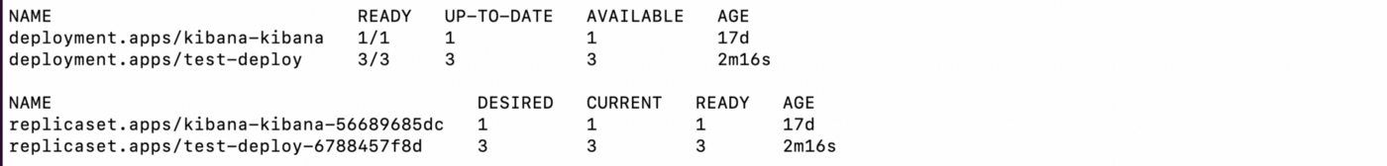

Now as our deployment workload is up and ready, let’s make some changes to it and try to roll back the same.

## Updating the test-deploy file :

As discussed earlier, if any changes like labels or container images of the deployment template are identified then only an update will be triggered against the given deployment.

Let’s update the **nginx** Pods to use the nginx:1.16.1 image, instead of the nginx:1.14.2 image, which we used earlier to create our deployment

We can update the image type by using the below given imperative command

**$ kubectl set image deployment.v1.apps/test-deploy nginx=nginx:1.16.1**

**Output:**

We can see below that our test-deploy file has been updated with a new nginx version



**Let’s use describe command to see the change in the deployment:**

**$ kubectl describe deploy test-deploy**

**Output:**

As can be seen in the highlighted output below, the deployment has been updated with a new **nginx** image type :

**Image: nginx:1.16.1**

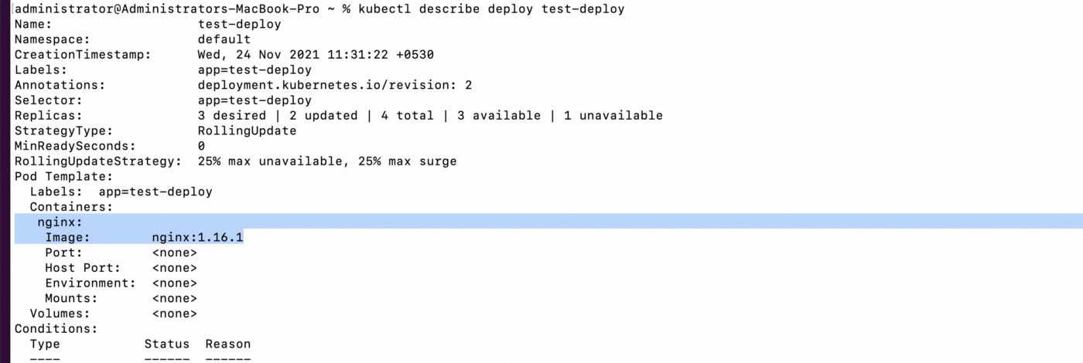

# Rolling back the Update in the deployment:

What if the update in the deployment has created some mess and your deployment workload is crashing and not stable. Don’t worry Kubernetes has a roll-back feature in place.

*In K8s by default, all of the Deployment’s rollout history is kept in the system so that you can roll back anytime you want (you can change that by modifying the revision history limit).*

**Let’s understand how to roll back the deployment by example**

Earlier we have rolled out an update by changing the nginx image to nginx:1.16.1.

Suppose that while updating the deployment one mess with

Suppose that while updating the deployment developer by mistake changes the nginx image name to nginx:1.191 , which is not a valid nginx version.

* $**kubectl set image deployment/nginx-deployment nginx=nginx:1.191**

Now let’s check the **rollout status** by using the below-given commands:

$**kubectl rollout status deployment/test-deploy**



We can see from the output that our test-deploy roll-out is kind of stuck. So as a k8s cluster administrator/developer, you need to roll back the updates.

We can further investigate the issue by running

$**kubectl get pods**

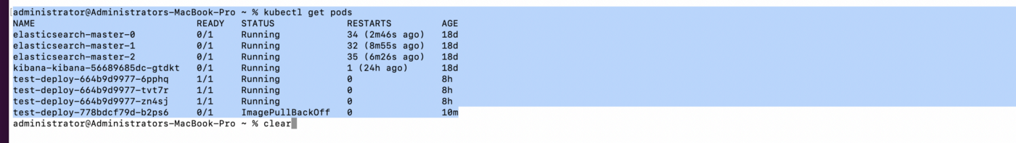

You can see that the test-deploy workload is showing an error:ImagePullBackOff

Now if we want to roll back the new update to its older version, you can use the rollout undo command

# Rolling Back to an Older Version:

To roll back the existing deployment to any previous version, k8s provides a rollout undo functionality

Type the following command on your terminal

$ **kubectl rollout undo deployment/nginx-deployment**

The output below clearly shows that the deployment has been rolled back



Let’s go ahead and check the deployment status

$ **kubectl rollout status deployment/test-deploy**$ **kubectl get deployment test-deploy**



we can see that our deployment has now rolled back and is up and running.

## Rolling Back to a specific version:

We can also roll back the deployment to a specific version. As K8s maintains the revision history of the deployment workload

So let's check the history to find the revision details and then pick the specific revision tag to roll back

**$ kubectl rollout history deployment/nginx-deployment**

**Output:**

We can see that our **test-deploy file** has got three revisions 1,3,4

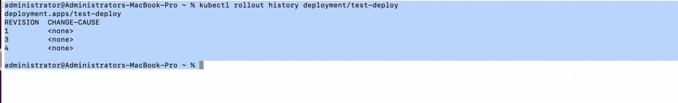

Now if we want to roll back to a specific revision tag we can use the following command

$ **kubectl rollout undo deployment/test-deploy --to-revision=3**

**Let’s see the output :**



Let’s check the test-deploy workload details, first, we will use describe command and then see the revision history details

$ **kubectl describe deployment test-deploy$ kubectl rollout history deployment/test-deploy**

**The output will look like this:**

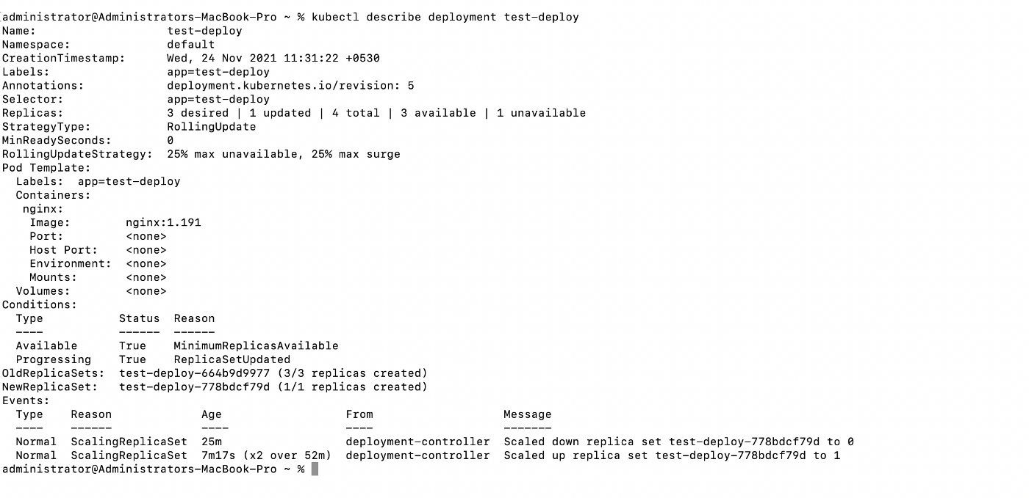

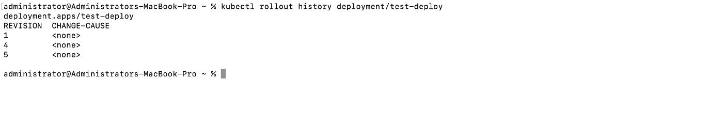

We can see in describe command output that our deployment with revision version 3 has been revised and our rollout history shows the revision version as **1,4,5** which earlier was, **1,3,4**

# What’s next In working with the deployment Series?

We will continue our learning journey by discussing

* How one can scale up the Deployment to facilitate more load in the given k8s cluster
* How to pause the running deployment?

**Kubernetes Networking Fundamentals**

**The Kubernetes Network Model specifies:**

* **Every Pod gets its own IP address.** There should be no need to create links between pods and no need to map container ports to host ports.
* Pods on a node can communicate with all pods on all nodes **without NAT**.
* **Agents on a node ( eg. system daemons, Kubelet ) can communicate with all the pods in that node.**
* **Containers within a Pod share their network namespace ( IP and MAC address )** and therefore can communicate with each other using the loopback address.

**Kubernetes networking addresses four concerns:**

1. Container-to-Container Networking
2. Pod-to-Pod Networking
3. Pod-to-Service Networking
4. Internet-to-Service Networking

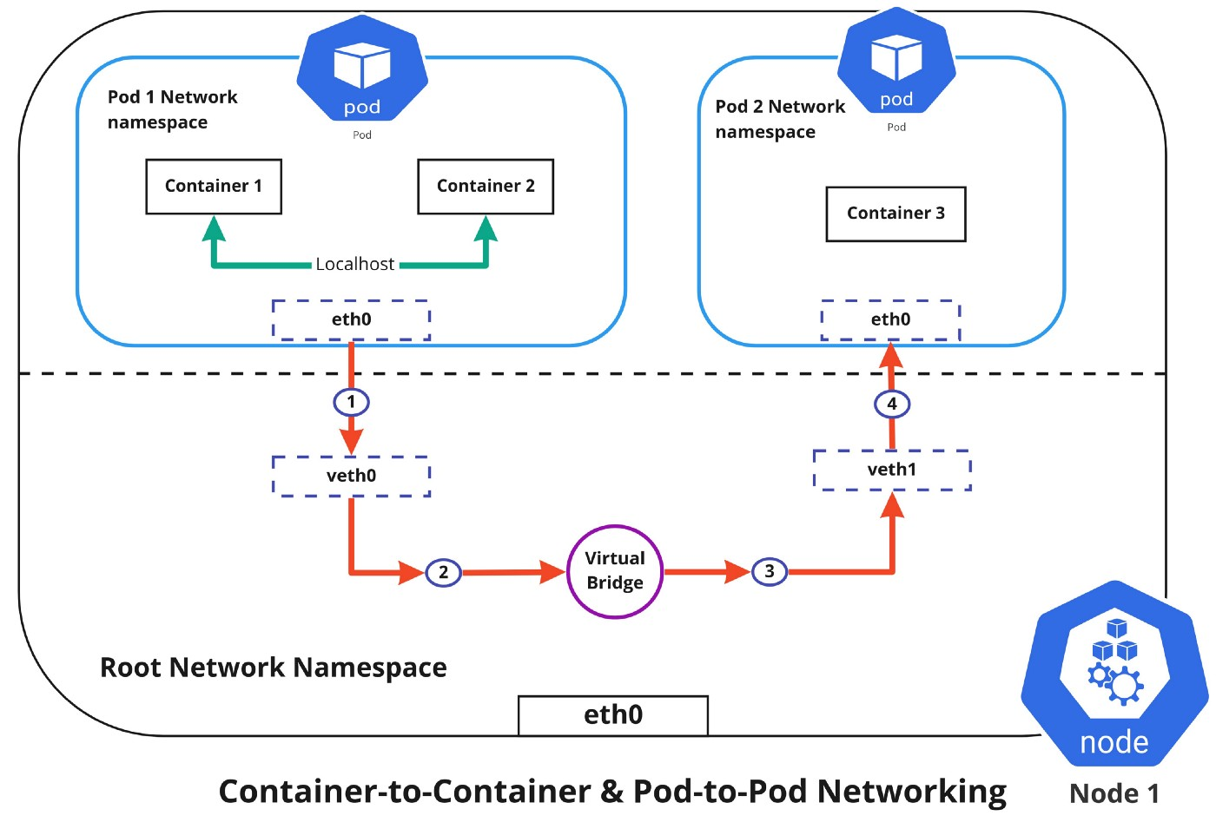

**Container-to-Container Networking**

Container-to-Container networking happens through the Pod network namespace. Network namespaces allow us to have separate network interfaces and routing tables that are isolated from the rest of the system and can operate independently. Every Pod will have its own network namespace and containers inside that Pod share the same IP address and ports. All communication between these containers would happen via the localhost as they are all part of the same namespace. ( Represented by the green line in the diagram )

**Pod-to-Pod Networking**

In Kubernetes, every node has a designated CIDR range of IPs for Pods. This would ensure that every Pod gets a unique IP address that can be seen by other Pods in the cluster and also ensures that when a new Pod is created, the IP address never overlaps. Unlike Container-to-Container networking, Pod-to-Pod communication happens using real IPs, whether the Pod is deployed on the same node or a different node in the cluster.

You can notice from the diagram above that, for Pods to communicate with each other, the traffic has to flow between the Pod network namespace and the Root network namespace. This is achieved by connecting both the Pod namespace and the root namespace by a virtual ethernet device or a veth pair (veth0 to Pod namespace 1 and veth1 to Pod namespace 2 in the diagram). Both these virtual interfaces would be connected via a virtual network bridge which will then allow traffic to flow between them using the ARP protocol.

So if data is sent from Pod 1 to Pod 2, the flow of events would like this ( refer to diagram above )

1. Pod 1 traffic flows through eth0 to the root network namespaces virtual interface veth0.
2. Then traffic goes via veth0 to the virtual bridge which is connected to veth1.
3. Traffic goes via the virtual bridge to veth1.
4. Finally, traffic reaches eth0 interface of Pod 2 via veth1.

**Pod-to-Service Networking**

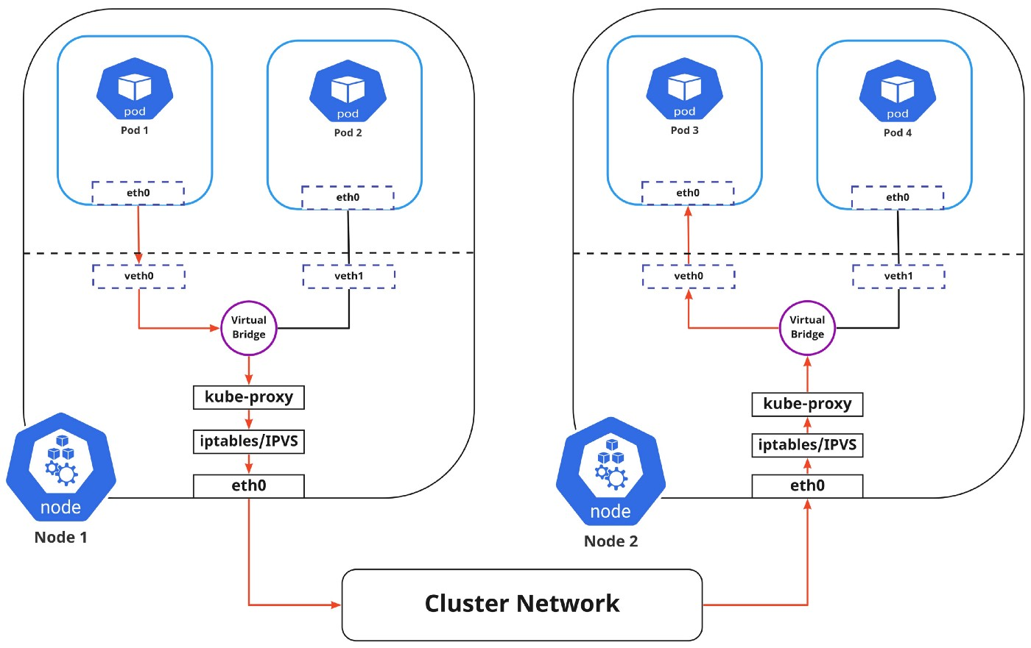

Pods are very dynamic in nature. They may need to scale up or down based on demand. They may be created again in case of an application crash or a node failure. All of these events cause the Pods IP address to change and this makes networking a challenge.

Kubernetes solves this problem by using Service. So what exactly is the service responsible for?

1. Assigning a static virtual IP address in the frontend that would be used to connect any backend Pods that are associated with the Service.
2. Load-balancing any traffic that is addressed to this virtual IP to the set of backing Pods.
3. Keeping a track of the IP address of the Pods, so even if the Pod IP address changes, the clients wouldn’t have any trouble connecting to the Pod as they only directly connect with the static virtual IP address of the Service itself.

The in-cluster load balancing can be done in two ways:

1. IPTABLES: In this mode, kube-proxy watches for changes in the API Server, and for each new service, it installs iptables rules, which capture traffic to the Service’s clusterIP and port and this would redirect that traffic to the backend Pod for this Service. The Pod is selected randomly. This mode is more reliable and has a lower system overhead because traffic is handled by Linux Netfilter without the need to switch between userspace and the kernel space. ( Refer — [iptables proxy mode](https://kubernetes.io/docs/concepts/services-networking/service/#proxy-mode-iptables) )
2. IPVS: IPVS is built on top of the Netfilter and implements transport-layer load balancing. IPVS uses the netfilter hook function using the hash table as the underlying data structure and works in the kernel space. This means that kube-proxy in IPVS mode will redirect traffic with lower latency, higher throughput, and much better performance compared to kube-proxy in iptables mode. ( Refer — [IPVS proxy mode](https://kubernetes.io/blog/2018/07/09/ipvs-based-in-cluster-load-balancing-deep-dive/) )

I found an interesting read comparing kube-proxy modes here — [iptables vs ipvs](https://www.tigera.io/blog/comparing-kube-proxy-modes-iptables-or-ipvs/)

The flow of the package from Pod 1 to Pod 3 via a service to a different node is shown in the diagram above ( marked in red ). Please note that the package traveling to the virtual bridge would have to route it via the default route (eth0) as the ARP protocol running on the bridge wouldn’t understand the Service and later they to be filtered by iptables which in turn would use the rules defined in the node by kube-proxy. Therefore the diagram directly shows the path as it is.

**Internet-to-Service Networking**

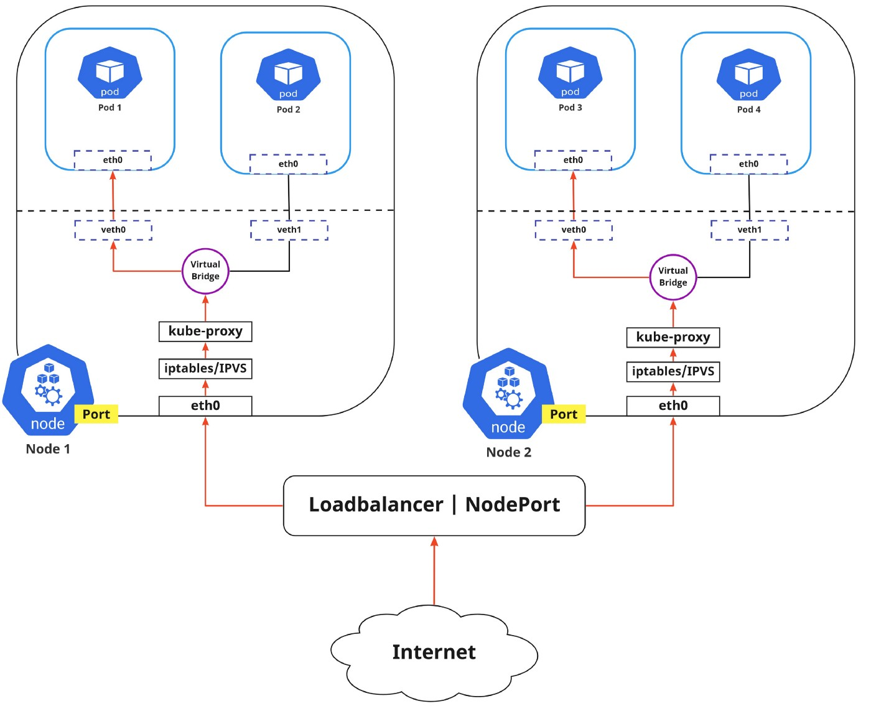

So far we have discussed how traffic is routed within the cluster. Now if we need to expose an application to the external network, we could do that in two ways:

1. **Egress**: This is when you want to route traffic from your Kubernetes Service out to the Internet. In this, iptables would perform the source NAT so the traffic would appear to be coming from the node and not the pod.
2. **Ingress**: This is the incoming traffic to services coming from the external world. Ingress also allows and blocks particular communications with services using a set of rules for connections. Typically, there are two ingress solutions that function on different network stack regions: the service load balancer and the ingress controller.

**Discovering services:**

There are two ways in which Kubernetes can discover a Service:

1. **Environment Variables**: The kubelet service running on the node where your Pod runs are responsible for setting up environment variables for each active service in the format {SVCNAME}\_SERVICE\_HOST & {SVCNAME}\_SERVICE\_PORT. Do note that you must create the Service before the client Pods come into existence. Otherwise, those client Pods won’t have their environment variables populated.
2. **DNS**: The DNS service is implemented as a Kubernetes service that maps to one or more DNS server pods which are scheduled just like any other pod. Pods in the cluster are configured to use the DNS service, with a DNS search list that includes the pod’s own namespace and the cluster’s default domain. A cluster-aware DNS server, such as CoreDNS, watches the Kubernetes API for new Services and creates a set of DNS records for each one. If DNS has been enabled throughout your cluster then all Pods should automatically be able to resolve Services by their DNS name. The Kubernetes DNS server is the only way to access ExternalName Services. ( Refer — [DNS for Services and Pods](https://kubernetes.io/docs/concepts/services-networking/service/#discovering-services) )

**ServiceTypes for Publishing Services:**

Kubernetes Services provide us with a way of accessing a group of Pods which may usually be defined by using a label selector. This could be applications trying to access other applications within the cluster or it could also allow us to expose an application running in the cluster to the external world. Kubernetes ServiceTypes allow you to specify what kind of Service you want.

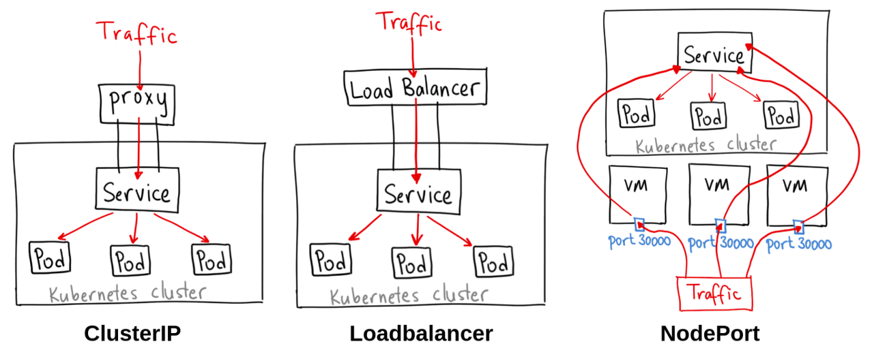

Image Credits: [Ahmet Alp Balkan](https://medium.com/@ahmetb)

The different ServiceTypes are:

1. **ClusterIP**: This is the default ServiceType. This makes the Service only reachable from within the cluster and allows applications within the cluster to communicate with each other. There is no external access.
2. **LoadBalancer**: This ServiceType exposes the Services externally using the cloud provider’s load balancer. Traffic from the external load balancer is directed at the backend Pods. The cloud provider decides how it is load-balanced.
3. **NodePort**: This allows the external traffic to access the Service by opening a specific port on all the nodes. Any traffic that is sent to this Port is then forwarded to the Service.
4. **ExternalName**: This type of Service maps a Service to a DNS name by using the contents of the externalName field by returning a CNAME record with its value. No proxying of any kind is set up.

Clap

**Kubernetes Architecture — Deep Dive**

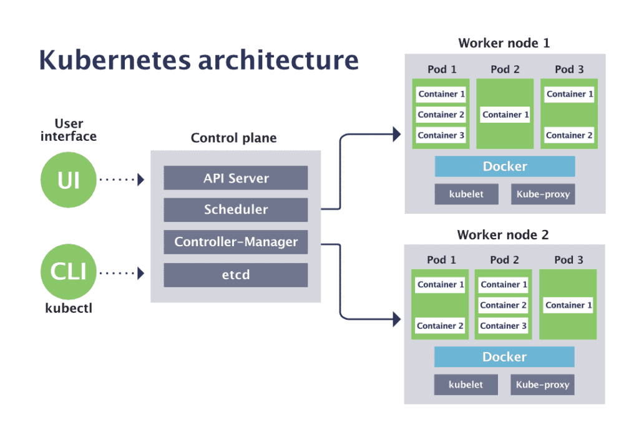

**CONTROL PLANE COMPONENTS:**

**ETCD:**

Etcd is a fast, distributed, and consistent key-value store that is used as a backing store for persistently storing Kubernetes object data such as pods, replication controllers, secrets, services, etc. In fact, etcd is the only place where Kubernetes stores cluster state and metadata. The only component that talks to etcd directly is the Kubernetes API server. All other components read and write data to etcd indirectly through the API server.

Etcd also implements a watch feature, which provides an event-based interface for asynchronously monitoring changes to keys. Once a key is changed, its watchers get notified. The API Server component heavily relies on this to get notified and to move the current state of etcd towards the desired state.

**What should the number of etcd instances be an odd number?**

In an HA environment, you would typically have 3,5, or 7 instances of etcd instances running, but why? Since etcd is a distributed data store, it is possible to scale it horizontally but also you need to ensure that the data in each instance is consistent and for this, your system needs to reach a consensus on what the state is. Etcd uses [RAFT consensus algorithm](https://www.geeksforgeeks.org/raft-consensus-algorithm/) for this.

The algorithm requires a majority (or quorum) for the cluster to progress to the next state. If you have only 2 instances of ectd, if either of them fails, the etcd cluster can’t transition to a new state because no majority exists and in the case of 3 instances, one instance can fail and quorum can be reached as a majority of instances are still available.

**API Server:**

The API server is the only component in Kubernetes that directly interacts with etcd. All other components in Kubernetes and also by the clients (kubectl) must go through the API server to work with the cluster state. API server provides the following functionalities:

* Provides a consistent way of storing objects in etcd.
* Performs validation of those objects so clients can’t store improperly configured objects which could have happened if they were writing to the etcd datastore directly.
* Provides a RESTful API to create, update, modify, or delete a resource.
* Provides [optimistic concurrency locking](https://stackoverflow.com/questions/52910322/kubernetes-resource-versioning#:~:text=Optimistic%20concurrency%20control%20(sometimes%20referred,updated%2C%20the%20version%20number%20increases.) so changes to an object are never overridden by other clients in the event of concurrent updates.
* Performs authentication and authorization of a request that is sent by the client. It uses the plugins to extract the client’s username, user ID, and groups the user belongs to and determine whether the authenticated user can perform the requested action on the requested resource.
* Responsible for [admission control](https://kubernetes.io/docs/reference/access-authn-authz/admission-controllers/) if the request is trying to create, modify or delete a resource. Example: AlwaysPullImages, DefaultStorageClass, ResourceQuota, etc.
* Implements a watch mechanism (similar to etcd) for clients to watch for changes. This allows components such as the Scheduler and Controller Manager to interact with the API Server in a loosely coupled manner.

**Controller Manager:**

In Kubernetes, controllers are control loops that watch the state of your cluster, then make or request changes where needed. Each controller tries to move the current cluster state closer to the desired state. Controller tracks at least one Kubernetes resource type and these objects have a spec field that represents the desired state.

Examples of controllers:

* Replication Manager (a controller for ReplicationController resources)
* ReplicaSet, DaemonSet, and Job controllers
* Deployment controller
* StatefulSet controller
* Node controller
* Service controller
* Endpoints controller
* Namespace controller
* PersistentVolume controller

Controllers use the watch mechanism to be notified of changes. They watch the API server for changes to resources and perform operations for each change, whether it’s a creation of a new object or an update or deletion of an existing object. Most of the time, these operations include creating other resources or updating the watched resources themselves, but because using watches doesn’t guarantee the controller won’t miss an event, they also perform a re-list operation periodically to make sure they haven’t missed anything.

The Controller Manager also performs lifecycle functions such as namespace creation and lifecycle, event garbage collection, terminated-pod garbage collection, [cascading-deletion garbage collection](https://kubernetes.io/docs/concepts/architecture/garbage-collection/), node garbage collection, etc

Also, read — [Cloud Controller Manager](https://kubernetes.io/docs/concepts/architecture/cloud-controller/)

**Scheduler:**

The scheduler is a control plane process that assigns pods to nodes. It watches for newly created pods that have no nodes assigned and for every pod that the scheduler discovers, the scheduler becomes responsible for finding the best node for that pod to run on.

Nodes that meet the scheduling requirements for a Pod are called feasible nodes. If none of the nodes are suitable, the pod remains unscheduled until the scheduler is able to place it. Once it finds a feasible node, it runs a set of functions to score the nodes and the node with the highest score is selected. It then notifies the API server about the selected node and this process is called binding.

The selection of nodes is a 2-step process:

1. **Filtering** the list of all nodes to obtain a list of acceptable nodes the pod can be scheduled to. (eg. the PodFitsResources filter checks whether a candidate Node has enough available resource to meet a Pod’s specific resource requests)
2. **Scoring** the list of nodes obtained from step-1 & ranking them to choose the best node. If multiple nodes have the highest score, a round-robin is used to ensure pods are deployed across all of them evenly.

Factors that need to be taken into account for scheduling decisions can include:

* Pod’s requests for hardware/software resources? Is the node reporting a memory or a disk pressure condition?
* Does the node have a label that matches the node selector in the pod specification?
* If the pod requests to be bound to a specific host port, is that port already taken on this node or not?
* Does the pod tolerate the taints of the node?
* Does the pod specify node affinity or anti-affinity rules? etc.

The Scheduler doesn’t instruct the selected node to run the pod. All the Scheduler does is update the pod definition through the API server. The API server through the watch mechanism then notifies the Kubelet that the pod has been scheduled. Then the kubelet service on the target node sees the pod has been scheduled to its node, it creates and runs the pod’s containers.

**WORKER NODE COMPONENTS:**

**Kubelet:**

Kubelet is an agent that runs on each node in the cluster and is the component responsible for everything running on a worker node. It makes sure that containers are running in a Pod.

The main functions of kubelet service are:

1. Register the node it’s running on by creating a node resource in the API server.
2. Continuously monitor the API server for Pods that have been scheduled to the node.
3. Start the pod’s containers by using the configured container runtime.
4. Continuously monitors running containers and reports their status, events, and resource consumption to the API server.
5. Runs the container liveness probes, restart containers when the probes fail, terminate containers when their Pod is deleted from the API server and notifies the server that the pod has terminated.

**Service proxy:**

It runs on each node and ensures that one pod can talk to another pod, one node can talk to another node, one container can talk to another container, and so on. It is responsible for watching the API Server for changes on services and pods definitions to maintain the entire network configuration up to date. When a service is backed by more than one pod, the proxy performs load balancing across those pods.

The kube-proxy got its name because it was an actual proxy server that used to accept connections and proxy them to the pods, but the current implementation uses iptables rules to redirect packets to a randomly selected backend pod without passing them through an actual proxy server.

High-Level view of it works:

1. When a service is created, a virtual IP address is assigned immediately.
2. API server notifies the kube-proxy agents running on worker nodes that a new service has been created.
3. Each kube-proxy makes the service addressable by setting up iptables rules, ensuring each service IP/Port pair is intercepted and the destination address modified to one of the pods that back the service.
4. Watches the API server for changes to services or its endpoint objects.

**Container runtime:**

Container runtimes that focus on running containers, setting up namespace, and cgroups for containers are called lower-level container runtimes and the ones that focus on formats, unpacking, management, and sharing of images and provide APIs for developers needs are called higher-level container runtimes (container engine).

Container runtime takes care of:

1. Pulling the container image that is required by the container from an image registry, if its not available locally.
2. Extracting the image onto a copy-on-write filesystem and all the container layers overlay each other to create a merged filesystem.
3. Preparing a container mount point
4. Setting the metadata from container image like overriding CMD, ENTRYPOINT from user inputs, setting up SECCOMP rules, etc to ensure container runs as expected.
5. Altering the kernel to assign some sort of isolation like process, networking & filesystem to this container.
6. Alerting the kernel to assign some resource limits like CPU or memory limits.
7. Pass system call (syscall) to the kernel to start the container.
8. Making sure SElinux/AppArmor is set up properly.

# Working With ClusterIP Service Type In Kubernetes

## **Working with services in Kubernetes Using ClusterIP**

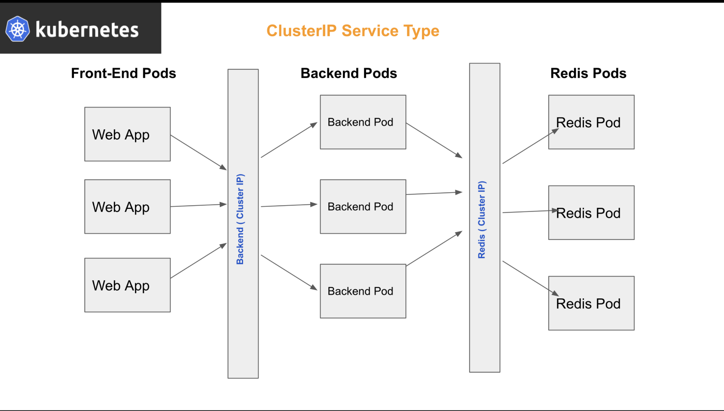

In continuation to my last piece on working with services :

## [Working With Services In Kubernetes](https://medium.com/the-programmer/services-in-kubernetes-844ac2e69c6d" \t "_blank)

### **[What is nodeport service in kubernetes? How NodePort Works ?](https://medium.com/the-programmer/services-in-kubernetes-844ac2e69c6d" \t "_blank)**

[medium.com](https://medium.com/the-programmer/services-in-kubernetes-844ac2e69c6d" \t "_blank)

where we discussed how we can enable the external world application to talk to our internal pods deployed in the k8s cluster by making use of the **NodePort type service**. Today I am excited to discuss Kubernetes services in more detail by venturing into the role of **ClusterIP as one of the**prominent services to enable communications of multiple pods within the cluster.

But, before we jump into the ClusterIP type service, let’s again understand what is Services in K8s briefly

# What Are Services in K8s?

In Kubernetes, a Service is an abstraction that defines a logical set of Pods and a policy by which to access them, this kind of patterns is also sometimes called a micro-service.

If you are from a programming background and have been an API developer you must be familiar with the term REST object, services in k8s is quite similar to this REST object.

* One can **POST** a Service definition to the API server to create a new instance.
* The name of a Service object must be a valid**DNS label name**.

Each pod in the Kubernetes cluster has got the cluster IP and Network IP, but these pods cannot be directly accessed externally as those IPs are not exposed outside the cluster without a **Service**.

Kubernetes services allow our applications to be exposed to receive external world traffic, and also helps these pods lying in the node cluster to communicate with each other internally.

# Types of Kubernetes Service:

Kubernetes Services allows external connection to the internal cluster Pods and also manages internal communication among the Pods within the cluster via different Services **type** in defined int the **ServiceSpec.**

**These service types are**

* **ClusterIP**
* **NodePort**
* **LoadBalancer**

**NodePort** we have already covered in my last article :

## [Working With Services In Kubernetes](https://medium.com/the-programmer/services-in-kubernetes-844ac2e69c6d" \t "_blank)

### **[What is NodePort service in Kubernetes? How NodePort Works ?](https://medium.com/the-programmer/services-in-kubernetes-844ac2e69c6d" \t "_blank)**

[medium.com](https://medium.com/the-programmer/services-in-kubernetes-844ac2e69c6d" \t "_blank)

Let me today help you all, understand **ClusterIP type**and its implementation using YAML file definition and Kubectl commands.

# What Is ClusterIP?

## A Society Analogy :

If you have lived in the gated society in the metro cities, you would have experienced that this society comprises multiple high-rise towers with multiple flats belonging to individual towers. Multiple families reside within each flat of the given tower. Imagine each tower having its own common address which in turn has a gateway to multiple flats with their own unique address, so if one has to reach out to a particular flat in tower B, it has to first locate the tower B gate address and then will be getting the access of local flat address lying within the tower B.

The address of tower A & Tower B can be considered similar to **ClusterIP**, this cluster IP’s of each tower acts like a single endpoint/ gateway (Service)to connect to each pod (Family) living in the given cluster having their own local IP addresses.

## Let’s Understand ClusterIP Further With One More Example:

**In any given cluster node there can be multiple types of Pods viz**

* **Front-end pod**
* **Backend** pods
* **Redis** pods
* **Database** MySQL pods

**etc…**

Each of these types of **pods** lying within an internal cluster will have a different internal network IP, which is liable to change. In order, to talk to each other. For example, the front-end pod may be talking to the backend pods, backend pods, in turn, may require to talk to **Redis** pods, there is the requirement for a more reliable and efficient mechanism, **ClusterIP** is our friend here.

**Refer to the image below:**

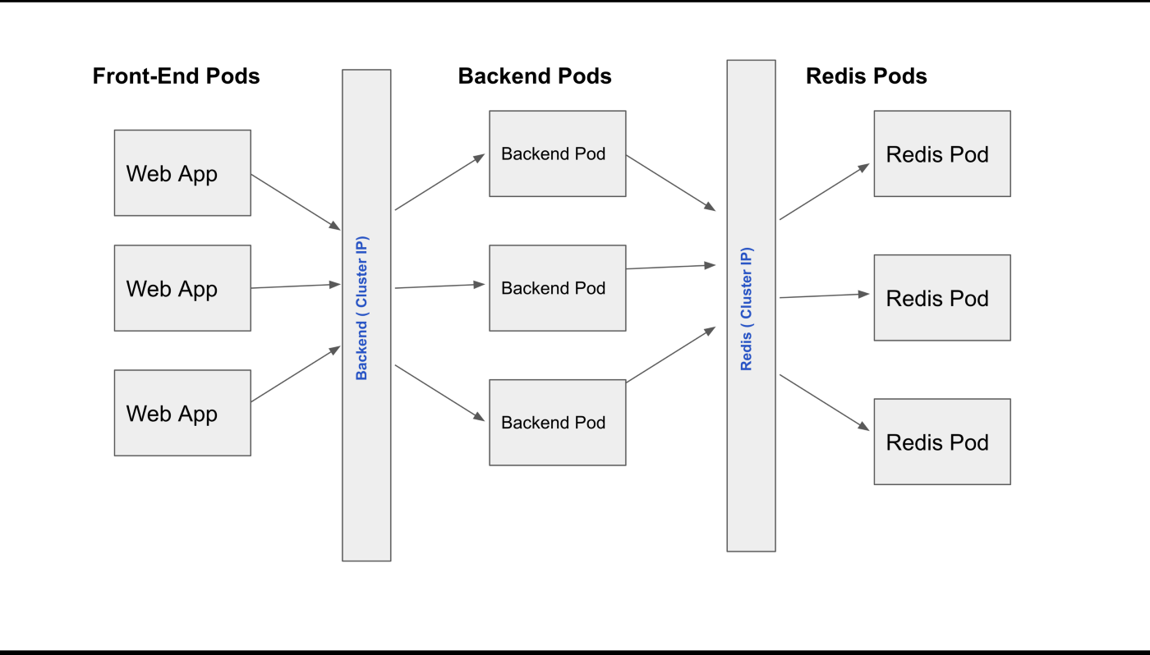

As can be clearly seen that whenever a front-end pod wants to communicate with backend pods, it has to simply communicate to a ClusterIP service named **backend**, which is a single endpoint service managing the communication to all backend pods. Similarly, if backend pods need to access the Redis cache service it has to make a service call to cluster IP service named **Redis**, which will allow the backend pods to communicate to respective Redis pods.

**To summarize**: These common backend / Redis services are the **virtual IP’s** also known as C**lusterIP type service,** which effectively allows one pod type to communicate to another Pod type in the given cluster Node.

# Defining ClusterIP Service Type: (YAML)

Let’s put **CluserIP** to work, by defining the sample ClusterIP service YAML file:

**my-cluster-ip-demo.yaml file:**

**apiVersion**: v1  
**kind**: Service  
**metadata**:  
 **name**: Backend  
**spec**:  
 **type**: ClusterIP  
 **ports**:  
 - **targetPort**: 80  
 **port**: 80

## **Let’s Define A Sample Front-End Pod:**

And bind it to our ClusterIP service defined in **my-cluster-ip-demo.yaml file**

**my-demo-pod.yaml file :**

**apiVersion**: v1  
**kind**: Pod  
**metadata**:  
 **name**: my-demo-pod  
 **labels**:  
 **app**: my-test-pod   
 **type**: mobile-front-end-app**spec**:  
 **containers**: - **name**: nginx-container  
 **image**: nginx

Now we have a pod, with the label: my-demo-pod, let’s map this label to our service definition file to create our ClusterIP services, in order to do so we will have to define a new parameter called s**elector, in the spec section,**and pull the label parameter and place it under **selector** field as shown below

**Backend Service: (ClusterIP type )**

**my-cluster-ip-demo.yaml file:**

**apiVersion**: v1  
**kind**: Service  
**metadata**:  
 **name**: Backend  
**spec**:  
 **type**: ClusterIP  
 **ports**:  
 - **targetPort**: 80  
 **port**: 80  **selector:**   
 **name**: my-demo-pod   
 **type**: front-end-app

**Now that we have defined all the required YAML files it is time to create and compile those YAML file using kubectl command**

**So let’s first create a pod file as defined in our, my-demo-pod.yaml file above**

**Open your Kubernetes cluster terminal :** (**minikube** cluster in case you are on the local machine )

* Create my-demo-pod.yaml using **vim** command
* Copy-paste the YAML code defined **my-demo-pod.yaml file**
* create the pod using the command below

**$ kubectl apply -f test-pod.yaml**

**Output**:

Our pod file my-pod-demo has been created and running

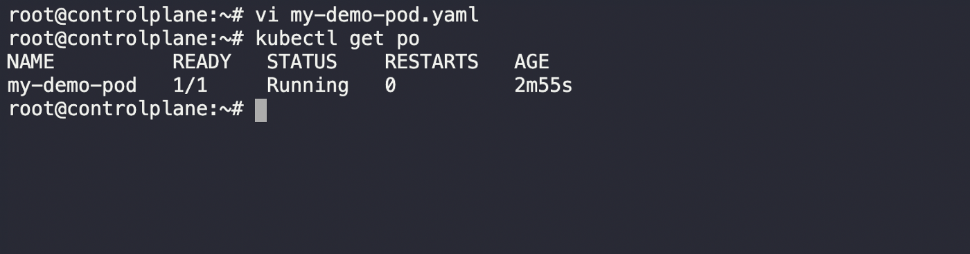

**Now that we have our pod file up and running, it’s time to create service as defined in our “my-cluster-ip-demo.yaml file “**

* create **my-cluster-ip-demo**.yaml using **vim** command
* copy paste the YAML code defined in **my-cluster-ip-demo.yaml file**
* create the service pod using the command below

$ kubectl create -f **my-cluster-ip-demo.yaml**

**Output:**

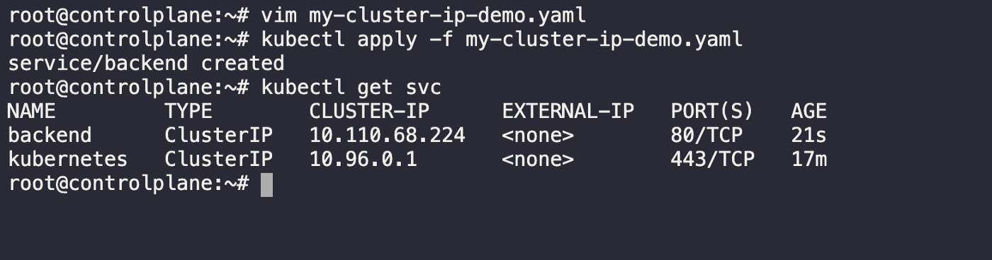

Our service of type ClusterIP has been successfully created and has been bound to our demo using pod using selector as shown below :

$ **kubectl describe svc backend**

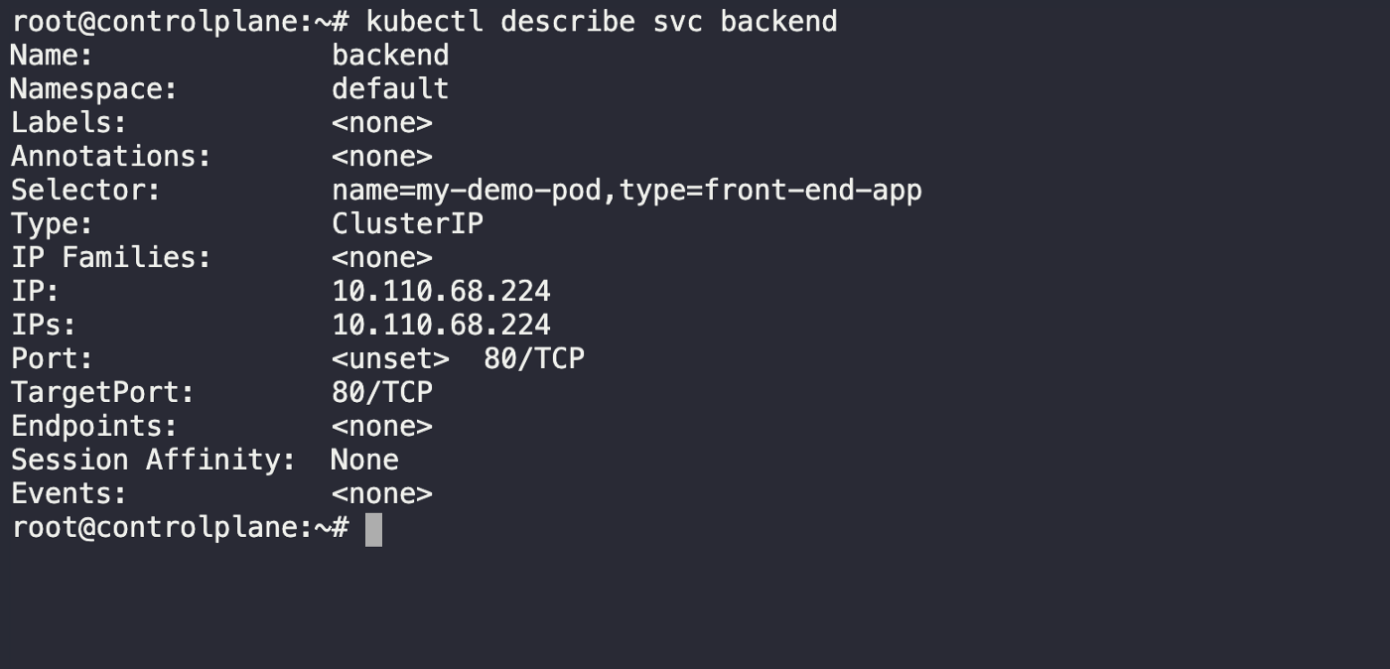

# What’s Next?

We have covered NodePort & ClusterIP services type in detail so far and understood how one can define and create such services using YAML file defintionn and Kubectl CLI. But still we have not covered one more important K8s service type called “**LoadBalancer**”

We will look into this in our next piece of working with services in K8s , till then its time to sign-off with this

# Working With Node Affinity In Kubernetes

## **How Does Node affinity Work in Kubernetes?**

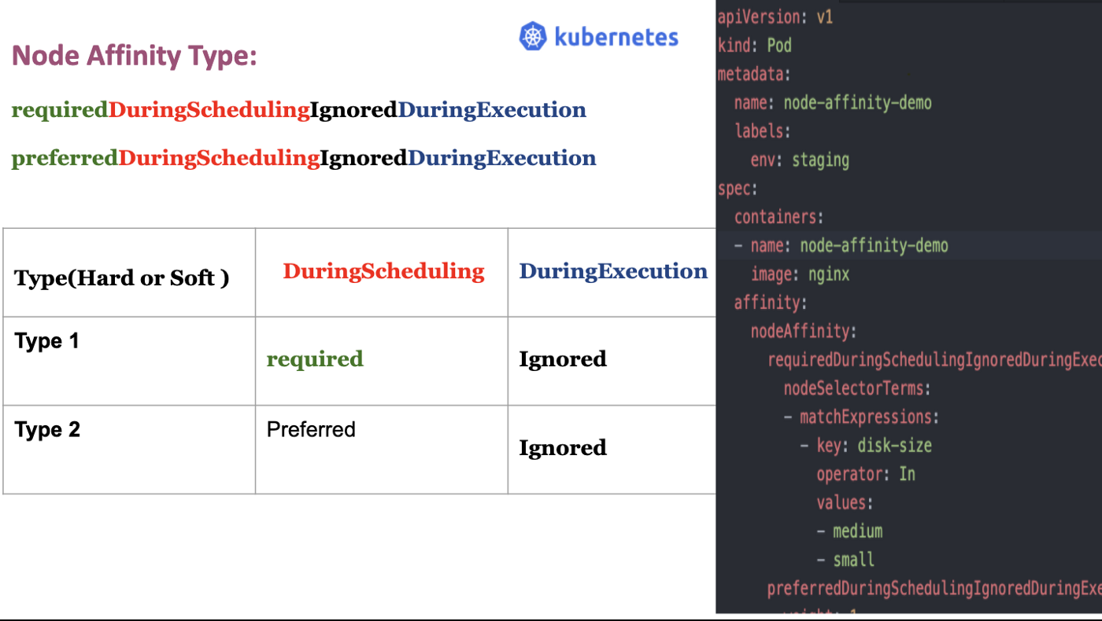

Welcome to this brand new piece of working with Kubernetes series,

In the previous piece:

## [Working with Node Selector & Node Affinity In Kubernetes](https://medium.com/the-programmer/working-with-node-selector-node-affinity-in-kubernetes-7943d6ba6018" \t "_blank)

### **[Node Selector & Node Affinity in Kubernetes](https://medium.com/the-programmer/working-with-node-selector-node-affinity-in-kubernetes-7943d6ba6018" \t "_blank)**

[medium.com](https://medium.com/the-programmer/working-with-node-selector-node-affinity-in-kubernetes-7943d6ba6018" \t "_blank)

we discussed,

How one can allow any particular pod with a certain type of workload to be specifically scheduled on the particular Node, using the simplicity and power of **nodeSelector.**

Let’s revisit the example we discussed in the last piece:

**apiVersion**: v1  
**kind**: Pod  
**metadata**:  
 **name**: nginx  
 **labels**:  
 **env**: staging  
**spec**:  
 **containers**:  
 - **name**: nginx  
 **image**: nginx  
   
 **nodeSelector**:  
 **size**: large

Here we are trying to place our Pod, using **nodeSelector** key-value pair

**size:large**

In such a case, one thing which limits the node selector approach of placing the specific pod to a specific node is its ability to handle cases like

* **size: Large or Medium**
* **Size: Not big**
* **size: Not small, etc…**

So, If someone wants to provision the pod in the node based on such cases, he will not be able to handle this scenario by just using the Node Selector. What one can do? Well the answer lies in the concept of

## “Node Affinity”

# What is Node Affinity?

Node affinity is objectively used to perform the same task as **nodeSelector** where it allows you to constrain which nodes your pod is eligible to be scheduled on, based on labels on the node. But it differs in its ability to make this constraint become more expressive

The affinity language in node affinity offers the protocols or matching rule based on logical OR/ AND operation, NOT operations, etc..

## Understanding Node Affinity & It’s Type By Example:

Let’s write the Pod definition

**apiVersion**: v1  
**kind**: Pod  
**metadata**:  
 **name**: node-affinity-demo  
 **labels**:  
 **env**: staging  
**spec**:  
 **containers**:  
 - **name**: node-affinity-demo  
 **image**: nginx **affinity**:  
 **nodeAffinity**:  
 **requiredDuringSchedulingIgnoredDuringExecution**:  
 **nodeSelectorTerms**:  
 - **matchExpressions**:  
 - **key**: size  
 **operator**: In  
 **values**:  
 - large  
 - small

In node selector, we used **nodeSelector** field under the Spec, but here in the pod definition, it is replaced by more complex terms as shown below

**affinity**:  
 **nodeAffinity**:  
 **requiredDuringSchedulingIgnoredDuringExecution**:  
 **nodeSelectorTerms**:  
 - **matchExpressions**:  
 - **key**: size  
 **operator**: In  
 **values**:  
 - large  
 - small

affinity is used to define **nodeAffinity** parameter which encompasses the complex sentence like the term

**requiredDuringSchedulingIgnoredDuringExecution**:

This sentence encompasses **nodeSelectorTerms,**

whichin turn holds the field

- **matchExpressions**:  
 - **key**: size  
 **operator**: In  
 **values**:  
 - large  
 - small

it is the place where you manage the logical **AND, OR, NOT**expression to define more expressive constraints for the pod. If you carefully observe the

- **matchExpressions**

**It has :**

* **key**: which defines the parameter like **size**
* **operator**: here we place the operator: **In,**it can also have the values like **NotIn, Exists.**There are more operators which one need to refer to in the Kubernetes doc
* **value**: which defines values for the keys like,**large, medium, medium and small, medium or large, only medium, not small, etc..**
* It can hold multiple values like:

**values**:  
 - large  
 - small

**In** operator, ensures that the Pod is placed in the node based on matching key-value pairs. It can match based on multiple values.

Now that we have understood how we can create a pod definition making use of the **Node affinity** concept, it is imperative to understand:

## What happens when there are no node labels matching the kind of expression which we defined above?

There can be a situation that as per the pod’s affinity definition there are no matching node labels, which can match the expression values like large, small, etc, in such a scenario how does the pod gets handled by Kubernetes.

There can also be situations where the pod is already scheduled in the Node, but someone changed the node label knowingly or accidentally, how does Kubernetes handle this kind of situations

Well to answer it better, we have to understand the types of node affinity

## Node Affinity Type:

The types of Node affinity actually define the behavior of our scheduler with respect to Node affinity and based on the stage of our Pod’s lifecycle.

There are two major categories of Node Affinity

1. **Available:**

It has two types of node affinity :

**requiredDuringSchedulingIgnoredDuringExecution**

and

**preferredDuringSchedulingIgnoredDuringExecution**

**2. Planned**:

**requiredDuringSchedulingrequiredDuringExecution**

Let’s understand each of these in detail, by breaking these terms up to make more sense.

# Available:

## **- requiredDuringSchedulingIgnoredDuringExecution:**

## **- preferredDuringSchedulingIgnoredDuringExecution:**

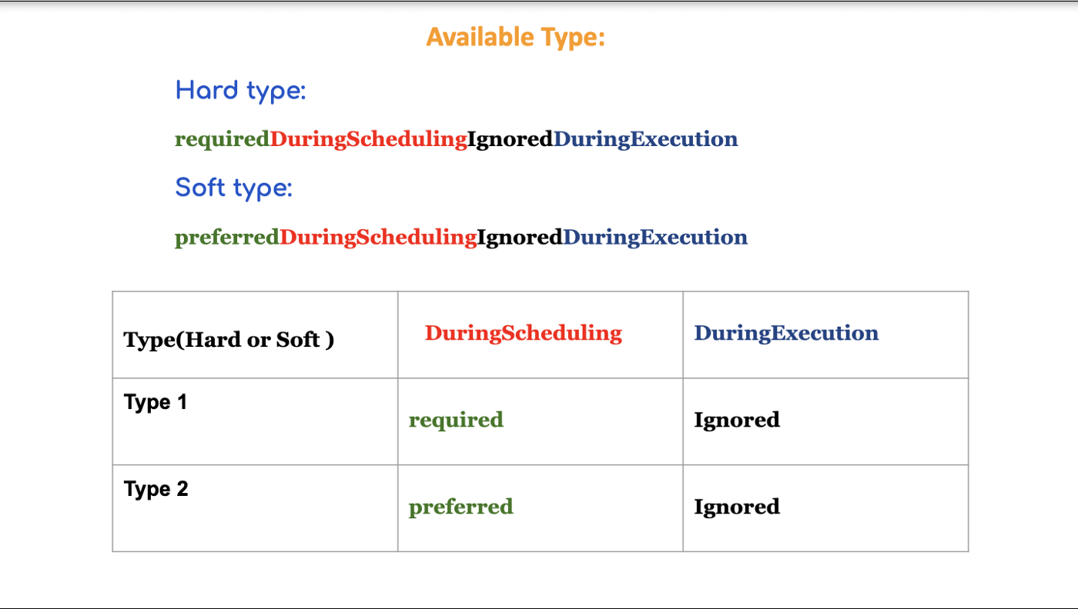

Fig 1.0: **Node Affinity Type Explanation**

If we break our Available Node Affinity type as shown in the fig 1.0, we can clearly understand that pod has two important state’s in its lifecycle, w.r.t Node affinity

* **DuringScheduling**
* **DuringExecution**

# ****DuringScheduing:****

It is the state when the POD is being created for the first time

so if we have the situation where at the time of pod creation, there is no matching Node label, Kubernetes refers to the type parameter as shown in the table above to enforce decisions on pod’s scheduling.

## required:

If the parameter is of the type **required:**In that case, the scheduler will mandate the POD to be scheduled based on the given Affinity rule, so if there are no matching label at the Node side, this pod will not be scheduled in the Node by our scheduler. That is why we can call this a “**Hard**” type of enforcement rule.

## preferred

If the parameter is of the type **preferred:**In that case, the scheduler will try to enforce the but will not guarantee, so there are chances that POD may be allowed to schedule in the Node. That is why it also is known as a soft kind of rule, here we have given a choice to the scheduler that placement of pod is not as important as executing the workload.

# ****DuringExecution:****

This is a state where POD is already running in the given NODE.

In this state, if someone by mistake removed the node label, the already POD will be managed by scheduler based on the available Node affinity parameter

“**ignored**” **DuringExecution**, as shown in fig1.0

which tells the scheduler to ignore this situation and keep running the POD in the node.

There is also another type of Node Affinity which is kind of Planned and that is :

## Planned Type:

## **" requiredDuringSchedulingrequiredDuringExecution"**

Here at the time of POD execution, one can also define it to be of Type requiredDuringExecution

instead of **ignoredDuringExecution.**

which tells the scheduler to evict the running POD, if the NODE in which is was scheduled has been modified and there is no matching label available.

Let’s Understand all that we discussed by the POD definition below:

## node-affinity-demo.yaml

**apiVersion**: v1  
**kind**: Pod  
**metadata**:  
 **name**: node-affinity-demo  
 **labels**:  
 **env**: staging  
**spec**:  
 **containers**:  
 - **name**: node-affinity-demo  
 **image**: nginx **affinity**:  
 **nodeAffinity**:  
 **requiredDuringSchedulingIgnoredDuringExecution**:  
 **nodeSelectorTerms**:  
 - **matchExpressions**:  
 - **key**: size  
 **operator**: In  
 **values**:  
 - large  
 - small **preferredDuringSchedulingIgnoredDuringExecution**:  
 - **weight**: 1  
 **preference**:  
 **matchExpressions**:  
 - **key**: Zone  
 **operator**: In  
 **values**:  
 - Zone 1  
 - Zone 2

**Let’s understand :**

**preferredDuringSchedulingIgnoredDuringExecution**

The **weight** field in **preferredDuringSchedulingIgnoredDuringExecution** has the value in the range 1-100. At the time of Node sorting, the scheduler gives higher weight to nodes having the labels **zone=Zone1** or **zone=Zone2**. If a node has **size=large and zone=Zone1**, it is preferred over another that has **size=large** but has no**zone label** or one that points to a different zone.

*The weight number gives the matching node a relatively higher weight than other nodes. The higher the number, the higher the weight.*

# Understanding the covered concepts through Example:

## Case 1: There is a matching Node with matching Labels

**Step1 : Label the Node**

By default, your **minikube** cluster will have one default master node

let’s retrieve the node and describe it using the following command shown below, to see if there are any labels attached.

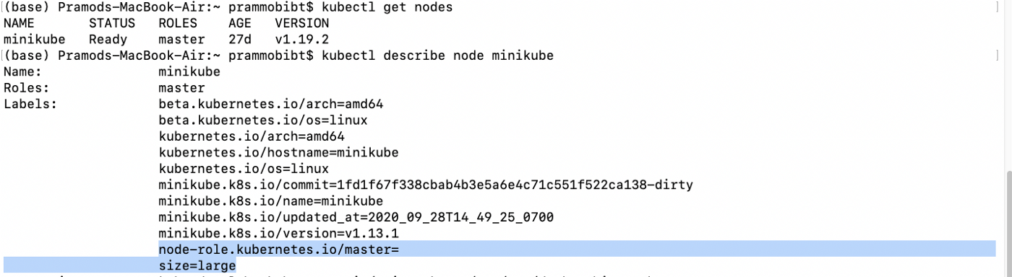

In my previous article on Node Selector, I have already created one node with a label which is shown in the highlighted area, in our output shown above, where **minikube** master node has the label **“size=large”**

**But if you don’t have one, you can label any node by the following steps :**

* Run kubectl get nodes to get the names of your cluster's nodes. Pick out the one that you want to add a label to,
* Run kubectl label nodes <node-name> <label-key>=<label-value> to add a label to the node you've chosen.

For example, if my node name is “**minikube**” (which is a default master node of my cluster), if you want to create a label using the following key-value pair: “**size=large”**

then you have to type the command as shown below

**$ kubectl label nodes minikube size=large**

**Step 2: Let’s create a POD**, using the definition file, which we have already discussed above when we created the **node-affinity-demo.yaml, let me write it down once again for the convinience**

## node-affinity-demo.yaml

**apiVersion**: v1  
**kind**: Pod  
**metadata**:  
 **name**: node-affinity-demo  
 **labels**:  
 **env**: staging  
**spec**:  
 **containers**:  
 - **name**: node-affinity-demo  
 **image**: nginx **affinity**:  
 **nodeAffinity**:  
 **requiredDuringSchedulingIgnoredDuringExecution**:  
 **nodeSelectorTerms**:  
 - **matchExpressions**:  
 - **key**: size  
 **operator**: In  
 **values**:  
 - large  
 - small **preferredDuringSchedulingIgnoredDuringExecution**:  
 - **weight**: 1  
 **preference**:  
 **matchExpressions**:  
 - **key**: Zone  
 **operator**: In  
 **values**:  
 - Zone 1  
 - Zone 2

now let’s create this pod file using the below CLI:

**$kubectl apply -f node-affinity-demo.yaml**

Let’s check if our pod has been scheduled based on the Node affinity parameter or not, by getting all pods with the below command

**$kubectl get pods**

## output:

(base) Pramods-MacBook-Air:~ **prammobibt$ kubectl get pods**NAME READY STATUS RESTARTS AGEnginx 1/1 Running 0 42hnginx-6799fc88d8–9d75l 1/1 Running 1 10d**node-affinity-demo 1/1 Running 0 3m6s**web-app 1/1 Running 1 10dwebapp-7694cb7f68-crwj8 0/1 ImagePullBackOff 0 10dwebapp-7694cb7f68-kjnng 0/1 ImagePullBackOff 0 10dwebapp-7694cb7f68-r8wnq 0/1 ImagePullBackOff 0 10d(base) Pramods-MacBook-Air:~ prammobibt$

you can see the highlighted output string, “**node-affinity-demo 1/1 Running 0 3m6s,”**which shows that our pod “**node-affinity-demo**” has been scheduled successfully on our master node. This happened because the label on the **minikube** master node has the matching label “**size=large**”,

**Case2: Now suppose there is a label mismatch in the POd’s affinity definition, file,**

**node-affinity-test-2.yaml:**

**apiVersion**: v1  
**kind**: Pod  
**metadata**:  
 **name**: node-affinity-demo-2  
 **labels**:  
 **env**: staging  
**spec**:  
 **containers**:  
 - **name**: node-affinity-demo-2  
 **image**: nginx **affinity**:  
 **nodeAffinity**:  
 **requiredDuringSchedulingIgnoredDuringExecution**:  
 **nodeSelectorTerms**:  
 - **matchExpressions**:  
 - **key**: disk-size  
 **operator**: In  
 **values**:  
 - medium  
 - small

here we have created a pod definition file, where, **matchExpressions** has a key-value pair

**“disk-size= medium or small”**

- **matchExpressions**:  
 - **key**: disk-size  
 **operator**: In  
 **values**:  
 - medium  
 - small

as we have no, **node label** with this key-value pair, it would be interesting to investigate how this POD named : **node-affinity-demo-2,**will be treated by the schedular, let’s see

Create the POD : **node-affinity-test-2.yaml:**

$ kubectl apply -f **node-affinity-test-2.yaml**

## output:

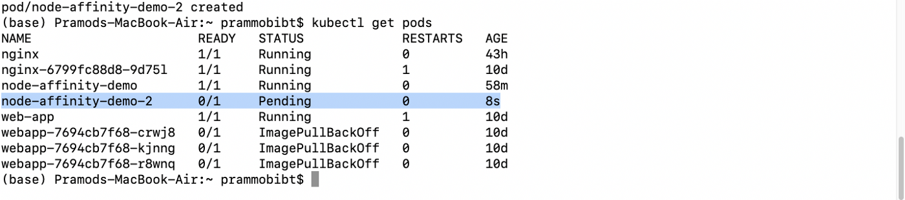

Fig 3.0

As can be seen in the output string highlighted with blue color in fig 3.0, our newly created pod

“**node-affinity-demo-2**”, has a pending status and has not been scheduled, the reason is, that there are no matching labels in the **minikube** master node which can match the below-given expression defined in our pod file

- **matchExpressions**:  
 - **key**: disk-size  
 **operator**: In  
 **values**:  
 - medium  
 - small

So our POD has not been scheduled by the scheduler. This explains how our scheduler treats our POD based on the node affinity type. It would be interesting to explore

## **What happens when we will use, preferredDuringSchedulingIgnoredDuringExecution?**

## node-affinity-test-3.yaml

**apiVersion**: v1  
**kind**: Pod  
**metadata**:  
 **name**: node-affinity-demo-3  
 **labels**:  
 **env**: staging  
**spec**:  
 **containers**:  
 - **name**: node-affinity-demo-3  
 **image**: nginx **affinity**:  
 **nodeAffinity**:  
 **preferredDuringSchedulingIgnoredDuringExecution**:  
 - **weight**: 1  
 **preference**:  
 **matchExpressions**:  
 - **key**: size  
 **operator**: In  
 **values**:  
 - large  
 - medium

Let’s create this pod file, using the apply command as shown below:

$ kubectl apply -f node-affinity-test-3.yaml

**Output**:

It can be seen from the below-given output, which I have highlighted with blue color**,**our new pod **node-affinity-demo-3** has been successfully placed in the master node, even though there was no matching label attached to our master node based on the node affinity **matchExpressions**

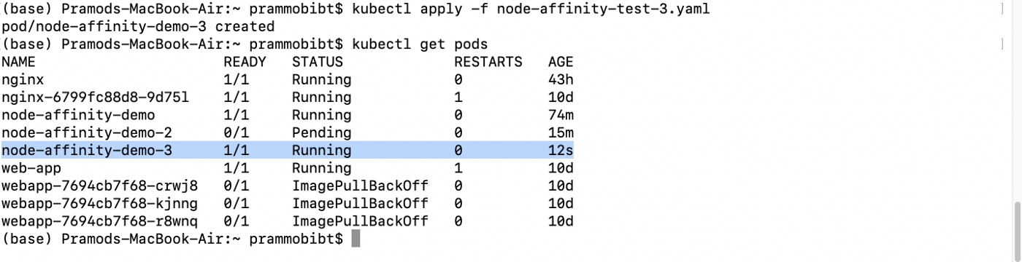

This goes on to show that if our Node affinity type is: “**preferredDuringSchedulingIgnoredDuringExecution**”, our scheduler will still place the pod in the Node, as here it will give preference to the execution of pod workload, irrespective of expression mismatch with Node label.

I Hope, these use cases have clarified how Node affinity functions.

# What’s Next?

In the upcoming part of our Working with Kubernetes series, we will cover

* Taints & Toleration Vs Node affinity,
* We will revise the concepts and work on some practical examples

## Thanks a lot……..For Reading …..

# Working With Taints & Tolerations In Kubernetes

## **What is Taints & Tolerants In Kubernetes and How Does It Work?**

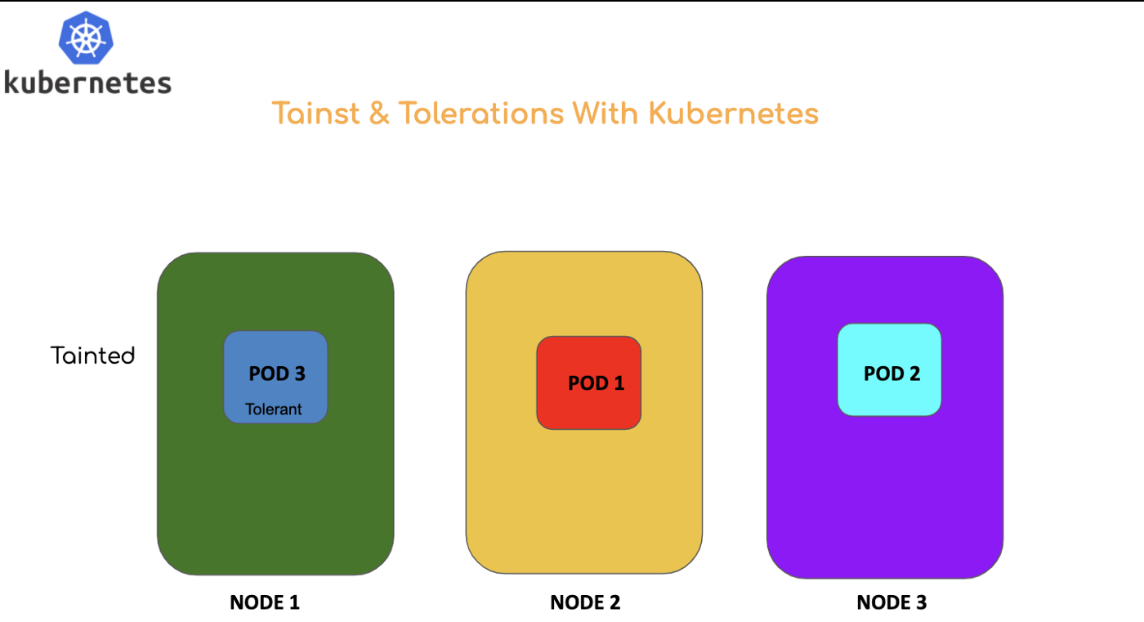

In general life, we often develop an affinity with people whom we like and want to engage very often, similarly, in Kubernetes, we can establish a close affinity between nodes and pods.

If you want to ensure that only a few types of pods get accommodated in any given worker **Node** and repelling the other pods which you don’t want to be a part of the worker **Node**, you can use the concept of

**“Taints & Tolerations ”**

# Let’s Understand with mosquito & human analogy:

Suppose you don’t want the mosquito to bite you, in that case, what do you do? You make use of mosquito repellant or apply Odomos(mosquito repellant gel).

Wherever on your body, you apply Odomos that part becomes “**Tainted**”. Our mosquito is non-tolerant to this type of taint, so whenever they will come closer to the tainted body part they will not be able to tolerate and will fly away.

**So our body here is “Tainted ” and Mosquito is “Non-tolerant ”**

But if any other type of bug comes which is tolerant to the applied taint (**repellant**)they will be able to sit on our body.

**So in this case body is “Tainted ” other bug is “Tolerant ”.**

With this analogy, now we can understand that some types of Nodes of are tainted to repel some non-tolerant type of Pods, this pod will not be abe able attach to such Nodes, while some other type of Pods which are tolerant to the tainted worker Node, will be able to reside in that Node.

## Taints & Tolerations In Kubernetes Context:

**In the case of Kubernetes**

* **Node**: is the person on which the bug wanted to sit. Node her is generally tainted
* **Pod**: is the Bug/Mosquito Itself. Pod here is generally made tolerant

*Taint and tolerations are just a mechanism to impose restrictions to ensure that pods are not scheduled onto inappropriate worker nodes.*

**Let’s understand with the figure given below:**

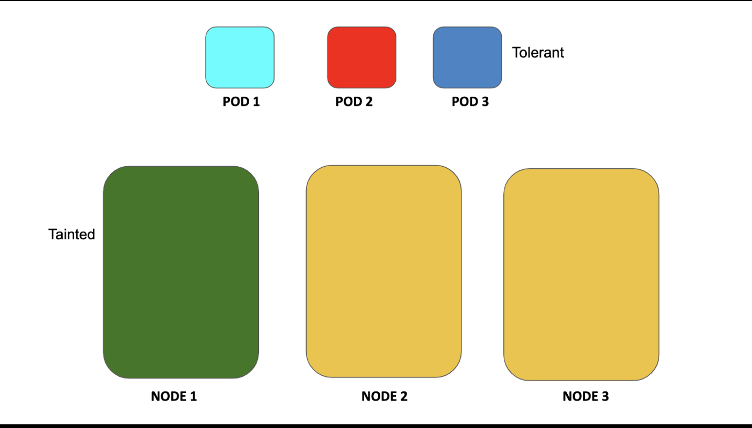

**Explanation:**

## Worker NODE 1 Tainted & POD 3 Marked Tolerant:

NODE 1 here is marked as Tainted with (green color), which means that None of the pods, POD 1, POD 2, POD 3 will be able to reside on the NODE 1 until any one or all of them are marked tolerant to Node 1 taints.

So if we mark **POD 3 to be tolerant against the tainted NODE 1**as shown in the figure above, and leave other pods, pod 1, pod 2 to be non-tolerant to Node 1 taints, here is how the situation may look like:

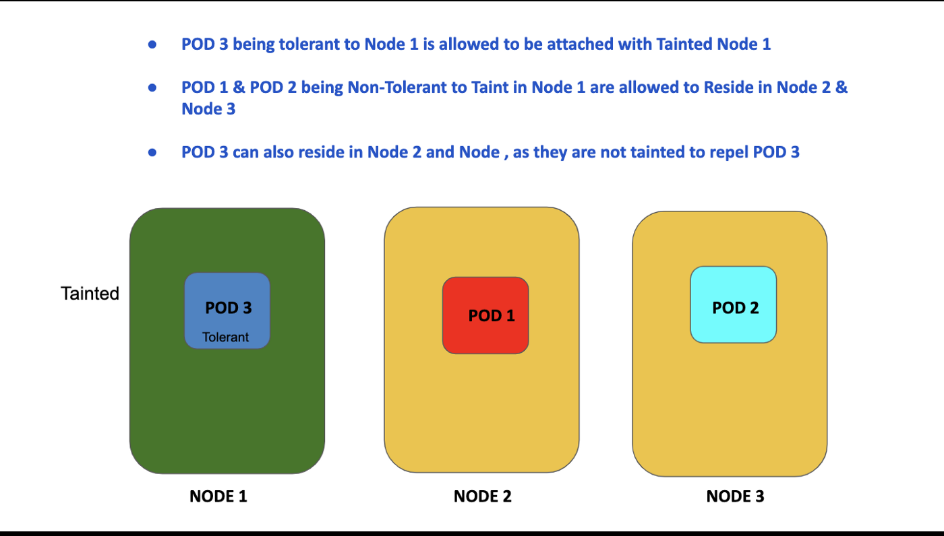

## Explanation:

POD 3 is allowed to reside in NODE 1 as it has been marked tolerant to it. The rest of the pods are allowed to be accommodated in NODE 2 and NODE 3.

**Note!**

POD 3 even though marked tolerant to NODE 1, has all the freedom to be a part of Other Nodes: Node 2 & Node 3, but pods POD 1, POD 2 will not be allowed to be accommodated in NODE 1, until they are marked tolerant to it.

So with this intuition and understanding its time to understand

# How Taints Are Applied?

You add a taint to a node using [kubectl taint](https://kubernetes.io/docs/reference/generated/kubectl/kubectl-commands" \l "taint" \t "_blank).

For example, adding taint using kubectl taint command will have the following syntax:

**kubectl taint nodes <node name >key=value:taint-effect**

**Here,**

* **taint**: is the command to apply taints in the nodes
* **nodes**: are set of worker nodes
* **node name**: is the name of the specific worker node, on which taint has to be applied, it has a key-value pair
* **key-value pair:**it is used to specify which application type in the pod will this node may be attached
* **taint-effect**: This is used to define how the pod will be treated if they are not tolerant of the taint.

**Taint effect has the following types**

* NoSchedule
* PreferNoSchedule
* NoExecute

So this is how the final command will look like:

**kubectl taint nodes node1 app=blue: NoSchedule**

here node1 is tainted with a pod with key-value pair app=blue, where pods are mapped with a taint-effect type: **NoSchedule**. It means no **pods** will be scheduled on to the given node, **node1 until it has matching tolerations**

# Adding Tolerations To The Pod:

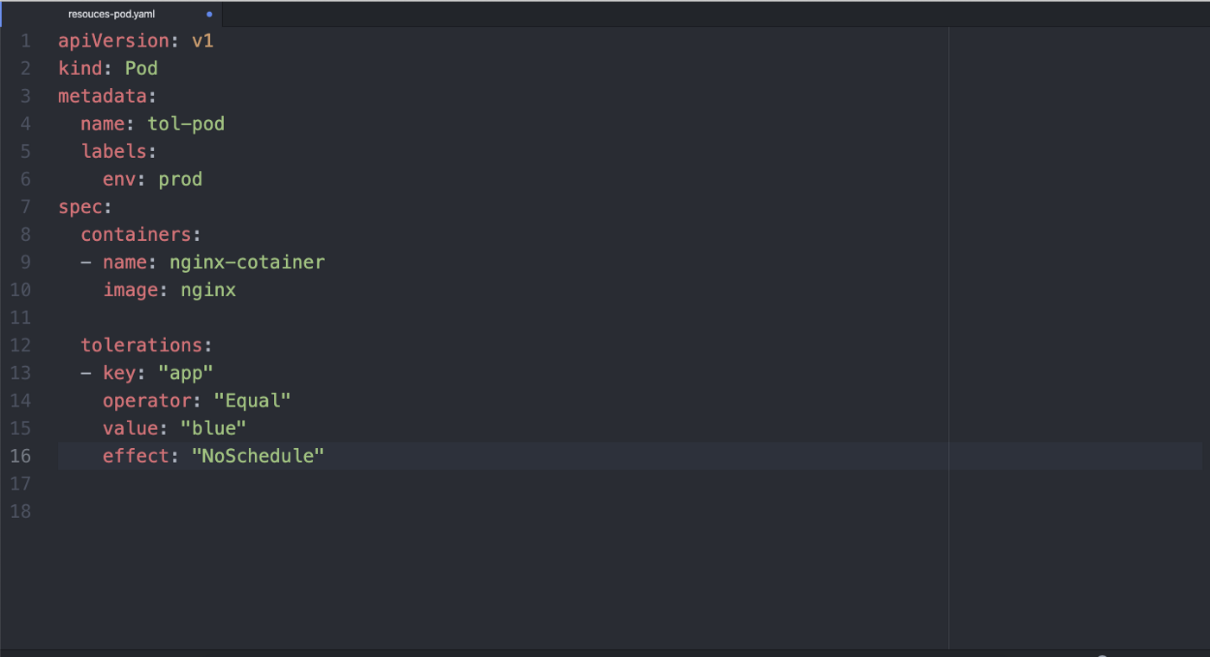

In the above pod definition, we specify tolerations for a pod in the Pod’s Spec section as shown in the fig above.

**tolerations**:  
- **key**: "app"  
 **operator**: "Equal"  
 **value**: "blue"  
 **effect**: "NoSchedule"

This tolerations definition matches, to the below command,

**kubectl taint nodes node1 app=blue: NoSchedule**

where we added taint to match the pod with key-value pair **app=blue.**

So with this toleration, now Pod **tol-pod** will be allowed to be scheduled with Node which is tainted to accept the value type **app= blue**.

**How Does Taints & Toleration Work Together:**

Tolerations defined in the pod definition matches the taint (mapped with worker nodes), where it looks for matching keys and taint-effect

**Remember: There are two special cases:**

By default operation is of type : **Equal**

* If in the definition there is an empty **key** with operator type **Exists**, it matches all keys, values, and effects, which means this key-value mapped with any taint, will tolerate everything.
* An empty **effect** matches all effects with key, **Key**.

## Understanding Other Taint Effects:

**Taint Effect: PreferNoSchedule**

**tolerations**:  
- **key**: "app"  
 **operator**: "Equal"  
 **value**: "blue"  
 **effect**: "PreferNoSchedule"

If we change the taint-effect type to : **effect**: "PreferNoSchedule",

this means it is a “preference” or “soft” version of NoSchedule -- the system will try to avoid placing a pod that does not tolerate the taint on the node, but it is not required

**Taint Effect: NoExecute**

To understand it better let’s take a new use case where we have multiple tolerations mapped with the same key-value pair but have a different type of taint effects

Let’s add a taint a node: node 1, as shown below

**- $ kubectl taint nodes node1 app=blue:NoSchedule  
- $ kubectl taint nodes node1 app=blue:NoExecute  
- $ kubectl taint nodes node1 app=green:NoSchedule**

**Now let’s create a pod definition with two tolerations, as shown below:**

**apiVersion**: v1  
**kind**: Pod  
**metadata**:  
 name: tol-pod  
 labels:  
 env: prod  
**spec**:  
 **containers**:  
 - name: nginx-cotainer  
 image: nginx  
   
 **tolerations**:  
 - key: "app"  
 operator: "Equal"  
 value: "blue"  
 effect: "NoSchedule"  
 - key: "app"  
 operator: "Equal"  
 value: "blue"  
 effect: "NoExecute"

**Explanation:**

In the above-depicted situations, our pod will not be scheduled onto the node, **node1**as there is no toleration matching the third taint.

But, if the pod is already running in the node, it is able to continue doing so, in case the node is newly tainted, as the third taint is the only one of the three tolerations, which is not defined to be handled by the node.

Generally, if any node is having a taint of type **NoExecute** and any pod that has not developed, tolerations to handle the taint , will be evicted(**if they pre-exist before node was tainted )**butany pods that do tolerate the taint will never be evicted.

**tolerationSeconds:**

If we want to instruct pod with taint-effect: NoExecute , to stay bound to the Node which was tainted and has been forced to evict, for some particular duration we can use an optional tolerationSeconds field, in the **tolerations** definition, as shown below

**tolerations**:  
- **key**: "app"  
 **operator**: "Equal"  
 **value**: "app"  
 **effect**: "NoExecute"  
 **tolerationSeconds**: 3600

# Summary:

We understood

* What is Taints & Tolerations?
* Why Taints & Tolerations are Is Used?
* How to add taints onto the Worker Node?
* How to Add Toleration Onto The Pod?

I would like to close this piece with some bullet points which mentioned the use cases of Taints & Tolerations. As we have discussed so far Taints and tolerations are a flexible way to repel pods away from nodes or evict pods that shouldn’t be running, so it is worth seeing one of the important use cases of the same:

## Dedicated Node Bound To A Particular User Groups/Set of Users

* If as a Kubernetes admin or DevOps architect you want to use any particular worker node in the k8s cluster, exclusively for a particular set or user group, we can do so by,

**$ kubectl taint nodes nodename dedicated=groupName:NoSchedule**

The pods with the tolerations will then be allowed to use the dedicated & tainted nodes in the cluster. In order for Pod to be scheduled onto the nodes with a dedicated label, it is required that Pod has a definition of node affinity where this label dedicated: groupName has to be specified.

We will learn more about Node Affinity in our Next article in this series or Taints & Tolerations.

**2. Taint based Evictions**:

We can use **NoExecute** taint effect wisely to enforce pod eviction based on Node issues which need to be handled to address resource constraints in the node or any other relevant issue related to worker Nodes.

# What’s Next?

We will look into some more advanced use case of Taints & Tolerations like

* **Node Affinity**
* **Taint based Pod Eviction use cases**
* **How to control specialized hardware-level specifications in the Nodes?**
* and many more…..

If you loved this piece show me some support and affection by following me and clapping

# Working with Node Selector & Node Affinity In Kubernetes

## **Node Selector & Node Affinity in Kubernetes**

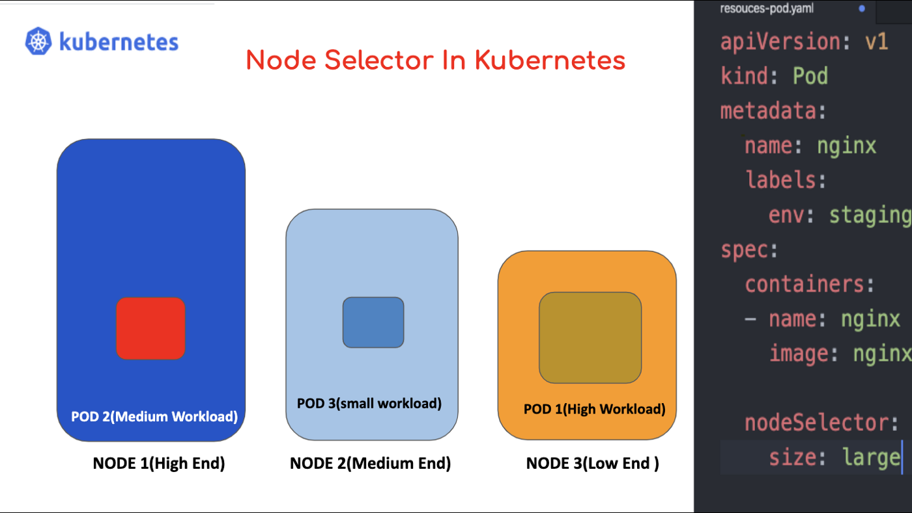

## “If you stretch beyond your capacity without putting your wisdom into practice, you are bound to break ”

The same applies to our Kubernetes worker nodes. If you will try to schedule a heavy workload to the worker node of low capacity, there is a higher probability of this node filling fast and create inefficiency in the cluster. So as a Kubernetes administrator or developer what you should do?

**To understand this scenario let me paint a visual picture of a hypothetical situation below:**

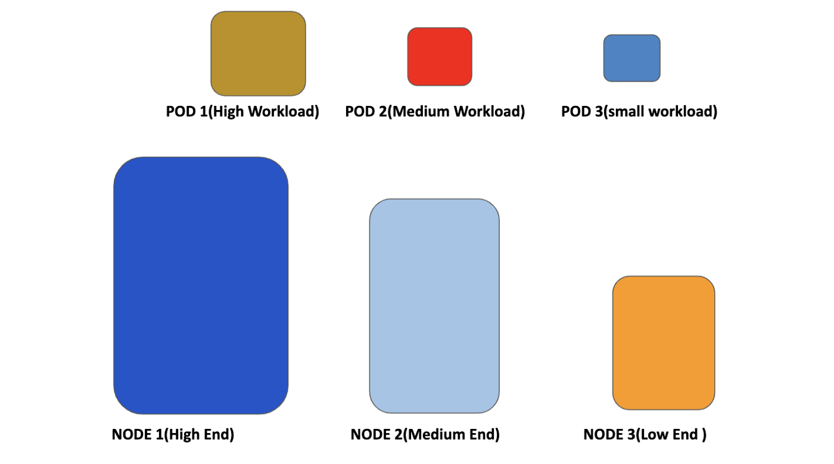

Fig 1.0

## Explanation:

In fig 1.0, there are three worker node, NODE 1, NODE 2, NODE 3.

* NODE 1 is a high-end machine which has high storage and memory capacity
* NODE 2 is a medium-end machine with a medium level of storage and memory capacity.
* NODE 3 is a low-end machine with a low level of storage and memory capacity.

**Also, there are three pods with**

* POD 1 with a Very heavy workload
* POD 2with a Medium level workload
* POD 3 with the lowest workload

Now by default Kubernetes may end up in the situation depicted below in fig 2.0

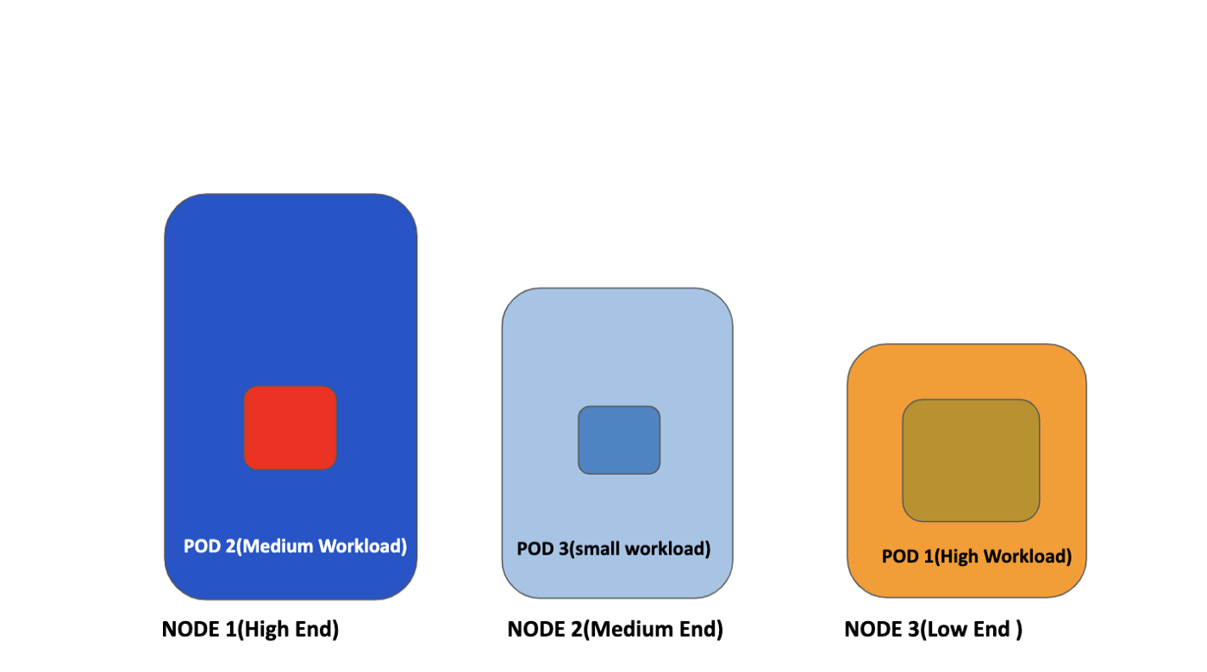

Fig 2.0

**Explanation:**

As shown in fig 2.0, there can be a situation that POD 1 with the heaviest workload may end up being scheduled in NODE 3 which has the lowest capacity and smaller workload pod may end up being scheduled in NODE 1 or NODE 2 for that matter. Which you as an administrator may not want to happen.

So to handle this kind of uncertainties there is a concept of

* **Node Selector**
* **Node Affinity**

Let’s get into the details of both solutions

# What Is Node Selector & How Does It Work?

As explained above, you may want to schedule a particular type of pod with a particular type of workload to be scheduled only to a particular type of Node selectively.

Generally, such constraints are not required, as our scheduler is intelligent enough to automatically do a reasonable placement to avoid placing the pod on a node with insufficient free resources, but there are some instances where you may want more control on a node where a pod lands, for example

* You may want to ensure that any given pod should end up on a machine with an SSD attached to it
* Or You may desire to co-locate pods from two different services that communicate a lot into the same availability zone.

The **node selector** is one such mechanism or constraint which we can apply to our pod to ensure that it is placed into a particular type of Node. One has to specify the field

“**nodeSelector**”,

which comes under the Pod’s Spec definition. This field makes use of key-value pairs. Any pod to be eligible for running onto any specific Node has to have the specified key-value pairs as labels of the intended Node.

# How to apply nodeSelector?

## Step1: First Label the Node :

**Get the name of the node**

To label, the node, use the following command to get all the nodes you have in your K8S cluster

**$ kubectl get nodes**

So if you run the above command you will get to see at least one node which will be your master node, as shown below.

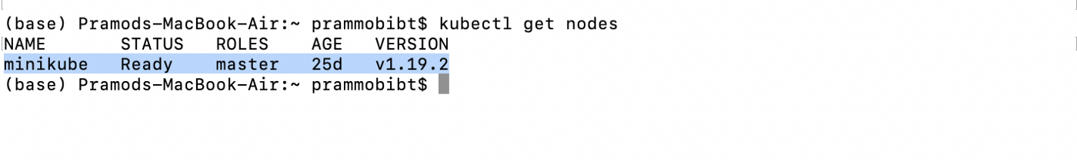

Here is my case: the highlighted area depicts our master node. we can look into the details of this node using

**$ kubectl describe nodes**

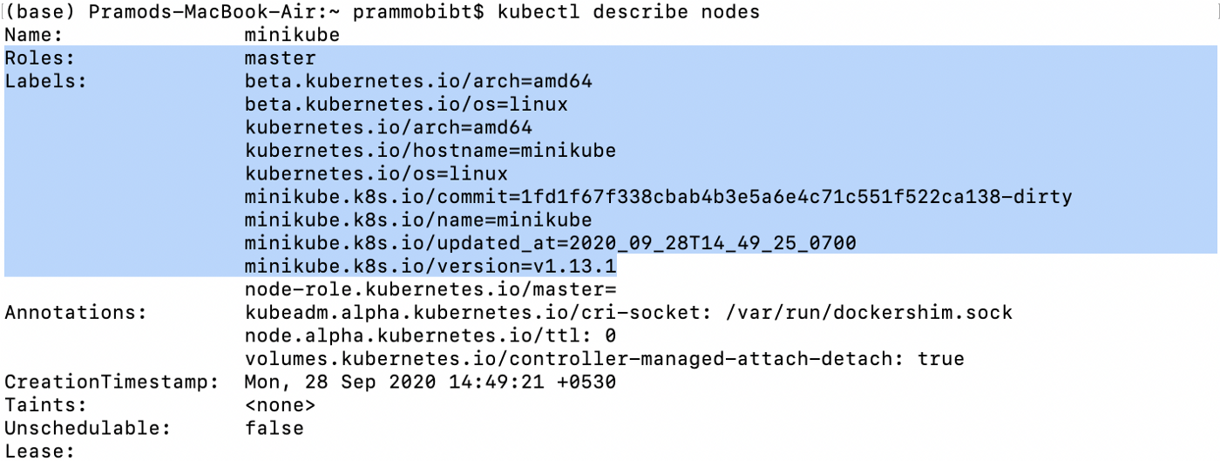

You can see that this **minikube** is our default master node has some pre-defined labels.

**Attach Labels To The Node You Want** :

Here we only have master node **minikube** so we will label it, using the command below:

**$ kubectl label node minikube size=large**

Once you apply this command, a node with node name (**minikube** )will be labeled with key-value pairs:

**“ size=large “**

Let’s view the Node label, To See if our label has been mapped successfully, by typing the command:

**$ kubectl describe nodes**

**output**:

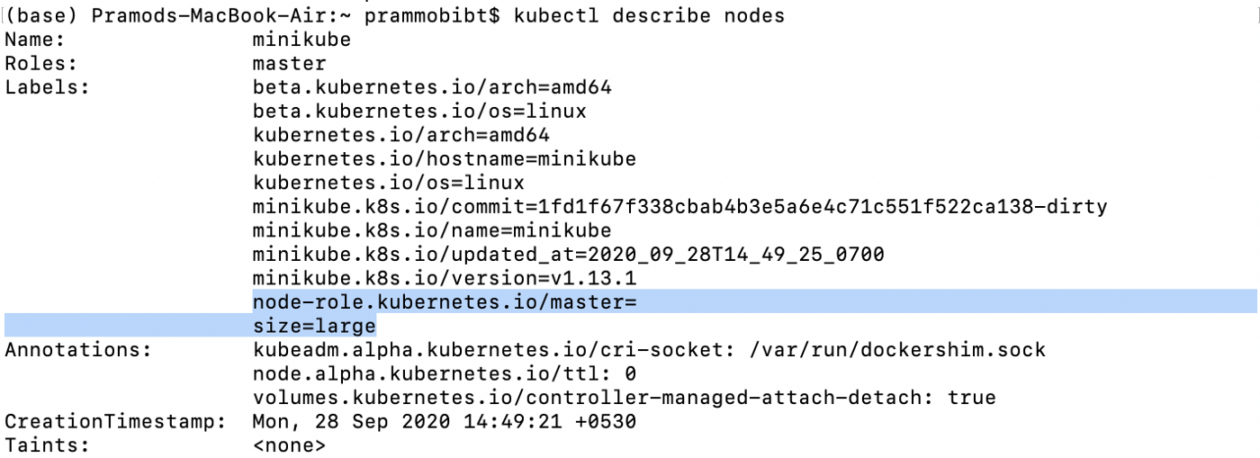

If you carefully observe the above output, the highlighted area shows that our node **minikube** has been labeled with key-value pair, size=large

Now that we have labeled our Node, it’s time to create a Pod which will be making use of **nodeSelector** field to define this key-value pair

**Step2: Create a Pod definition and make use of nodeSelector ,**

as shown below in the :**node-sel-demo.yaml:**

**apiVersion**: v1  
**kind**: Pod  
**metadata**:  
 **name**: nginx  
 **labels**:  
 **env**: staging  
**spec**:  
 **containers**:  
 - **name**: nginx  
 **image**: nginx  
   
 **nodeSelector**:  
 **size**: large

Step3: Create this Pod using the **apply** command as shown below

**$ kubectl apply -f nod-sel-demo.yaml**

this will successfully create the pod which has been scheduled to run on our **minikube** master node based on the **nodeSelector** , key-value parameter as shown below

**nodeSelector**:  
 **size**: large

Let’s verify if our pod has been scheduled on our master node or not, using the below command:

$ **kubectl get pods -o wide**

**output**:

it can be clearly seen by the highlighted area that our pod **nginx**, has been scheduled on master node **minikube**.

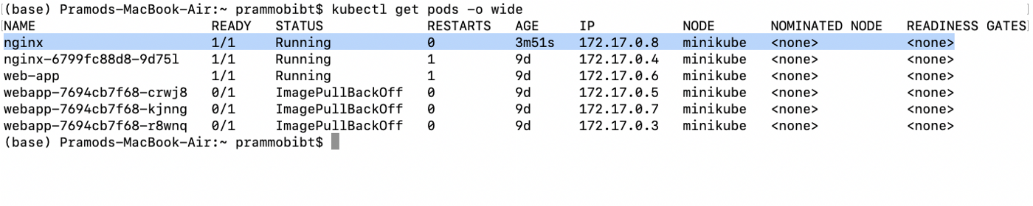

# Node Selector Limitation:

Now that we have learned how to label any specific node and then use that label to bind any particular Pod to be specifically scheduled on this node using **nodeSelector**(key-value pair),

it is imperative to understand that if you want to run our **Pod** on a particular node based on the following conditions, like

* **size**: large or medium
* **size**: Not Small

This type of logical expression type of selection cannot be achieved by **nodeSelector**, for this one has to use

**“ Node Affinity “**

We will look into the details of **nodeAffinity,**

in our next section where we will cover

* **What Is Node Affinity?**
* **What is Affinity?**
* **How Node Affinity Works?**
* **Example Pod definition to understand nodeAffinity application**

# ****Working With Services In Kubernetes****

## **Working with services in Kubernetes**

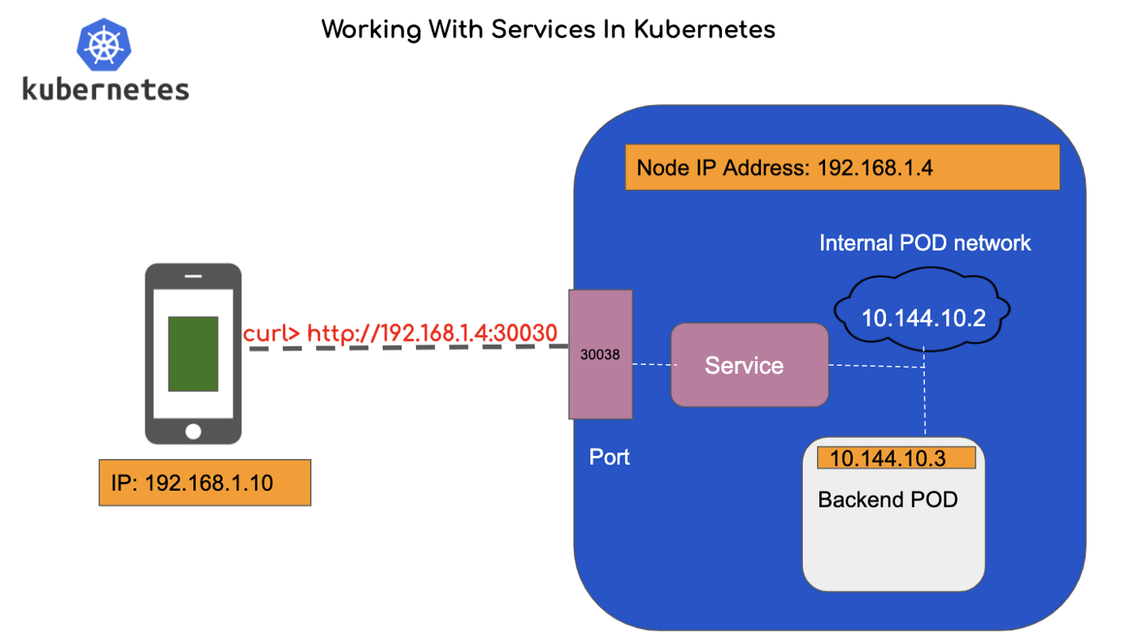

It is not only sufficient to have skilled individuals who know their job better, how these talented individuals communicate and help each other out as a team player which makes productive work happen, is what matters the most.

In a similar fashion, deploying different types of front-end and backend applications on the server is not sufficient, it is how these applications will exchange data with each other is what makes the client server-based ecosystem function effectively. In Kubernetes, we deploy all kinds of Pods which can be concerned with backend, front-end, and external data sources These logical sets of Pods are exposed to the external world to be discovered by Kubernetes services.

So with this basic understanding let’s define

## What Is Kubernetes Service?

*In Kubernetes, a Service is an abstraction that defines a logical set of Pods and a policy by which to access them, this kind of patterns is also sometimes called a micro-service.*

Each pod in the Kubernetes cluster has got the cluster IP and Network IP, but these pods cannot be directly accessed externally as those IPs are not exposed outside the cluster without a **Service**. Kubernetes services allow our applications to be exposed to receive external world traffic, it does this in three different ways, let’s see what ar those methodologies

## How Kubernetes Services Are Exposed?

To understand how a service is exposed to the outer world so that outer world solutions can connect with applications lying as a pod in the cluster node. Let’s me give you a visual explanation below

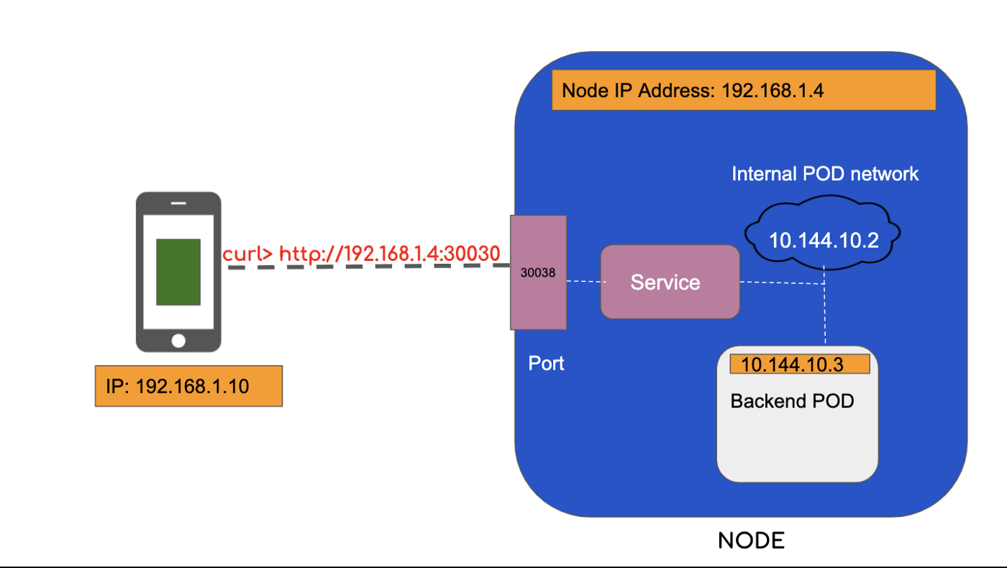

**Fig 1.0 Internal POD being connected to eternal mobile app via kubernetes service**

## Explanation:

As can be seen in fig 1.0, our mobile app is lying outside the cluster, wants to connect with the backend application pod. When it comes to the cluster-level pod, every pod has its own network IP, which in the case of the backend pod here is: 10.144.10.3. Now for an external mobile app to communicate with this pod, it can’t directly make an IP call to 10.144.10.3, it has to come up with some other mechanism.

Here, our external app is lying on the same network on which our Node is also available, so the only way our external app can connect is by this network IP where cluster node is also accessible. So in order to make our mobile app talk to the backend pod, Kubernetes has a service module that is exposed to the outer world and is listening to the node port 30038. This service is connected to POD level Network IP via pod level port.

Thus mobile app will make a curl request using node-level network IP and connecting to Node port **30038,**as shown below

**$curl>http://192/168.1.4:30038**

This is one way our Kubernetes service enables an external level connection for the applications pods lying inside the Nodes.

Now it's time to get into the depth of what are the ways in which Kubernetes exposes the services, for which we need to understand what are the services types and how these services are defined in the pod definition.

## Types of Kubernetes Service:

Kubernetes Services can be exposed in different ways by specifying a **type** in the **ServiceSpec**: which are

* **ClusterIP**
* **NodePort**
* **LoadBalancer**

## NodePort Kubernetes Service:

In our fig 1.0 explanation, we saw a glimpse of how **Node Port**is used to expose the pod to the outer mobile app. Let us get into the details of the same by revisiting fig 1.0 below:

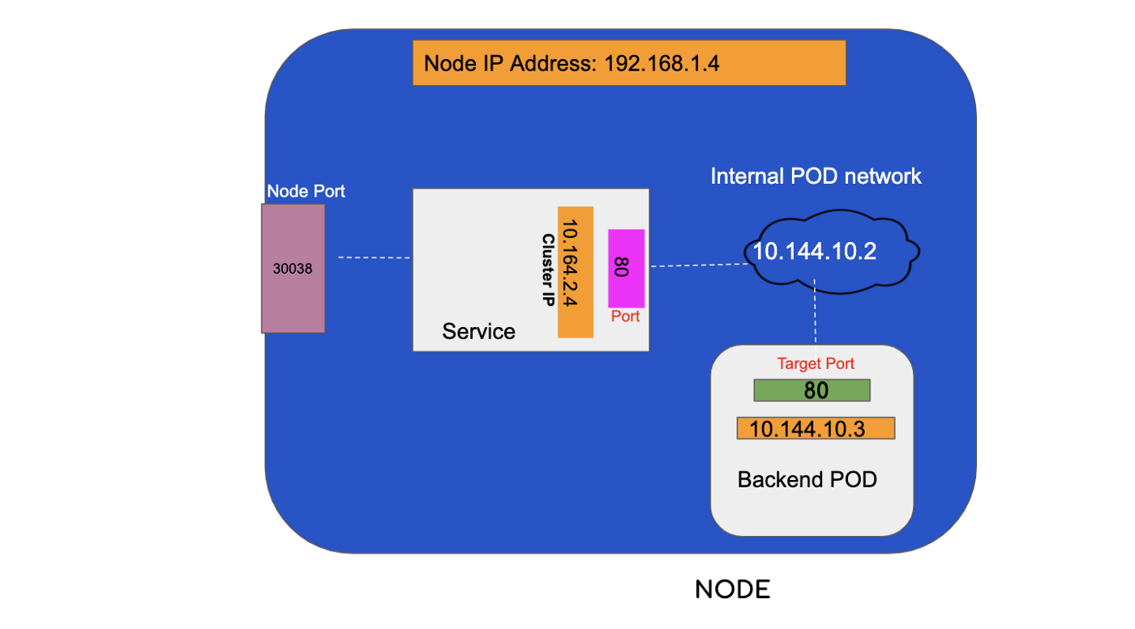

Fig 2.0 : Ports in Cluster Node

## Explanation Fig 2.0:

There can be seen 3 different ports

* NodePort: 30038
* Service Port : 80
* Target Port(Pod level): 80

## **NodePort :**

Kubernetes service of type **NodePort**, which exposes the application pod on a port across each of our cluster nodes, It is a kind of open port available on every Kubernetes nodes of the cluster and it is responsible to route all the inbound traffic towards the service lying inside the nodes.

A NodePort is an open port on every node of your cluster. Kubernetes transparently routes incoming traffic on the NodePort, to your service, even if your application is running on a different node.

**NodePort** is assigned from a pool of cluster-configured **NodePort**ranges which typically lies in the range of 30000–32767.

# Putting NodePort To Work :

Let’s create a service and define NodePort to understand how it works in Kubernetes to expose our services

## Let’s create service-demo.yaml:(Referring our Fig 2.0)

**apiVersion**: v1  
**kind**: Service  
**metadata**:  
 **name**: my-service-demo  
**spec**:  
 **type**: NodePort  
 **ports**:  
 - **targetPort**: 80  
 **port**: 80  
 **nodePort**: 30038

**Remember**!

Out of all **ports,** parameter only mandatory field is port, so if we don’t provide targetPort, it will by defualt consider the port no defined in **port** section. And If we don’t specify the nodePort field, any free nodePort value between 30000- 32767 will be allocated by Kubernetes.

What do you think? What is missing in the service definition file above? Well if you carefully examine you will see that there is no mentioning of which pod to map the target port to, our service has not been allocated which pod to connect to on the given target port, so in order to enable it, let’s write a simple pod file below and map it with service-demo.yaml, file

## my-test-pod.yaml file:

**apiVersion**: v1  
**kind**: Pod  
**metadata**:  
 **name**: my-test-pod  
 **labels**:  
 **app**: my-test-pod   
 **type**: mobile-front-end-app **spec**:  
 **containers**: - **name**: nginx-container  
 **image**: nginx

Now we have a pod, with the label: my-test-pod, let’s map this label to our service definition file to create our services, in order to do so we will have to define a new parameter called **node Selector, in the spec section,**and pull the label parameter and place it under **selector** field

**my-test-service.yaml:**

**apiVersion**: v1  
**kind**: Service  
**metadata**:  
 **name**: my-service-demo  
**spec**:  
 **type**: NodePort  
   
 **ports**:  
 - **targetPort**: 80  
 **port**: 80  
 **nodePort**: 30038  
   
  **selector:**   
 **name**: my-test-pod   
 **type**: mobile-front-end-app

This way we have now connected the service to the pod.

**So let’s first create a pod file as defined in our, my-test-pod.yaml file above**

* Create my-test-pod.yaml using cat command
* Copy-paste the YAML code defined **my-test-pod.yaml file**
* create the pod using the command below

**$ kubectl apply -f test-pod.yaml**

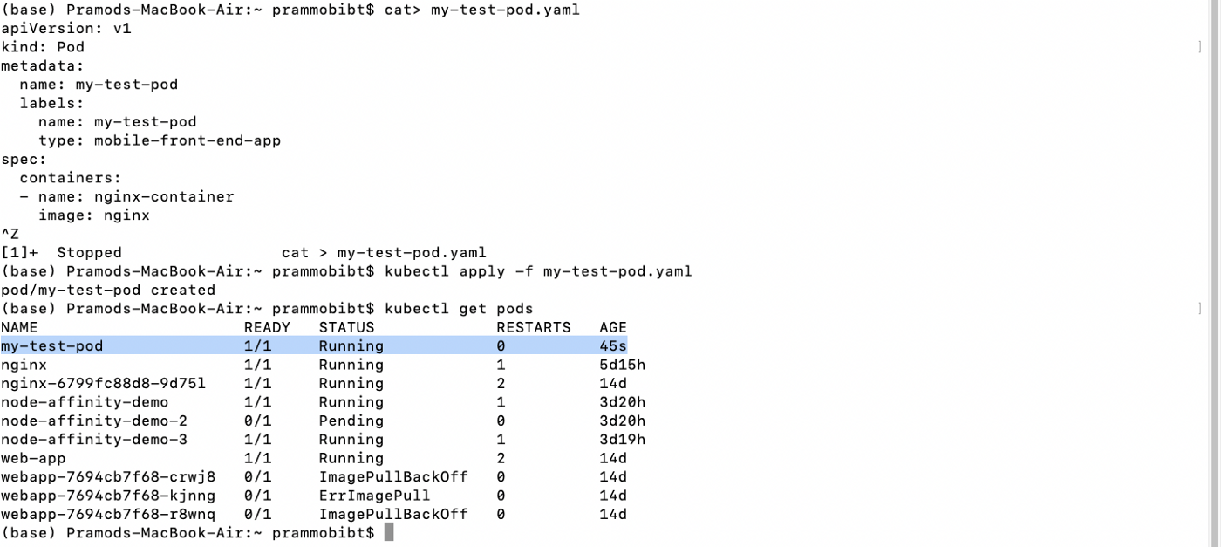

Output: You can see from the highlighted string, which shows that my-test-pod has been created successfully and running.

**Now that we have our pod file up and running, it’s time to create service as defined in our “my-test-service.yaml file “**

* create my-test-service.yaml using **cat** command
* copy paste the yaml code defined in **my-test-service.yaml file**
* create the pod using the command below

$ kubectl create -f **my-test-service.yaml**

## See the output below:

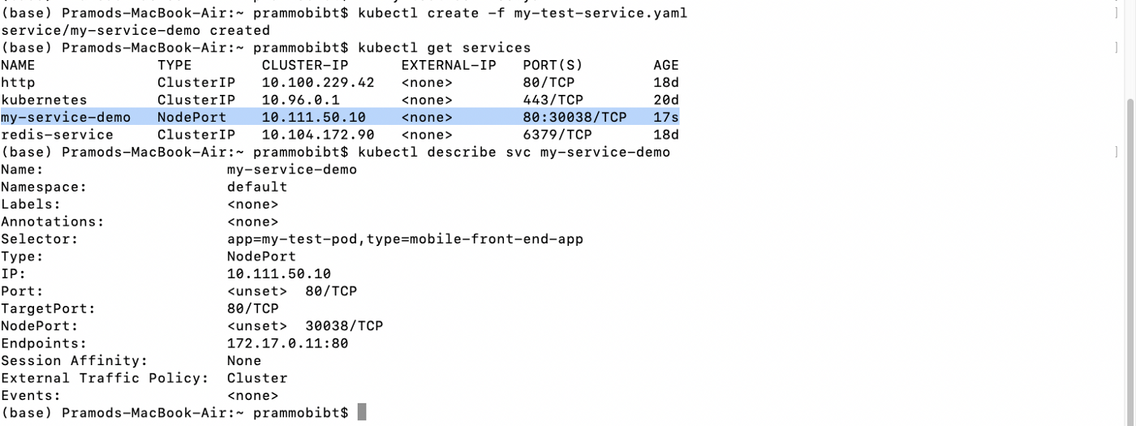

The string highlighted shows clearly that our service has been created as NodePort type and has a **cluster IP: 10.111.50.10**(**this will differ in your case**), this service is running on Node Port: **30038**

So now that service has been deployed let’s access the Nginx web app which we deployed in our pod using the NodePort: 30038

For that first get the IP address of your **minikube** cluster :

$ minikube IP

for me, IP address is: **192.168.99.102**

so to access the Nginx web app, type [http://192.168.99.102:30038](http://192.168.99.102:30038/)

you will see the following output:

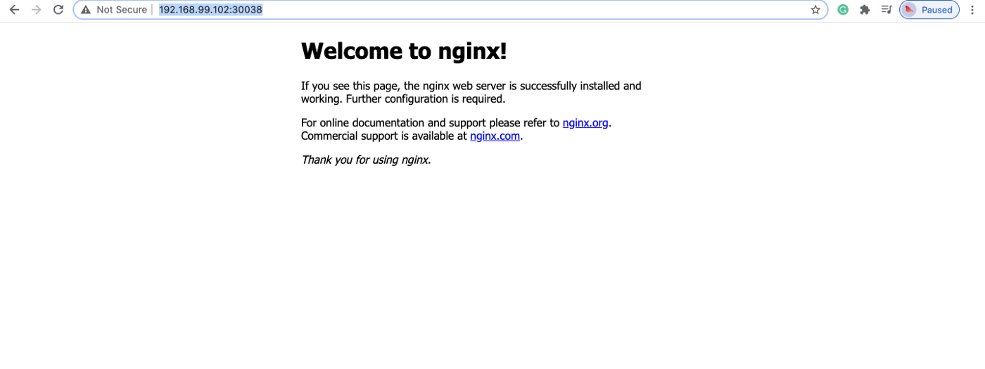

This shows that the pod deployed in the cluster node is being accessed by our service exposed by NodePort: 30038.

# What’s Next?

We will look into other types of services

* Cluster IP
* Load Balancer

# Terraform — Provision Amazon EKS Cluster using Terraform

Create and Deploy AWS EKS Cluster with Terraform.

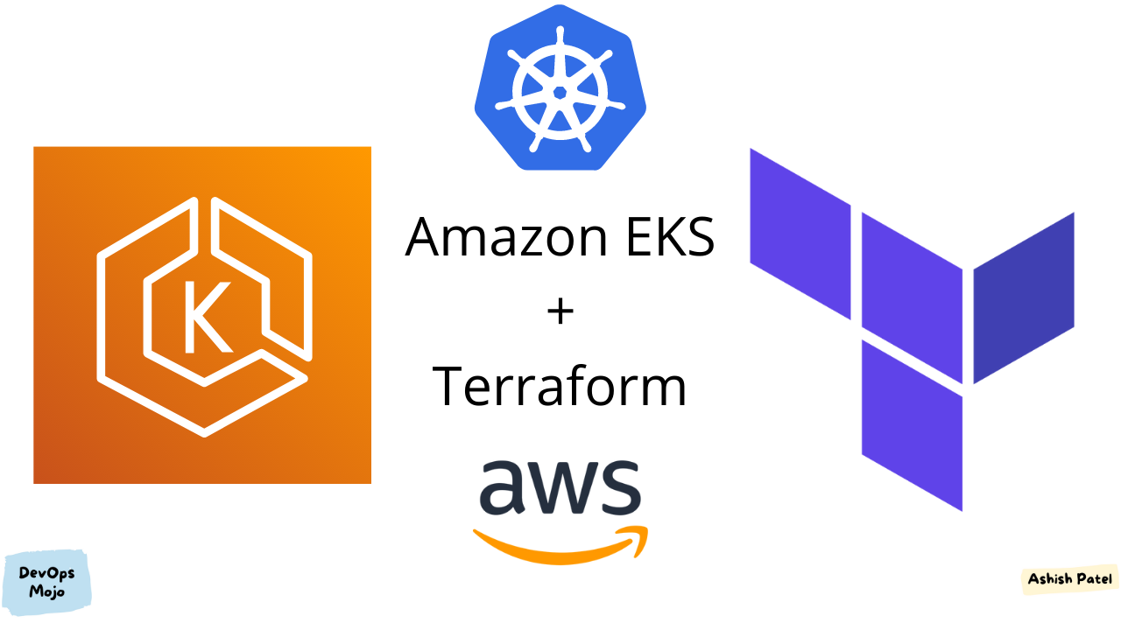

Amazon EKS and Terraform

## **TL;DR:**

[Amazon EKS](https://aws.amazon.com/eks/) (Elastic Kubernetes Service) is a managed container service to run and scale Kubernetes applications in the cloud or on-premises.

[HashiCorp](https://www.hashicorp.com/) [Terraform](https://www.terraform.io/) is an Infrastructure as Code (IaC) tool that lets you define both cloud and on-prem resources in human-readable configuration files that you can version, reuse, and share.

The purpose of this article is to create Amazon EKS Cluster using Terraform.

## **Prerequisite**

* [AWS Account](https://aws.amazon.com/free/)
* [Terraform](https://www.terraform.io/downloads)

## Terraform Initial Setup Configuration

Create an AWS provider. It allows to interact with the AWS resources, such as VPC, EKS, S3, EC2, and many others.

Terraform Provider

## [Terraform State Setup](https://medium.com/devops-mojo/terraform-remote-states-overview-what-is-terraform-remote-state-storage-introduction-936223a0e9d0)

Create Terraform backend to specify the location of the backend Terraform state file on S3 and the DynamoDB table used for the state file locking. This step is optional.

Remote state is simply storing that state file remotely, rather than on your local filesystem. In a enterprise project and/or if Terraform is used by a team, it is recommended to setup and use remote state.

Terraform Remote State (Backend)

## Network Infrastructure Setup

Setting up the VPC, Subnets, Security Groups, etc.

*Amazon EKS requires subnets must be in at least two different availability zones.*

1. Create AWS **VPC** (Virtual Private Cloud).
2. Create two public and two private **Subnets** in different availability zones.
3. Create **Internet Gateway** to provide internet access for services within VPC.
4. Create **NAT Gateway** in public subnets. It is used in private subnets to allow services to connect to the internet.
5. Create **Routing Tables** and associate subnets with them. Add required routing rules.
6. Create **Security Groups** and associate subnets with them. Add required routing rules.

Network Infrastructure (VPC) Setup

## EKS Cluster Setup

Create EKS cluster. Kubernetes clusters managed by Amazon EKS make calls to other AWS services on your behalf to manage the resources that you use with the service. For example, EKS will create an Auto Scaling Groups for each instance group if you use managed nodes.

**Setting up the IAM Roles and Policies for EKS:**EKS requires a few IAM Roles with relevant Policies to be pre-defined to operate correctly.

IAM Role: Create Role with the needed permissions that Amazon EKS will use to create AWS resources for Kubernetes clusters and interact with AWS APIs.

IAM Policy: Attach the trusted Policy (AmazonEKSClusterPolicy) which will allow Amazon EKS to assume and use this role.

Terraform EKS Cluster

## Node Groups (Managed) Setup

Create a Node Group(s) to run application workload.

IAM Role: Similar to the EKS cluster, before you create worker node group, you must create IAM role with needed permissions for the node group to communicate with other AWS services.

IAM Policy: Attach the trusted Policy (AmazonEKSWorkerNodePolicy) which will allow amazon EC2 to assume and use this role. Also, attach the AWS managed permission Policy (AmazonEKS\_CNI\_Policy, AmazonEC2ContainerRegistryReadOnly).

Terraform EKS Node Groups

## Terraform Variables

Create IAM user with administrator access to the AWS account, and get access key and secret key for authentication.

Define Terraform variables for AWS resources:

Terraform Variables

Set Terraform variables values as per your requirements:

Terraform Variables Values

Define Terraform data sources:

Terraform Data Source

Define Terraform output that required to connect with EKS cluster such as endpoint, certificate:

## Terraform Execution: Infrastructure Resources Provisioning

Once you have finished declaring the resources, you can deploy all resources.

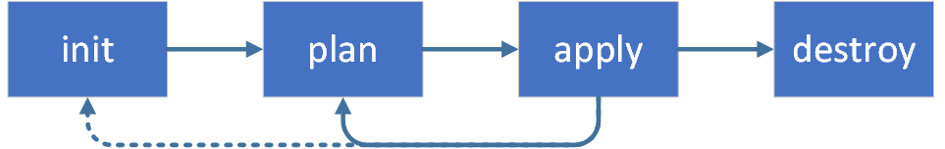

1. terraform init: command is used to initialize a working directory containing Terraform configuration files.
2. terraform plan: command creates an execution plan, which lets you preview the changes that Terraform plans to make to your infrastructure.
3. terraform apply: command executes the actions proposed in a Terraform plan to create or update infrastructure.

After the complete creation, you can see resources in your AWS account.

## Cleanup

To destroy previously-created infrastructure with Terraform, run below command:

terraform destroy: command is a convenient way to destroy all remote objects managed by a particular Terraform configuration.



[[](https://calvineotieno010.medium.com/?source=post_page-----64f03c418c99--------------------------------)](https://calvineotieno010.medium.com/?source=post_page-----64f03c418c99--------------------------------)

[Calvine Otieno](https://calvineotieno010.medium.com/?source=post_page-----64f03c418c99--------------------------------)

Jan 31

·

10 min read

·

Listen

# Blue Green and Canary Infrastructure with Terraform



This concept is so popular nowadays. Terraform enables you to create infrastructure with code and codes can be version controlled. In this article, instead of talking about what are the advantages of Terradorm or how to install it (you can check it from <https://www.terraform.io/>), we will make a real-world example on AWS.

# Prerequisites

I will be using Amazon Web Services (AWS) for this tutorial, but the code or implementation won't vary too much with another provider like Google Cloud Platform, Azure etc

You need to have some basic knowledge of Terraform. Also, you will need to have:

* A working AWS account. You can signup and use the free tier offered by AWS
* AWS CLI installed on your local machine
* Terraform installed on your local machine
* AWS IAM User with proper permissions and configure your [**AWS profile**](https://docs.aws.amazon.com/cli/latest/userguide/cli-configure-profiles.html)

## **What is Blue-Green and Canary deployments?**

Blue-Green deployment is a DevOps practice that aims to reduce downtime on updates by creating a new copy of the desired component while maintaining the current.

Canary deployment is a deployment that releases an application or a service incrementally to a subset of users. It’s the lowest risk-prone compared to all other deployment strategies because of this control.

Given that, you end with two versions of the system: One with the actual version (blue) and another with a new one (green). When the new version is up and running, you can seamlessly switch traffic to it. This is useful not only to reduce downtime but also to improve rollback time when something bad happens.

## Blue/Green Infrastructure

While Blue/Green deployment is a technique more commonly used with application deployment, the reduced costs of the cloud, in addition to the tools we have right now, make it possible to have two copies of an entire cloud infrastructure with little to no pain.

It’s also important to note that doing Blue/Green deployment of the entire Cloud Infrastructure is not a silver bullet and certainly a bit too much if you are doing small changes, for example, adding a new or changing EC2 instance type in your stack. If you plan to do major or breaking changes is a win and this deployment type is worth it.

After finishing this, you will be able to create an infrastructure containing:

* A Virtual Private Cloud
* Three Subnets, each one in a different Availability Zone
* An Internet Gateway
* A custom Route Table
* Associate Custom Route Table and Subnet
* A Security Group
* EC2 instances serving an Apache HTTPd server on the Port 80
* A Load Balancer pointing to those instances
* **Optional**: Attach A DNS Record to the Load Balancer

Most of these components will be the same for both the Blue/Green environments with minor differences for each environment.

The full example can be seen [**here**](https://github.com/NYARAS/hashicorp-terraform/tree/main/blue-green-canary)**.**

# Step 1: Setup Provider, Backend with Terraform

We start by creating a folder and opening the folder in your favourite editor of choice. I will be using vs code editor.  
The first thing we must create is providers configuration. Terraform relies on plugins called “providers” to interact with cloud providers, SaaS providers, and other APIs. Terraform configurations must declare which providers they require so that Terraform can install and use them

Terraform stores the state of the infrastructure in a JSON file. It’s recommended to store that file on an external backend like Amazon S3. As in we are using AWS for this tutorial, we will stick to S3, but [Terraform supports the equivalent in each provider](https://www.terraform.io/language/settings/backends).

First, you need to create the S3 bucket in which the state will reside. You can do this either via the AWS S3 console or by doing:

aws s3api create-bucket --create-bucket-configuration LocationConstraint=eu-west-1 --bucket blue-green-for-learning-here --region us-east-1 | jq

We have referenced some variables e.g var.aws\_profilehere, so we need to define them. We create a file variables.tf:

**Note**: Configure AWS profile. Here the profile is personal-deployment you can change this to suit yours.

## Step 2: Create VPC

Create a file namedvpc.tf with this content:

cidr\_block: 10.0.0.0/16 allows us to use IP Addresses that starts with 10.0.X.X This will give us **65,536**IP Addresses ready to use.

You can check for the remaining arguments [here](https://registry.terraform.io/providers/hashicorp/aws/latest/docs/resources/vpc).

## Step 3: Create Public Subnets

To do anything useful we will first need subnets. We will create 3 of them, each in a different availability zone. Create file named subnets.tf with this content:

Here we create three subnets specifying:

* **count**: The number of subnets we want to create
* **availability\_zone**: In this case, we are using the [**element()**](https://www.terraform.io/language/functions/element)function which takes a list and an index and returns the element, even if the index is greater than the number of elements. This is useful to assign a different availability zone to each subnet.
* **vpc\_id**: The VPC ID of the vpc we just created.
* **cidr\_block**: We interpolated the previously defined infrastructure\_version variable into the CIDR block. This will help in the future when creating the second version (green).

You can check for the remaining arguments [here](https://registry.terraform.io/providers/hashicorp/aws/latest/docs/data-sources/subnet#argument-reference).

## Step 4: Create Internet Gateway

To enable our vpc to connect to the internet, we must have an [internet gateway.](https://docs.aws.amazon.com/vpc/latest/userguide/VPC_Internet_Gateway.html)

Create a file named internet\_gw.tf with this content:

You can check for the arguments [here](https://registry.terraform.io/providers/hashicorp/aws/latest/docs/resources/internet_gateway#argument-reference).

## Step 5: Create a custom route table

Create a custom route table for the public subnets. Public subnets can reach the internet by using this.

Create a file named route\_table.tf with this content:

## Step 6: Associate custom route table and subnet

In the same file route\_table.tf

## Step 7: Create Security Group

We add security group inbound and outbound rules for our EC2 instances. We need to open the ports we need for our instances.

You can check for the remaining arguments [here](https://registry.terraform.io/providers/hashicorp/aws/latest/docs/resources/security_group#argument-reference).

## Step 8: AMI data source

We will be creating our blue environment soon and we will be adding an EC2 instance. We will be using [Amazon Linux 2 AMI](https://aws.amazon.com/amazon-linux-2/?amazon-linux-whats-new.sort-by=item.additionalFields.postDateTime&amazon-linux-whats-new.sort-order=desc). This step is not necessary for this demo but I want to show you how you can get the latest AMI ID for Amazon Linux 2 OS:

Create a file name ami\_datasource.tf with this content:

## Step 9: Create Blue Environment

First, let's add the [local values](https://www.terraform.io/language/values/locals#local-values) we will need for our environment.

Create a file named locals.tf with this content:

Here we create subnets local values. For now, only focus on the subnets

Let’s add a [user data](https://docs.aws.amazon.com/AWSEC2/latest/UserGuide/instancedata-add-user-data.html) script. Create a file named apache-script.sh with this content:

Now, create a file named blue.tf with this content:

Let’s explain a little bit about this file.

We have created a resource of type **aws\_instance,**with these parameters:

* **count**: The number of resources of this type. In this case, it’s based on the enable\_blue\_env and blue\_instance\_count variables that have defaults true and 2 respectively.
* **ami**: The Amazon Machine Image for the instance. In this case, as we mentioned in step 8, we usedata.aws\_ami.amzlinux.id to get the latest Amazon Linux OS image ID.
* **instance\_type:**The type of the instance with a default of t2.micro
* **user\_data:**This allows us to assign an initialization script to the instance. In our case, we are running an Apache Httpd server with a custom webpage. There are better ways to define user data scripts, but we’ll keep it simple for now.

Don't bother about lines **16-35,**we will come to understand them in our next step.

You can find the remaining arguments [here](https://registry.terraform.io/providers/hashicorp/aws/latest/docs/resources/instance#argument-reference).

Let us update our variable.tf to this:

## Step 10: Create Load Balancer

Create a file named load\_balancer.tf with this content:

In this file we have created a Load Balancer with:

* **name**: Self-explanatory
* **subnets**: The subnets the load balancer is available in
* **security\_groups**: We have added the previously created security groups to be able to access it
* **load\_balancer\_type**: Here we are using **application**load balancer type
* **listener**: We have added a aws\_lb\_listener resource type that listens on port 80 of the load balancer. The listener uses a default action with aws\_lb\_target\_group we created in previous step 9 lines **16–35.**We also define health\_check with simple HTTP healthcheck that targets port 80 of the instance.

We have created all the components we need for our blue environment. Let’s add one more file for the outputs.

Create a file named outputs.tf with this content:

Here, we have added an output that displays the Load Balancer Public DNS. All Good now 😁. Let's now start playing with terraform commands.

The first command we need to run is terraform fmt to format our configuration files.



terraform fmt

The next command we need to do is run terraform init to initialize our working directory, load remote state and download all the modules we need

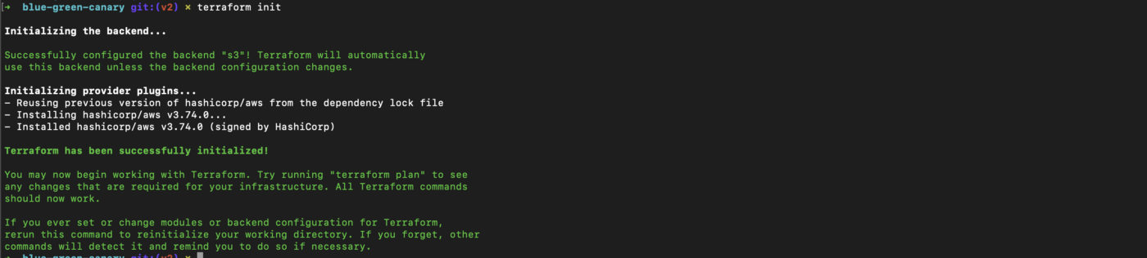

terraform init

Then we run terraform validate to validate our configuration files. Validate runs checks that verify whether a configuration is syntactically valid and internally consistent.



terraform validate

The next command we need to run is terraform plan to create an execution plan with a preview of changes we will make in our infrastructure.

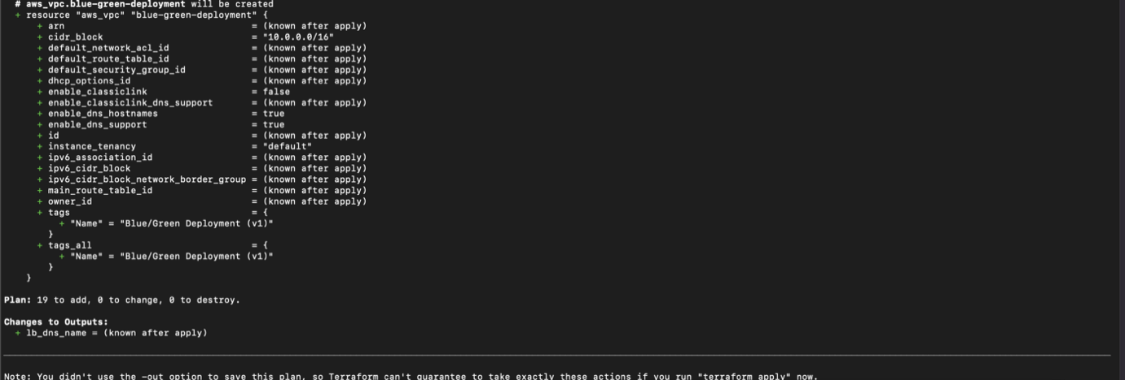

terraform plan

As you can see in the image, this plan will add 19 resources.

The next command we need to run is terraform apply to execute the actions proposed in terraform plan. This is where we accept the changes and apply them against real infrastructure.



terraform apply

**Apply complete! Resources: 19 added, 0 changed, 0 destroyed.**

And you can access the webpage using the lb\_dns\_name output 😁.



Blue Env

We can do a curl for loop for this lb\_dns\_name:

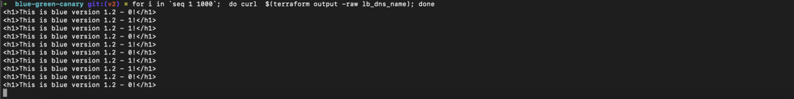

curl blue env

Hurray!!! We are done with the Blue Environment configuration.

Let’s now create the Green Environment.

## Step 11: Create Green Environment

Our Green environment will just be the same as the Blue environment with only one difference that it will have a new version of deployment.

Create a file name green.tf with this content:

Let's update the Load Balancerload\_balancer.tf with this new content:

The update here is to include both the two target groups, blue-green-deployment-blue and blue-green-deployment-green ,[stickiness](https://docs.aws.amazon.com/elasticloadbalancing/latest/application/sticky-sessions.html) and traffic distribution for the two environments with defaults100 to Blue Environment and 0 to Green Environment.

Let’s also create a traffic distribution map local values in locals.tf file.

Update locals.tf file with this content:

You can read more about AWS ALB traffic distribution [here](https://aws.amazon.com/premiumsupport/knowledge-center/elb-make-weighted-target-groups-for-alb/).

Let's also update the variables.tf to this content:

Let’s run terraform apply to create a green environment and enable 90% traffic to the blue environment:

terraform apply -var traffic\_distribution=blue-90 -var enable\_green\_env=true -auto-approve

Now if we do a curl for loop for this lb\_dns\_name you can see most of the traffic 90%is going to the blue deployment with a few 10%to the green deployment.

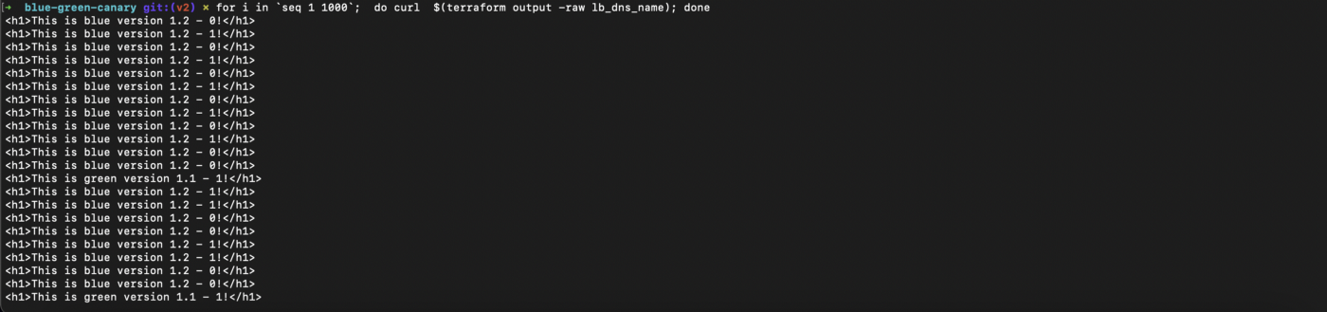

for i in `seq 1 1000`; do curl $(terraform output -raw lb\_dns\_name); done

Let’s run terraform apply to split traffic between the two deployments 50–50 :

terraform apply -var traffic\_distribution=split -var enable\_green\_env=true -auto-approve

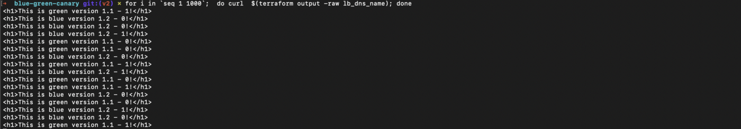

for i in `seq 1 1000`; do curl $(terraform output -raw lb\_dns\_name); done

You can see the traffic is evenly distributed between the two deployments.

Finally, let's completely switch green deployment and disable blue deployment.

terraform apply -var traffic\_distribution=green -var enable\_green\_env=true -var enable\_blue\_env=false -auto-approve

Now if we do a curl for loop for this lb\_dns\_name we can see we are only getting responses from the green new green deployment.

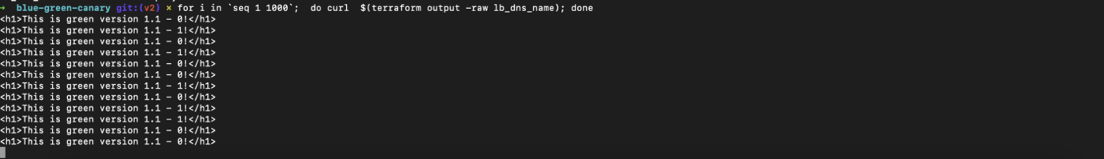

for i in `seq 1 1000`; do curl $(terraform output -raw lb\_dns\_name); done

This is 🤩 . Congratulations 👏 .

## Optional: Attach A DNS Record to the Load Balancer

I'm not going to cover much on this case, but what I've ended up doing in production is creating a DNS Record that points to a specific version of the Load Balancer. An example of this terraform could be:

The do terraform apply:

terraform apply -var traffic\_distribution=green -var enable\_green\_env=true -var enable\_blue\_env=false -var domain\_name=yourdomain.com -auto-approve

Please change yourdomain.com var to your domain.



yourdomain.com



New outputs

Please note this configuration for DNS only works when you have your domain hosted in [AWS Route53](https://aws.amazon.com/route53/)

If you are doing this just for fun, please do terraform destroy to delete the new green deployment:

terraform destroy -var traffic\_distribution=green -var enable\_green\_env=true -var enable\_blue\_env=false -auto-approve

If you added domain configuration then run:

terraform destroy -var traffic\_distribution=green -var enable\_green\_env=true -var enable\_blue\_env=false -var domain\_name=yourdomain.com -auto-approve

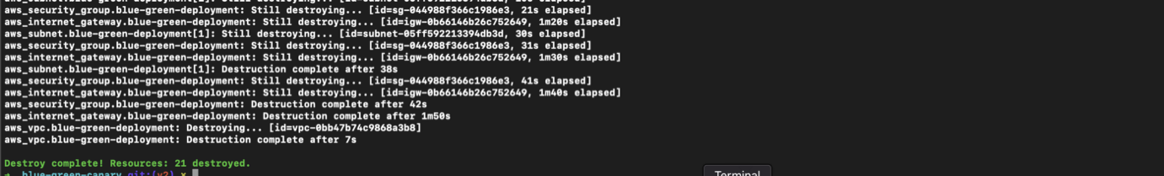

terraform destroy -var traffic\_distribution=green -var enable\_green\_env=true -var enable\_blue\_env=false -var domain\_name=yourdomain.com -auto-approve

**Destroy complete! Resources: 21 destroyed 😁.**

# Automate Provisioning of Kubernetes Clusters on AWS with Terraform

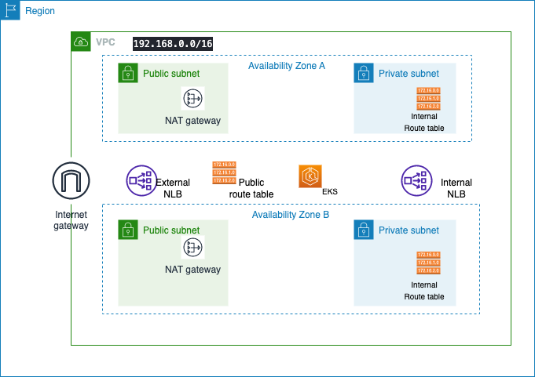

Architecture Design

Terraform can provision resources on Kubernetes much the same way you can provision cloud resources like AWS Cloud, Google Cloud, and Azure.

This article demonstrates how to use Terraform to provision Amazon Elastic Kubernetes Service (EKS). One advantage to using Amazon EKS is that we can use the AWS provider to fetch credentials necessary to access our Kubernetes cluster.

With the complexity of creating and configuring the EKS cluster, it makes sense to automate the process using Terraform, and in this article, we are going to create and manage our EKS cluster using Terraform. We will then deploy a sample Laravel docker application.

## Why use Terraform?

The most obvious question would be why would you want to do this? The kubectand eksctltools work fine and the Kubernetes manifests (YAML), so why not stick to that?

Running infrastructure at any scale almost always guarantees a dizzying array of components and configurations. Different teams within an organization may have the need for similar infrastructure with slight variations. That infrastructure may be spread over multiple topographies, from on-premise to one or more cloud vendors.

While it is possible to use infrastructure providers’ user (console) and command line (CLI) interfaces to spin up and configure components one at a time, the end result is typically hard to organize and maintain in a simple and straightforward way.

Building Kubernetes infrastructure that is scalable, secure, and reliable has a lot of moving parts and may take time depending on your experience. Along with running applications with Kubernetes, you will have to work with configuring networking, compute resources, storage, as well as supporting components like monitoring. To ensure that best practices for building infrastructure are maintained, we can use common patterns that provide consistency and customization where needed.

Terraform is a tool to manage the entire lifecycle of infrastructure using **Infrastructure as Code (IaC)**. That means declaring infrastructure components in configuration files that are then used by Terraform to provision, adjust and tear down infrastructure in various cloud providers.

For example, say you are working in AWS and would like to spin up several EC2 instances of a specific type. You would define the type and the number of instances in a configuration file, and Terraform would use that to communicate with the AWS API to create those instances. The same file could then be used to adjust the configuration, for example increasing or decreasing the number of instances.

## Prerequisites

You need to have some basic understanding of working with Kubernetes and creating an EKS cluster using an AWS management console or CLI and basic knowledge of Terraform. You will need to have:

* A working AWS account. You can signup and use the free tier offered by AWS
* AWS CLI installed on your local machine
* Terraform installed on your local machine
* kubectl installed on your local machine

Just to know the various components we will be creating.

## Architectural Design



Architectural Diagram

* VPC
* Two public and private subnets
* Public-facing Internet Gateway
* Two NAT Gateways in our public subnets following the recommendation from AWS for EKS
* Control plane managed by AWS
* Worker nodes and connect them to the master node
* Deploy our sample Laravel application

## Step 2: Setup Provider with Terraform

We start by creating a folder and opening the folder in your favorite editor of choice. Am a vs code diehard 😄.  
The first thing we must create is providers configuration. Terraform relies on plugins called “providers” to interact with cloud providers, SaaS providers, and other APIs. Terraform configurations must declare which providers they require so that Terraform can install and use them

**Note**: Configure AWS profile. Here the profile is default and you can change this to suit yours.

The second component we are going to create is the VPC.

## Step 3: Setup Subnets with Terraform

As a best practice, we need to create public and private subnets in each availability zone. We are going to create two public and private subnets following [**AWS's recommendation for production deployment**](https://docs.aws.amazon.com/eks/latest/userguide/create-public-private-vpc.html).

* To the subnets, we want to attach a tag called “kubernetes.io/cluster/eks” where “eks” is the name of the EKS cluster. The cloud control manager which is one of the processes that we have in the control plane orchestrates connecting to the VPC, subnets, worker nodes, and all these configurations and it needs to know which resource to connect to and that is why we need these tags for public and private subnets so that the cloud control manager can connect to them.
* The load balancer controller also needs a way to know which subnet is public and which one is private so we can attach tags to our subnets so that the controller can easily connect to them.

## Step 4: Setup Internet Gateway

An internet gateway is a horizontally scaled, redundant, and highly available VPC component that allows communication between your VPC and the internet. Read more.

## Step 5: Setup NAT Gateway and Elastic IP address

NAT Gateway is used to enable instances in private subnets to connect to the internet (for example, for software installation or updates). Also, we will need to allocate a public static IP address for those NAT Gateways. And for that purpose, we will use another AWS service called Elastic IP. [Read more here](https://docs.aws.amazon.com/vpc/latest/userguide/vpc-nat-gateway.html).  
Referring to our architecture, we need to set up two NAT Gateway and that means we gonna need two Elastic IP addresses.

## Step 6: Setup Routing Table and Route Table association

A route table contains a set of rules, called routes, that are used to determine where network traffic from your subnet or gateway is directed.[Read more here.](https://docs.aws.amazon.com/vpc/latest/userguide/VPC_Route_Tables.html)  
We will set up one public and two private route tables. You can refer to our architecture above.

## Step 7: Setup EKS Cluster and Worker nodes

It’s now time to set up our EKS cluster since we have our VPC and its components set up. We are going to create an EKS cluster with all its required components including the scaling configuration. Since this is for demo purposes, the scaling here is 1:1:1 as the default. The default Kubernetes master version we will use here is 1.19 and our worker nodes will be using t3.small on demand instance types as defaults.

Now that our terraform configuration is done, let’s create one bonus file. Let's output the VPC ID. This is just to show the power of [**Terraform outputs**](https://www.terraform.io/docs/language/values/outputs.html) 😄.

The next command we need to do is run terraform init to initialize our working directory and download all the modules we need.

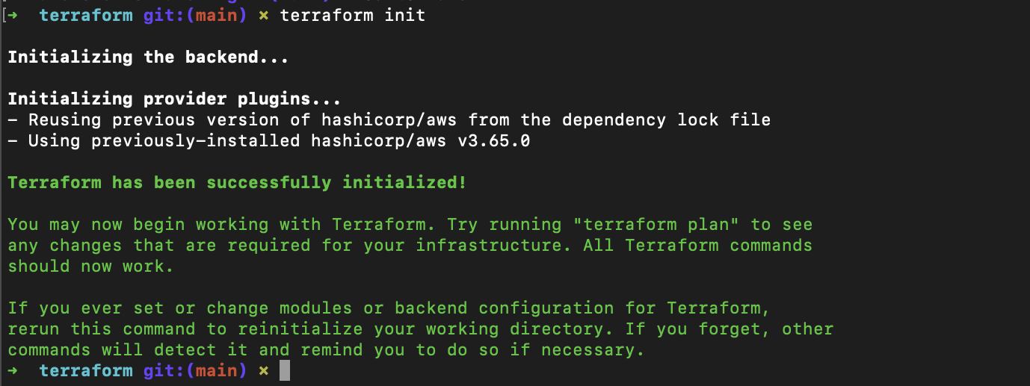

terraform init

The next command we need to run is terraform plan to create an execution plan with a preview of changes we will make in our infrastructure.

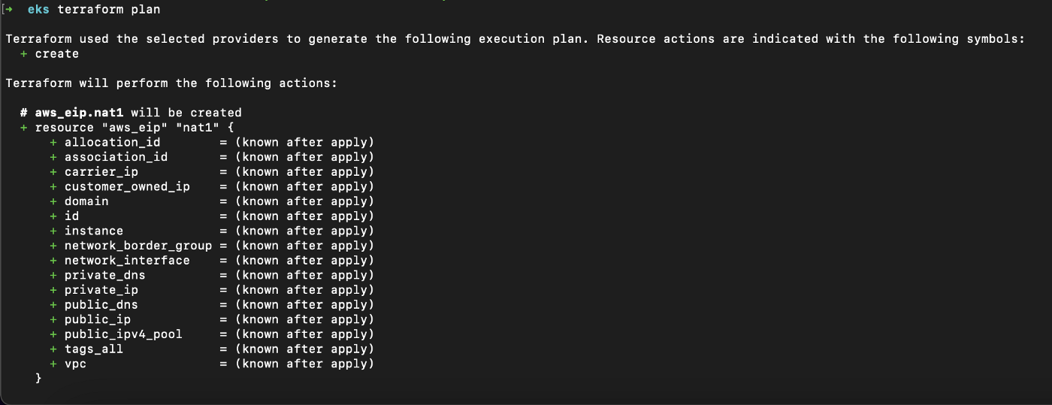

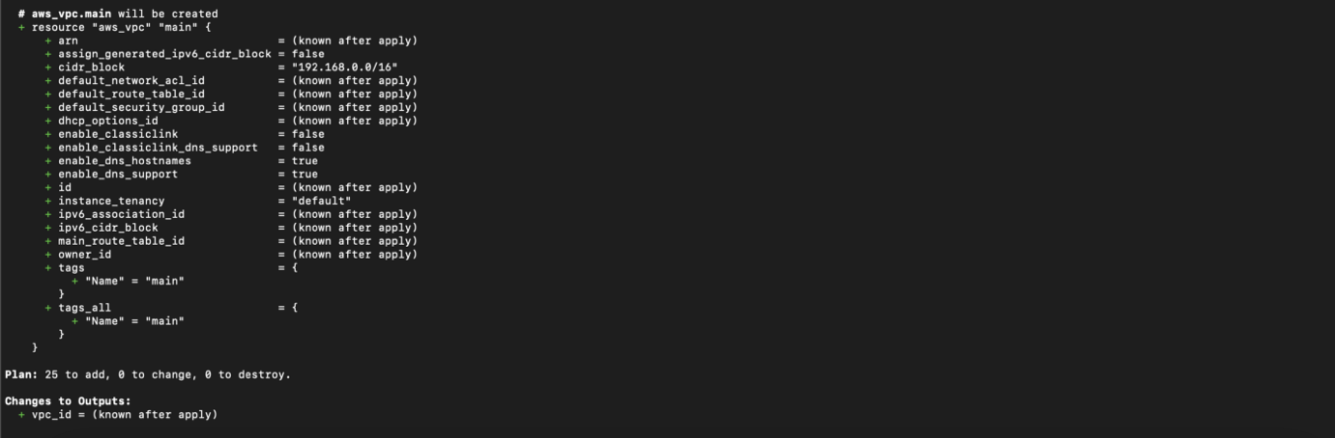

terraform plan

As you can see in the second image, this plan will add 25 resources.

The next command we need to run is terraform apply to execute the actions proposed in terraform plan. This is where we accept the changes and apply them against real infrastructure.

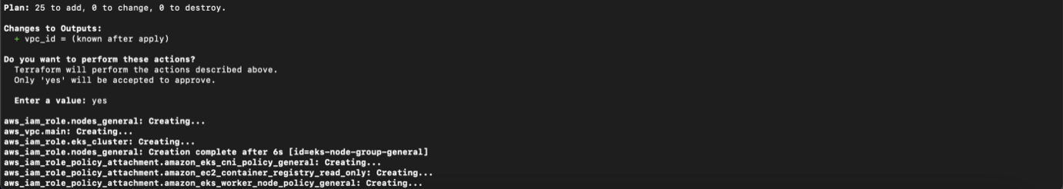

terraform apply



**Apply complete! Resources: 25 added, 0 changed, 0 destroyed.**

Now that our cluster is ready, let's run the kubectl command to create the deployment: kubectl apply -f deployment.yaml

Run kubectl command to get Pods in the Cluster:

kubectl get pods



Now that the containers are up and running, we need to access them externally. This is where the Kubernetes Service comes in; It exposes an application running on a set of Pods as a network service.

We will create a specification file to describe the service:

Run the command to deploy the service:

kubectl apply -f service.yaml

The Laravel service is now created. Run the command to get a list of services:

kubectl get services



Copy the link on the external IP of laravel-service and paste it in your browser tab:

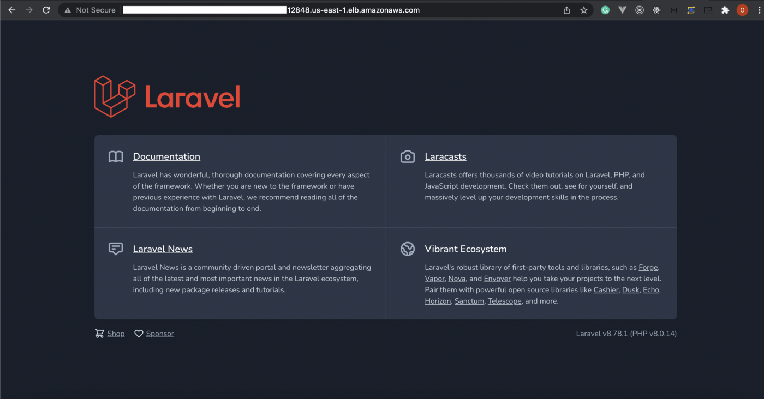

When you are done and you don’t want to leave the EKS cluster running which I recommend to avoid being billed by AWS, you can first delete the deployment and service by running:

kubectl delete -f deployment.yaml

kubectl delete -f service.yaml

Then finally running:

terraform destroy

to destroy the entire infrastructure.

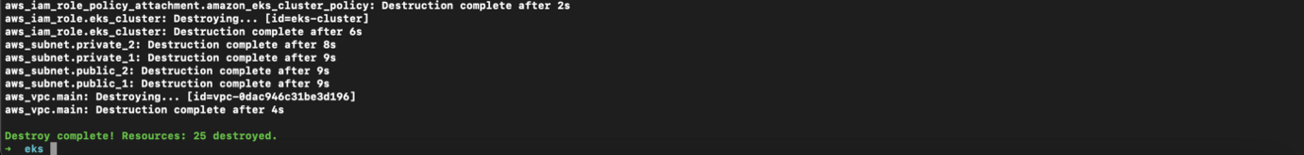

terraform destroy

**Destroy complete! Resources: 25 destroyed 😁.**

**Hosting a Static Website on AWS S3 using Terraform**

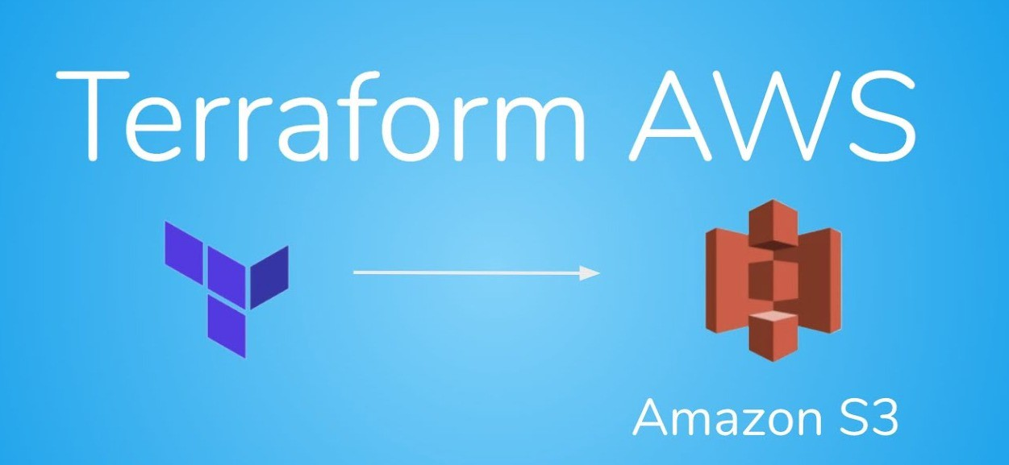

Hosting S3 Bucket with Terraform

Here you will understand how to use Terraform to get your static websites up and running on AWS. This is an extremely cost-effective method of website hosting. I’ll show you how to use AWS to launch a static website by uploading your website content to an S3 bucket and configuring your bucket to host your website.  
First of all, let me explain some of the terminologies.

**What is Terraform?**

Terraform is an open-source infrastructure as code (IAC) platform for building, managing, and deploying production-ready environments. Terraform uses declarative configuration files to codify cloud APIs. Terraform is capable of managing both third-party services and unique in-house solutions.

**What is Amazon S3?**

Amazon S3 (Simple Storage Service) is a web-based object storage service provided by Amazon Web Services. It’s a place where you may upload files and directories. It can save and retrieve any type of data, including documents, photos, and videos.

**Advantages of Using S3**

* Negligible costs
* High Availability
* Scale up automatically
* No CAPEX expenditures

**Prerequisites**

* AWS account
* A purchased domain
* Terraform installed

**S3 Static Website Infrastructure**

Only a few components are required to host a static website on S3, and we don’t even need anything fancy like VPCs or security groups to get started. Once we are finished we are going to have the following components:

* S3 bucket that hosts our website files for our www subdomain.
* Route 53 records pointed at to our S3 bucket.

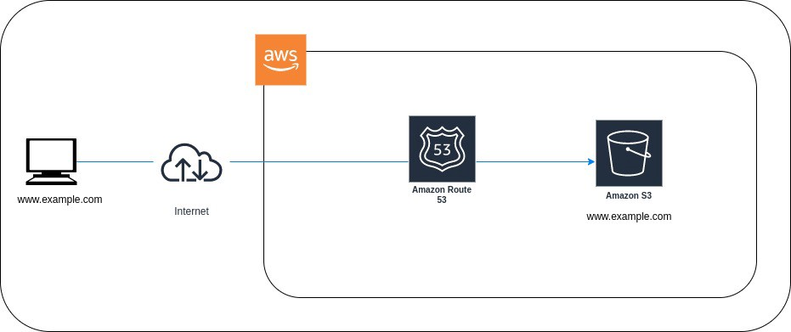

Infrastructure Diagram

**Setting up our Terraform components**

Now we’ll go through each of the files that make up our Terraform project and explain what they perform. You may fork my repository and follow along with this by forking it at the references section below.

**providers.tf**  
Terraform needs plugins called providers to interact with remote systems. In this case, we are only dealing with AWS but Terraform can also interact with other cloud services such as Azure and Google Cloud.

terraform {  
 required\_providers {  
 aws = {  
 source = "hashicorp/aws"  
 version = "4.2.0"  
 }  
 }  
}provider "aws" {  
 access\_key = var.access\_key  
 secret\_key = var.secret\_key  
 region = var.region  
}

The version of Terraform we’re using, as well as the version of the AWS provider, are also specified here. This is to guarantee that any future Terraform or AWS provider breaking changes do not prevent our scripts from operating. Then we setup the aws provider that we will use for the majority of our components.

**variables.tf**  
In this file, we define the variables that we are going to use.

variable "domain\_name" {  
 type = string  
 description = "Name of the domain"  
}  
variable "bucket\_name" {  
 type = string  
 description = "Name of the bucket."  
}  
variable "region" {  
 type = string  
 default = "us-west-2"  
}  
variable "access\_key" {  
 type = string  
}  
variable "secret\_key" {  
 type = string  
}

**terraform-dev.tfvars**  
The tfvars file is used to specify variable values. These will need to be updated for your domain. All you have to change is the below values for your website, the rest will remain the same. Replace example.com with your domain name without www

domain\_name = "example.com"  
bucket\_name = "example.com"

We’re going to set up our S3 buckets in this file. You may technically put all of your Terraform setup in one file, but I like to break them into multiple components since it is easier to understand.

**s3-bucket.tf**  
First, we will create a bucket.

resource "aws\_s3\_bucket" "bucket-1" {  
 bucket = "www.${var.bucket\_name}"  
}data "aws\_s3\_bucket" "selected-bucket" {  
 bucket = aws\_s3\_bucket.bucket-1.bucket  
}

Here we have created a bucket with the name of www.example.com

**s3-acl.tf**  
Then we set the acl for the given bucket.

resource "aws\_s3\_bucket\_acl" "bucket-acl" {  
 bucket = data.aws\_s3\_bucket.selected-bucket.id  
 acl = "public-read"  
}

**s3-versioning.tf**  
We also set the versioning for the bucket.

resource "aws\_s3\_bucket\_versioning" "versioning\_example" {  
 bucket = data.aws\_s3\_bucket.selected-bucket.id  
 versioning\_configuration {  
 status = "Enabled"  
 }  
}

**s3-cors.tf**  
Let us implement the cors policy for the bucket.

resource "aws\_s3\_bucket\_cors\_configuration" "example" {  
 bucket = data.aws\_s3\_bucket.selected-bucket.bucketcors\_rule {  
 allowed\_headers = ["Authorization", "Content-Length"]  
 allowed\_methods = ["GET", "POST"]  
 allowed\_origins = ["https://www.${var.domain\_name}"]  
 max\_age\_seconds = 3000  
 }  
}

**s3-bucket-policy.tf**  
We setup a policy which gives read access to the bucket.

resource "aws\_s3\_bucket\_policy" "bucket-policy" {  
 bucket = data.aws\_s3\_bucket.selected-bucket.id  
 policy = data.aws\_iam\_policy\_document.iam-policy-1.json  
}data "aws\_iam\_policy\_document" "iam-policy-1" {  
 statement {  
 sid = "AllowPublicRead"  
 effect = "Allow"resources = [  
 "arn:aws:s3:::www.${var.domain\_name}",  
 "arn:aws:s3:::www.${var.domain\_name}/\*",  
 ]actions = ["S3:GetObject"]principals {  
 type = "\*"  
 identifiers = ["\*"]  
 }  
 }  
}

**s3-website**  
Finally, we will set the website configuration that the bucket is going to fetch from as our index page.

resource "aws\_s3\_bucket\_website\_configuration" "website-config" {  
 bucket = data.aws\_s3\_bucket.selected-bucket.bucketindex\_document {  
 suffix = "index.html"  
 }error\_document {  
 key = "404.jpeg"  
 }# IF you want to use the routing rulerouting\_rule {  
 condition {  
 key\_prefix\_equals = "/abc"  
 }  
 redirect {  
 replace\_key\_prefix\_with = "comming-soon.jpeg"  
 }  
 }  
}

**s3-object-upload.tf**  
We also need to upload index and some images to our website. I have them saved under uploads folder in the same path. This will be done with the help of the following terraform codes.

resource "aws\_s3\_object" "object-upload-html" {  
 for\_each = fileset("uploads/", "\*.html")  
 bucket = data.aws\_s3\_bucket.selected-bucket.bucket  
 key = each.value  
 source = "uploads/${each.value}"  
 content\_type = "text/html"  
 etag = filemd5("uploads/${each.value}")  
 acl = "public-read"  
}resource "aws\_s3\_object" "object-upload-jpg" {  
 for\_each = fileset("uploads/", "\*.jpeg")  
 bucket = data.aws\_s3\_bucket.selected-bucket.bucket  
 key = each.value  
 source = "uploads/${each.value}"  
 content\_type = "image/jpeg"  
 etag = filemd5("uploads/${each.value}")  
 acl = "public-read"  
}

Here, it checks the content of the uploads directory and uploads the file based on the type. In this case, html and jpeg files. You can use them based on your requirements.

**route53.tf**  
Last but not least, the route 53 records must be created. I assume that you haven’t set up a hosted zone for this domain yet.

resource "aws\_route53\_zone" "main" {  
 name = var.domain\_name  
 tags = {  
 Name = "www.${var.domain\_name}"  
 description = var.domain\_name  
 }  
 comment = var.domain\_name  
}resource "aws\_route53\_record" "www-a" {  
 zone\_id = aws\_route53\_zone.main.zone\_id  
 name = "www.${var.domain\_name}"  
 type = "A"alias {  
 name = data.aws\_s3\_bucket.selected-bucket.website\_domain  
 zone\_id = data.aws\_s3\_bucket.selected-bucket.hosted\_zone\_id  
 evaluate\_target\_health = false  
 }  
}

This file is very self-explanatory. It just creates a record for www and refers it to the appropriate S3 bucket.

**Terraform command to deploy our infrastructure**

Now that we’ve put everything up, all we have to do is run the scripts to deploy our infrastructure. For these commands to function, make sure your computer is set up with all of the right AWS credentials.

$ terraform init  
$ export TF\_VAR\_access\_key="xxxxxxxxxxx" && export TF\_VAR\_secret\_key="xxxxxxxxxxxxx" && terraform apply -var-file terraform-dev.tfvars

**Conclusion**

You should now know how to host a static website with Amazon S3. Even though you had to go through a few steps, you did it ! If you’ve found this article helpful, please leave a clap and you can follow me for more articles . If you have any questions or constructive feedback, please let me know.

**kubernetes-network-policy-recipes**

# LIMIT traffic to an application

You can create Networking Policies allowing traffic from only certain Pods.

**Use Case:**

* Restrict traffic to a service only to other microservices that need to use it.
* Restrict connections to a database only to the application using it.

[](https://github.com/ahmetb/kubernetes-network-policy-recipes/blob/master/img/2.gif)

### Example

Suppose your application is a REST API server, marked with labels app=bookstore and role=api:

kubectl run apiserver --image=nginx --labels="app=bookstore,role=api" --expose --port=80

Save the following NetworkPolicy to api-allow.yaml to restrict the access only to other pods (e.g. other microservices) running with label app=bookstore:

kind: NetworkPolicy

apiVersion: networking.k8s.io/v1

metadata:

name: api-allow

spec:

podSelector:

matchLabels:

app: bookstore

role: api

ingress:

- from:

- podSelector:

matchLabels:

app: bookstore

$ kubectl apply -f api-allow.yaml

networkpolicy "api-allow" created

### Try it out

Test the Network Policy is **blocking** the traffic, by running a Pod without the app=bookstore label:

$ kubectl run test-$RANDOM --rm -i -t --image=alpine -- sh

/ # wget -qO- --timeout=2 http://apiserver

wget: download timed out

Traffic is blocked!

Test the Network Policy is **allowing** the traffic, by running a Pod with the app=bookstore label:

$ kubectl run test-$RANDOM --rm -i -t --image=alpine --labels="app=bookstore,role=frontend" -- sh

/ # wget -qO- --timeout=2 http://apiserver

<!DOCTYPE html>

<html><head>

Traffic is allowed.

### Cleanup

kubectl delete pod apiserver

kubectl delete service apiserver

kubectl delete networkpolicy api-allow

# ALLOW all traffic to an application

**Use Case:** After applying a [deny-all](https://github.com/ahmetb/kubernetes-network-policy-recipes/blob/master/01-deny-all-traffic-to-an-application.md) policy which blocks all non-whitelisted traffic to the application, now you have to allow access to an application from all pods in the current namespace.

Applying this policy makes any other policies restricting the traffic to the pod void, and allow all traffic to it from its namespace and other namespaces.

## Example

Start a web application:

kubectl run web --image=nginx --labels="app=web" --expose --port=80

Save the following manifest to web-allow-all.yaml:

kind: NetworkPolicy

apiVersion: networking.k8s.io/v1

metadata:

name: web-allow-all

namespace: default

spec:

podSelector:

matchLabels:

app: web

ingress:

- {}

A few remarks about this manifest:

* namespace: default deploy this policy to the default namespace.
* podSelector applies the ingress rule to pods with app: web
* Only one ingress rule is specified, and **it is empty**.
  + Empty ingress rule ({}) allows traffic from all pods in the current namespace, as well as other namespaces. It corresponds to:
  + - from:
  + - podSelector: {}
  + namespaceSelector: {}

Now apply it to the cluster:

$ kubectl apply -f web-allow-all.yaml

networkpolicy "web-allow-all" created"

Also apply the [web-deny-all policy](https://github.com/ahmetb/kubernetes-network-policy-recipes/blob/master/01-deny-all-traffic-to-an-application.md). This way you can validate that applying web-allow-all will make the web-deny-all void.

### Try it out

$ kubectl run test-$RANDOM --rm -i -t --image=alpine -- sh

/ # wget -qO- --timeout=2 http://web

<!DOCTYPE html>

<html><head>

...

Traffic is allowed.

### Cleanup

kubectl delete pod,service web

kubectl delete networkpolicy web-allow-all web-deny-all

# DENY external egress traffic

(a.k.a LIMIT traffic to pods in the cluster)

**Use Cases:**

* You want to prevent certain type of applications from establishing connections to the external networks.

**NOTE:** If you are using Google Kubernetes Engine (GKE), make sure you have at least 1.8.4-gke.0 master and nodes version to be able to use egress policies.

## Example

Save this policy to foo-deny-external-egress.yaml:

apiVersion: networking.k8s.io/v1

kind: NetworkPolicy

metadata:

name: foo-deny-external-egress

spec:

podSelector:

matchLabels:

app: foo

policyTypes:

- Egress

egress:

- ports:

- port: 53

protocol: UDP

- port: 53

protocol: TCP

- to:

- namespaceSelector: {}

Few remarks about this policy:

* This policy applies to pods with app=foo and in Egress (outbound) direction.
* Similar to [DENY egress traffic from an application](https://github.com/ahmetb/kubernetes-network-policy-recipes/blob/master/11-deny-egress-traffic-from-an-application.md) example, this policy allows all outbound traffic on ports 53/udp and 53/tcp for DNS resolution.
* to: specifies an empty namespaceSelector. This will select **all pods in all namespaces**, so the outbound traffic to pods in the cluster will be allowed.
  + And since they are not listed, traffic to the IP addresses outside the cluster are denied.

Now apply it to the cluster:

kubectl apply -f foo-deny-external-egress.yaml

networkpolicy "foo-deny-egress" created

## Try it out

Run a web application named web:

kubectl run web --image=nginx --labels="app=web" --expose --port=80

Run a pod with label app=foo. The policy will be enforced on this pod:

$ kubectl run --rm --restart=Never --image=alpine -i -t --labels="app=foo" test -- ash

/ # wget -O- --timeout 1 http://web:80

Connecting to web (10.59.245.232:80)

<!DOCTYPE html>

<html>

...

(connection is allowed)

The pod with app=foo label is able to connect to web Service.

Now try with an external address:

/ # wget -O- --timeout 1 http://www.example.com

Connecting to www.example.com (93.184.216.34:80)

wget: download timed out

(connection is blocked)

/ # exit

The pod is able to resolve the IP address of www.example.com, however it cannot establish a connection. Effectively, external traffic is blocked.

## Cleanup

kubectl delete pod,service web

kubectl delete networkpolicy foo-deny-external-egress

# DENY all non-whitelisted traffic from a namespace

💡 **Use Case:** This is a fundamental policy, blocking all outgoing (egress) traffic from a namespace by default (including DNS resolution). After deploying this, you can deploy Network Policies that allow the specific outgoing traffic.

Consider applying this manifest to any namespace you deploy workloads to (except kube-system).

💡 **Best Practice:** This policy will give you a default "deny all" functionality. This way, you can clearly identify which components have dependency on which components and deploy Network Policies which can be translated to dependency graphs between components.

## Manifest

kind: NetworkPolicy

apiVersion: networking.k8s.io/v1

metadata:

name: default-deny-all-egress

namespace: default

spec:

policyTypes:

- Egress

podSelector: {}

egress: []

Note a few things about this manifest:

* namespace: default deploy this policy to the default namespace.
* podSelector: is empty, this means it will match all the pods. Therefore, the policy will be enforced to ALL pods in the default namespace.
* List of egress rules is an empty array: This causes all traffic (including DNS resolution) to be dropped if it’s originating from Pods in default.

Save this manifest to default-deny-all-egress.yaml and apply:

$ kubectl apply -f default-deny-all-egress.yaml

networkpolicy "default-deny-all-egress" created

### Cleanup

kubectl delete networkpolicy default-deny-all-egress

## DENY egress traffic from an application

**Use Cases:**

* You want to prevent an application from establishing any connections to outside of the Pod.
* Useful for restricting outbound traffic of single-instance databases and datastores.

**NOTE:** If you are using Google Kubernetes Engine (GKE), make sure you have at least 1.8.4-gke.0 master and nodes version to be able to use egress policies.

## Example

Run a web application with app=web label:

kubectl run web --image=nginx --labels="app=web" --expose --port=80

Save the following to foo-deny-egress.yaml and apply to the cluster:

apiVersion: networking.k8s.io/v1

kind: NetworkPolicy

metadata:

name: foo-deny-egress

spec:

podSelector:

matchLabels:

app: foo

policyTypes:

- Egress

egress: []

Remarks about this manifest file:

* podSelector matches to app=foo pods
* policyTypes: ["egress"] indicates that this policy enforces policies for the egress (outbound) traffic.
* egress: [] empty rule set does not whitelist any traffic, therefore all egress (outbound) traffic is blocked.
  + You can drop this field altogether and have the same effect.

kubectl apply -f foo-deny-egress.yaml

networkpolicy "foo-deny-egress" created

### Try it out

Run a pod with label app=foo, and try to connect to the web service:

$ kubectl run --rm --restart=Never --image=alpine -i -t --labels="app=foo" test -- ash

/ # wget -qO- --timeout 1 http://web:80/

wget: bad address 'web:80'

/ # wget -qO- --timeout 1 http://www.example.com/

wget: bad address 'www.example.com'

What's failing is not establishing connection to the web hostname: The pod is **failing to resolve the the address**, because the network policy is not allowing it to establish connections to the kube-dns Pods.

### Allowing DNS traffic

So we slightly modify the YAML file to allow all outbound traffic on DNS ports (53/udp and 53/tcp):

apiVersion: networking.k8s.io/v1

kind: NetworkPolicy

metadata:

name: foo-deny-egress

spec:

podSelector:

matchLabels:

app: foo

policyTypes:

- Egress

egress:

# allow DNS resolution

- ports:

- port: 53

protocol: UDP

- port: 53

protocol: TCP

Now when we try again, we actually see the IP addresses are resolved, but the traffic is blocked:

/ # wget --timeout 1 -O- http://web

Connecting to web (10.59.245.232:80)

wget: download timed out

/ # wget --timeout 1 -O- http://www.example.com

Connecting to www.example.com (93.184.216.34:80)

wget: download timed out

/ # ping google.com

PING google.com (74.125.129.101): 56 data bytes

(...)

(ping does not work, hit ctrl+C to terminate)

/ # exit

Beware that the egress rule above allows Pod to connect not only kube-dns, but any host that serves traffic over port 53.

## Cleanup

kubectl delete pod,service web

kubectl delete networkpolicy foo-deny-egress

# ALLOW traffic from apps using multiple selectors

NetworkPolicy lets you define multiple pod selectors to allow traffic from.

**Use Case**

* Create a combined NetworkPolicy that has the list of microservices that are allowed to connect to an application.

### Example

Run a Redis database on your cluster:

kubectl run db --image=redis:4 --labels="app=bookstore,role=db" --expose --port=6379

Suppose you would like to share this Redis database between multiple microservices:

| **service** | **labels** |
| --- | --- |
| search | app=bookstore role=search |
| api | app=bookstore role=api |
| catalog | app=inventory role=web |

The following NetworkPolicy will allow traffic from only these microservices. Save it to redis-allow-services.yaml and apply to the cluster:

kind: NetworkPolicy

apiVersion: networking.k8s.io/v1

metadata:

name: redis-allow-services

spec:

podSelector:

matchLabels:

app: bookstore

role: db

ingress:

- from:

- podSelector:

matchLabels:

app: bookstore

role: search

- podSelector:

matchLabels:

app: bookstore

role: api

- podSelector:

matchLabels:

app: inventory

role: web

$ kubectl apply -f redis-allow-services.yaml

networkpolicy "redis-allow-services" created

Note that:

* Rules specified in spec.ingress.from are OR'ed.
* This means the pods selected by the selectors are combined are whitelisted altogether.

### Try it out

Run a pod that looks like the "catalog" microservice:

$ kubectl run test-$RANDOM --labels="app=inventory,role=web" --rm -i -t --image=alpine -- sh

/ # nc -v -w 2 db 6379

db (10.59.242.200:6379) open

(works)

Pods with labels not matching these microservices will not be able to connect:

$ kubectl run test-$RANDOM --labels="app=other" --rm -i -t --image=alpine -- sh

/ # nc -v -w 2 db 6379

nc: db (10.59.252.83:6379): Operation timed out

(traffic blocked)

### Cleanup

kubectl delete pod db

kubectl delete service db

kubectl delete networkpolicy redis-allow-services

==========

# ALLOW traffic from external clients

This Network Policy enables external clients from the public Internet directly or via a Load Balancer to access to the pod.

**Use Cases:**

* You need to expose the pods to the public Internet in a namespace [denying all non-whitelisted traffic](https://github.com/ahmetb/kubernetes-network-policy-recipes/blob/master/03-deny-all-non-whitelisted-traffic-in-the-namespace.md)

[](https://github.com/ahmetb/kubernetes-network-policy-recipes/blob/master/img/8.gif)

### Example

Run a web server and expose it to the internet with a Load Balancer:

kubectl run web --image=nginx --labels="app=web" --port=80

kubectl expose pod/web --type=LoadBalancer

Wait until an EXTERNAL-IP appears on kubectl get service output. Visit the http://[EXTERNAL-IP] on your browser and verify it is accessible.

The following manifest allows traffic from all sources (both internal from the cluster and external). Save it to web-allow-external.yaml and apply to the cluster:

kind: NetworkPolicy

apiVersion: networking.k8s.io/v1

metadata:

name: web-allow-external

spec:

podSelector:

matchLabels:

app: web

ingress:

- {}

$ kubectl apply -f web-allow-external.yaml

networkpolicy "web-allow-external" created

Visit the http://[EXTERNAL-IP] on your browser again and verify it still works.

### Remarks

This manifest specifies one ingress rule for the app=web pods. Since it does not specify a particular podSelector or namespaceSelector, it allows traffic from all resources, including external.

To restrict external access only to port 80, you can deploy an ingress rule such as:

ingress:

- ports:

- port: 80

### Cleanup

kubectl delete pod web

kubectl delete service web

kubectl delete networkpolicy web-allow-external

# ALLOW traffic from some pods in another namespace

Since Kubernetes v1.11, it is possible to combine podSelector and namespaceSelector with an AND (intersection) operation.

⚠️ This feature is available on Kubernetes v1.11 or after. Most networking plugins do not yet support this feature. Make sure to test this policy after you deploy it to make sure it is working correctly.

## Example

Start a web application:

kubectl run web --image=nginx --labels="app=web" --expose --port=80

Create a other namespace and label it:

kubectl create namespace other

kubectl label namespace/other team=operations

The following manifest restricts traffic to only pods with label type=monitoring in namespaces labelled team=operations. Save it to web-allow-all-ns-monitoring.yaml and apply to the cluster:

kind: NetworkPolicy

apiVersion: networking.k8s.io/v1

metadata:

name: web-allow-all-ns-monitoring

namespace: default

spec:

podSelector:

matchLabels:

app: web

ingress:

- from:

- namespaceSelector: # chooses all pods in namespaces labelled with team=operations

matchLabels:

team: operations

podSelector: # chooses pods with type=monitoring

matchLabels:

type: monitoring

$ kubectl apply -f web-allow-all-ns-monitoring.yaml

networkpolicy.networking.k8s.io/web-allow-all-ns-monitoring created

## Try it out

Query this web server from default namespace, without labelling the application type=monitoring, observe it is **blocked**:

$ kubectl run test-$RANDOM --rm -i -t --image=alpine -- sh

If you don't see a command prompt, try pressing enter.

/ # wget -qO- --timeout=2 http://web.default

wget: download timed out

(traffic blocked)

Query this web server from default namespace, labelling the application type=monitoring, observe it is **blocked**:

kubectl run test-$RANDOM --labels="type=monitoring" --rm -i -t --image=alpine -- sh

If you don't see a command prompt, try pressing enter.

/ # wget -qO- --timeout=2 http://web.default

wget: download timed out

(traffic blocked)

Query this web server from other namespace, without labelling the application type=monitoring, observe it is **blocked**:

$ kubectl run test-$RANDOM --namespace=other --rm -i -t --image=alpine -- sh

If you don't see a command prompt, try pressing enter.

/ # wget -qO- --timeout=2 http://web.default

wget: download timed out

(traffic blocked)

Query this web server from other namespace, labelling the application type=monitoring, observe it is **allowed**:

kubectl run test-$RANDOM --namespace=other --labels="type=monitoring" --rm -i -t --image=alpine -- sh

If you don't see a command prompt, try pressing enter.

/ # wget -qO- --timeout=2 http://web.default

<!DOCTYPE html>

<html>

<head>

...

(traffic allowed)

## Cleanup

kubectl delete networkpolicy web-allow-all-ns-monitoring

kubectl delete namespace other

kubectl delete pod web

kubectl delete service web

# ALLOW all traffic from a namespace

This policy is similar to [allowing traffic from all namespaces](https://github.com/ahmetb/kubernetes-network-policy-recipes/blob/master/05-allow-traffic-from-all-namespaces.md) but shows how you can choose particular namespaces.

**Use Case:**

* Restrict traffic to a production database only to namespaces where production workloads are deployed.
* Enable monitoring tools deployed to a particular namespace to scrape metrics from the current namespace.

[](https://github.com/ahmetb/kubernetes-network-policy-recipes/blob/master/img/6.gif)

### Example

Run a web server in the default namespace:

kubectl run web --image=nginx --labels="app=web" --expose --port=80

Now, suppose you have these three namespaces:

* default: (installed by Kubernetes) This is where your API is deployed.
* prod: Other production workloads run here. This has label purpose=production.
* dev: This is your dev/test area. This has label purpose=testing.

Create the prod and dev namespaces:

kubectl create namespace dev

kubectl label namespace/dev purpose=testing

kubectl create namespace prod

kubectl label namespace/prod purpose=production

The following manifest restricts traffic to only pods in namespaces that has label purpose=production. Save it to web-allow-prod.yaml and apply to the cluster:

kind: NetworkPolicy

apiVersion: networking.k8s.io/v1

metadata:

name: web-allow-prod

spec:

podSelector:

matchLabels:

app: web

ingress:

- from:

- namespaceSelector:

matchLabels:

purpose: production

$ kubectl apply -f web-allow-prod.yaml

networkpolicy "web-allow-prod" created

### Try it out

Query this web server from dev namespace, observe it is blocked:

$ kubectl run test-$RANDOM --namespace=dev --rm -i -t --image=alpine -- sh

If you don't see a command prompt, try pressing enter.

/ # wget -qO- --timeout=2 http://web.default

wget: download timed out

(traffic blocked)

Query it from prod namespace, observe it is allowed:

$ kubectl run test-$RANDOM --namespace=prod --rm -i -t --image=alpine -- sh

If you don't see a command prompt, try pressing enter.

/ # wget -qO- --timeout=2 http://web.default

<!DOCTYPE html>

<html>

<head>

...

(traffic allowed)

### Cleanup

kubectl delete networkpolicy web-allow-prod

kubectl delete pod web

kubectl delete service web

kubectl delete namespace {prod,dev}

# ALLOW traffic to an application from all namespaces

This NetworkPolicy will allow traffic from all pods in all namespaces to a particular application.

**Use Case:**

* You have a common service or a database which is used by deployments in different namespaces.

You do not need this policy unless there is already a NetworkPolicy [blocking traffic to the application](https://github.com/ahmetb/kubernetes-network-policy-recipes/blob/master/01-deny-all-traffic-to-an-application.md) or a NetworkPolicy [blocking non-whitelisted traffic to all pods in the namespace](https://github.com/ahmetb/kubernetes-network-policy-recipes/blob/master/03-deny-all-non-whitelisted-traffic-in-the-namespace.md).

[](https://github.com/ahmetb/kubernetes-network-policy-recipes/blob/master/img/5.gif)

### Example

Start a web service on default namespace:

kubectl run web --namespace=default --image=nginx --labels="app=web" --expose --port=80

Save the following manifest to web-allow-all-namespaces.yaml and apply to the cluster:

kind: NetworkPolicy

apiVersion: networking.k8s.io/v1

metadata:

namespace: default

name: web-allow-all-namespaces

spec:

podSelector:

matchLabels:

app: web

ingress:

- from:

- namespaceSelector: {}

$ kubectl apply -f web-allow-all-namespaces.yaml

networkpolicy "web-allow-all-namespaces" created"

Note a few things about this NetworkPolicy manifest:

* Applies the policy only to app:web pods in default namespace.
* Selects all pods in all namespaces (namespaceSelector: {}).
* By default, if you omit specifying a namespaceSelector it does not select any namespaces, which means it will allow traffic only from the namespace the NetworkPolicy is deployed to.

Note: Dropping all selectors from the spec.ingress.from item has the same effect of matching all pods in all namespaces. e.g.:

...

ingress:

- from:

However, prefer the syntax in the full manifest clear expression of intent.

### Try it out

Create a new namespace called secondary and query this web service in the default namespace:

$ kubectl create namespace secondary

$ kubectl run test-$RANDOM --namespace=secondary --rm -i -t --image=alpine -- sh

/ # wget -qO- --timeout=2 http://web.default

<!DOCTYPE html>

<html>

<head>

Similarly, it also works if you query it from any pod deployed to bar.

### Cleanup

kubectl delete pod web -n default

kubectl delete service web -n default

kubectl delete networkpolicy web-allow-all-namespaces -n default

kubectl delete namespace secondary

## DENY all traffic from other namespaces

**(a.k.a LIMIT access to the current namespace)**

You can configure a NetworkPolicy to **deny all the traffic from other namespaces while allowing all the traffic coming from the same namespace** the pod deployed to.

**Use Cases**

* You do not want deployments in test namespace to accidentally send traffic to other services or databases in prod namespace.
* You host applications from different customers in separate Kubernetes namespaces and you would like to block traffic coming from outside a namespace.

[](https://github.com/ahmetb/kubernetes-network-policy-recipes/blob/master/img/4.gif)

### Example

Start a web service in namespace default:

$ kubectl run web --namespace=default --image=nginx --labels="app=web" --expose --port=80

Save the following manifest to deny-from-other-namespaces.yaml and apply to the cluster:

kind: NetworkPolicy

apiVersion: networking.k8s.io/v1

metadata:

namespace: default

name: deny-from-other-namespaces

spec:

podSelector:

matchLabels:

ingress:

- from:

- podSelector: {}

$ kubectl apply -f deny-from-other-namespaces.yaml

networkpolicy "deny-from-other-namespaces" created"

Note a few things about this manifest:

* namespace: default deploys it to the default namespace.
* it applies the policy to ALL pods in default namespace as the spec.podSelector.matchLabels is empty and therefore selects all pods.
* it allows traffic from ALL pods in the default namespace, as spec.ingress.from.podSelector is empty and therefore selects all pods.

## Try it out

Query this web service from the foo namespace:

$ kubectl create namespace foo

$ kubectl run test-$RANDOM --namespace=foo --rm -i -t --image=alpine -- sh

/ # wget -qO- --timeout=2 http://web.default

wget: download timed out

It blocks the traffic from foo namespace!

Any pod in default namespace should work fine:

$ kubectl run test-$RANDOM --namespace=default --rm -i -t --image=alpine -- sh

/ # wget -qO- --timeout=2 http://web.default

<!DOCTYPE html>

<html>

### Cleanup

$ kubectl delete pod web -n default

$ kubectl delete service web -n default

$ kubectl delete networkpolicy deny-from-other-namespaces -n default

$ kubectl delete namespace foo

# Kubernetes — Liveness and Readiness Probes — Difference

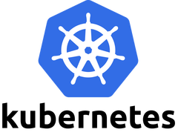

Liveness and Readiness probes are used to control the health of an application running inside a Pod’s container. Both of them are very similar in functionality, and usage.

# Liveness Probe

Suppose that a Pod is running our application inside a container, but due to some reason let’s say memory leak, cpu usage, application deadlock etc the application is not responding to our requests, and stuck in error state.

Liveness probe checks the container health as we tell it do, and if for some reason the liveness probe fails, it restarts the container. We can define liveness probe in 3 ways:

## Liveness command

**apiVersion: v1  
kind: Pod  
metadata:  
 labels:  
 test: liveness  
 name: liveness-exec  
spec:  
 containers:  
 - name: liveness  
 image: k8s.gcr.io/busybox  
 args:  
 - /bin/sh  
 - -c  
 - touch /tmp/healthy; sleep 30; rm -rf /tmp/healthy; sleep 600  
 livenessProbe:  
 exec:  
 command:  
 - cat  
 - /tmp/healthy  
 initialDelaySeconds: 3  
 periodSeconds: 5**

We are creating a container with name **liveness**, and as the container initialise we use the following command:

**- touch /tmp/healthy; sleep 30; rm -rf /tmp/healthy; sleep 600**

to create a file **healthy** at path **/tmp/healthy**, and delete it after 30 seconds.

**exec:  
 command:  
 - cat  
 - /tmp/healthy**

This commands tell the liveness probe to open file at path **/tmp/healthy**, and if it can’t the liveness probe will fail and container will restart.

**initialDelaySeconds: 3**

This is the delay which tells kubelet to wait for 3 seconds before performing the first probe

**periodSeconds: 5**

This field specifies that kubelet should perform a probe every 5 seconds.

So, according to above example our container will start and work fine for first 30 seconds, and after that liveness probe will fail and restart the container.

## Liveness HTTP request

**livenessProbe:  
 httpGet:  
 path: /healthz  
 port: 8080  
 initialDelaySeconds: 3  
 periodSeconds: 3**

In this case the kubelet will send **HTTP GET** request to **/healthz**endpoint at port **8080** of the application running inside the container. If the response is an error liveness probe will. Otherwise, it will consider the application to be alive.

## TCP Liveness probe

**livenessProbe:  
 tcpSocket:  
 port: 8080  
 initialDelaySeconds: 15  
 periodSeconds: 20**

In this case the kubelet will try to open a tcp socket at port 8080 in container running the application. If it succeeds the application will be considered healthy, otherwise the probe will fail, and the container will restart.

# Readiness Probe

In some cases we would like our application to be alive, but not serve traffic unless some conditions are met e.g, populating a dataset, waiting for some other service to be alive etc. In such cases we use readiness probe. If the condition inside readiness probe passes, only then our application can serve traffic.

Readiness probe is defined in 3 ways exactly like the Liveness probe above. We just need to replace **livenessProbe** with **readinessProbe** like this:

**readinessProbe:  
 exec:  
 command:  
 - cat  
 - /tmp/healthy  
 initialDelaySeconds: 5  
 periodSeconds:** 5

# Summary

Both liveness & readiness probes are used to control the health of an application. Failing liveness probe will restart the container, whereas failing readiness probe will stop our application from serving traffic.

<https://github.com/cloudnloud/interview-questions/blob/main/terraform/terraform-interview-questions-part-1.md>

## Terraform

1. What do you understand by Terraform in AWS? Terraform is a part of the AWS DevOps Competency and also an AWS Partner Network (APN) advanced technology partner. It is similar to AWS Cloud Formation in the sense that it is also an “infrastructure as code” tool that allows you to create, update, and version your AWS infrastructure.
2. What are the key features of Terraform? Terraform helps you manage all of your infrastructures as code and construct it as and when needed. Here are its key main features:

A console that allows users to observe functions The ability to translate HCL code into JSON format A configuration language that supports interpolation A module count that keeps track of the number of modules applied to the infrastructure.

1. Define IAC? IAC or Infrastructure as Code allows you to build, change, and manage your infrastructure through coding instead of manual processes. The configuration files are created according to your infrastructure specifications and these configurations can be edited and distributed securely within an organization.
2. What are the most useful Terraform commands? Some of the most useful Terraform commands are:

* terraform init - initializes the current directory
* terraform refresh - refreshes the state file
* terraform output - views Terraform outputs
* terraform apply - applies the Terraform code and builds stuff
* terraform destroy - destroys what has been built by Terraform
* terraform graph - creates a DOT-formatted graph
* terraform plan - a dry run to see what Terraform will do

1. Are callbacks possible with Terraform on Azure? By using the Azure Event Hubs, callbacks are probable on Azure. Terraform’s Azure supplier provides effortless functionality to users. Microsoft Azure Cloud Shell provides an already installed Terraform occurrence.
2. What is Terraform init? Terraform init is a control to initialize an operational index that contains Terraform pattern files. This control can be looped multiple times. It is the first command that should be run after writing the new Terraform design.
3. What is Terraform D? Terraform D is a plugin used on most in-service systems and Windows. Terraform init by default searches next directories for plugins.
4. Is history the same as it is on the web while using TFS API to provide resources? Yes, the narration is similar to on the web because UI keeps API as the base. The whole thing that is on the UI is availed during other methods and the API.
5. Why is Terraform used for DevOps? Terraform uses a JSON-like configuration language called the HashiCorp Configuration Language (HCL). HCL has a very simple syntax that makes it easy for DevOps teams to define and enforce infrastructure configurations across multiple clouds and on-premises data centers.
6. Define null resource in Terraform. null\_resource implements standard resource library, but no further action is taken. The triggers argument allows an arbitrary set of values that will cause the replacement of resources when changed.
7. What do you mean by Terraform cloud? Terraform Cloud is a platform that enables teams to use Terraform together, either on-demand or in response to various events. It is deeply integrated with Terraform's workflows and data, unlike a general-purpose continuous integration system. It includes easy access to shared state and secret data, detailed policy controls for updating infrastructure and governing the contents of Terraform, a private registry for sharing Terraform modules, and lots more.
8. Explain Oracle Cloud Infrastructure. Oracle cloud offered by Oracle Corporation is a cloud computing service providing storage, servers, applications, services, and network through a global network of managed data centers by Oracle Corporation. These services are provisioned on-demand over the Internet by the company.
9. What do you understand by terraform backend? Each Terraform configuration can specify a backend, which defines two main things:

Where operations are performed Where the state is stored (Terraform keeps track of all the resources created in a state file) 14. What are the version controls supported by Terraform besides GitHub? The version controls supported GitLab EE, GitLab CE, and Bucket cloud.

1. Name some major competitors of Terraform? Some of the top competitors and alternatives to Terraform are Azure Management Tools, Morpheus, CloudHealth, Turbonomic, and CloudBolt.

# Terraform Interview Questions

Explain the uses of Terraform CLI and list some basic CLI commands? 16. Explain the uses of Terraform CLI and list some basic CLI commands? The Terraform Command-Line Interface (CLI) is used to manage infrastructure and interact with Terraform state, configuration files, providers, etc.

Here are some basic CLI commands:

* terraform init - initializes the current directory
* terraform refresh - refreshes the state file
* terraform output - views Terraform outputs
* terraform apply - applies the Terraform code and builds stuff
* terraform destroy - destroys what has been built by Terraform
* terraform graph - creates a DOT-formatted graph
* terraform plan - a dry run to see what Terraform will do

1. What are modules in Terraform? A jug for numerous resources that are used jointly is known as a module in Terraform. The root module includes resources mentioned in the .tf files and is required for every Terraform.
2. What is a Private Module Registry? A Private Module Registry is a feature from Terraform Cloud that allows you to share Terraform modules across the organization. You can enforce rules or “sentinel policies” on the registry that specify how members of your organization can use the modules.
3. Is Terraform usable for an on-prem infrastructure? Yes, Terraform can be used for on-prem infrastructure. As there are a lot of obtainable providers, we can decide which suits us the best. All that we need is an API.
4. Does Terraform support multi-provider deployments? Yes, multi-provider deployments are supported by Terraform, which includes on-prem like Openstack, VMware, and we can manage SDN even using Terram too.
5. How is duplicate resource error ignored during terraform apply? We can try the following options:

Delete those resources from the cloud provider(API) and recreate them using Terraform Delete those resources from Terraform code to stop its management with it

Carry out a terraform import of the resource and remove the code that is trying to recreate them

1. Name all version controls supported by Terraform The supported version controls are:

Azure DevOps Services Azure DevOps Server Bitbucket Server Bitbucket Cloud Gitlab EE and CE Gitlab.com GitHub Enterprise GitHub.com (OAuth) GitHub.com

1. What are some of the built-in provisioners available in Terraform? Here is the list of built-in provisioners in Terraform:

Salt-masterless Provisioner Remote-exec Provisioner Puppet Provisioner Local-exec Provisioner Habitat Provisioner File Provisioner Chef Provisioner

1. Which command destroys Terraform managed infrastructure? The given command is used for this purpose:

terraform destroy [options] [dir]

1. Tell us about some notable Terraform applications. The applications of Terraform are pretty broad due to its facility of extending its abilities for resource manipulation. Some of the unique applications are:

Software demos development Resource schedulers Multi-cloud deployment Disposable environment creations Multi-tier applications development Self-service clusters Setup of Heroku App

1. What are the components of Terraform architecture? The Terraform architecture includes the following features:

Sub-graphs Expression Evaluation Vertex Evaluation Graph Walk Graph Builder State Manager Configuration Loader CLI (Command Line interface) Backend

1. Define Resource Graph in Terraform. A resource graph is a visual representation of the resources. It helps modify and create independent resources simultaneously. Terraform establishes a plan for the configuration of the graph to generate plans and refresh the state. It creates structure most efficiently and effectively to help us understand the drawbacks.
2. Can you provide a few examples where we can use for Sentinel policies? Sentinels are a powerful way to implement a variety of policies in Terraform. Here are a few examples:

Enforce explicit ownership in resources Restrict roles the cloud provider can assume Review an audit trail for Terraform Cloud operations Forbid only certain resources, providers, or data sources Enforce mandatory tagging on resources Restrict how modules are used in the Private Module Registry

1. What are the various levels of Sentinel enforcement? Sentinel has three enforcement levels - advisory, soft mandatory, and hard mandatory.

Advisory - Logged but allowed to pass. An advisory is issued to the user when they trigger a plan that violates the policy. Soft Mandatory - The policy must pass unless an override is specified. Only administrators have the ability to override. Hard Mandatory - The policy must pass no matter what. This policy cannot be overridden unless it is removed. It is the default enforcement level in Terraform.

1. How to Store Sensitive Data in Terraform? Terraform requires credentials to communicate with your cloud provider's API. But most of the time, these credentials are saved in plaintext on your desktop. GitHub is exposed to thousands of API and cryptographic keys every day. Hence, your API keys should never be stored in Terraform code directly. You should use encrypted storage to store all your passwords, TLS certificates, SSH keys, and anything else that shouldn't be stored in plain text.

# Terraform Interview Questions

1. What is Terragrunt, and what are its uses? Terragrunt is a thin wrapper that provides extra tools to keep configurations DRY, manage remote state and work with multiple Terraform modules. It is used for:

Working with multiple AWS accounts Executing Terraform commands on multiple modules Keeping our CLI flags DRY Keeping our remote state configuration DRY Keeping our Terraform code DRY 32. Explain State File Locking? State file locking is Terraform mechanism in which operations on a specific state file are blocked to avoid conflicts between multiple users performing the same process. When one user releases the lock, then only the other one can operate on that state. This helps in preventing state file corruption. This is a backend operation.

1. What do you understand by a Tainted Resource? A tainted resource is a resource that is forced to be destroyed and recreated on the next apply command. When a resource is marked as tainted, the state files are updated, but nothing changes on infrastructure. The terraform plan out shows that help will get destroyed and recreated. The changes get implemented when the next apply happens.
2. How to lock Terraform module versions? A proven way of locking Terraform module version is using the Terraform module registry as a source. We can use the ‘version’ attribute in module of the Terraform configuration file. As the Github repository is being used as a source, we need to specify versions, branch, and query string with ‘?ref’.
3. What is Terraform Core? Tell us some primary responsibilities of it. Terraform Core is a binary written statically compiled by using the Go programming language. The compiled binary offers an entry point for the users of Terraform. The primary responsibilities include:

Reading and interpolation of modules and configuration files by Infrastructure as code functionalities Resource Graph Construction Plugin communication through RPC Plan execution Management of resource state 36. Give the terraform configuration for creating a single EC2 instance on AWS. This is the Terraform configuration for creating a single EC2 instance on AWS:

provider “aws” {

region = “”}

resource “aws\_instance”

“example” {

ami = ""

instance\_type = ""

tags {

Name = "example"}

1. How will you upgrade plugins on Terraform? Run ‘terraform init’ with ‘-upgrade’ option. This command rechecks the releases.hashicorp.com to find new acceptable provider versions. It also downloads available provider versions. “.terraform/plugins/\_” is the automatic downloads directory.
2. How will you make an object of one module available for the other module at a high level? Ab output variable is defined in resource configuration. Declare the output variable of module\_A. Create a file variable.tf for module B. Establish the input variable inside this file having the same name as the key defined in module\_B. Replicate the process for making variable available to other modules
3. What are some of the latest Terraform Azure Provider factors? The latest versions involve new data resources and Azurem\_batch\_certificate, which helps in managing the certificate. This resource is used for controlling the prefix in networking. There is fixing of bugs, and azurerm\_app\_service has also been enhanced.
4. How will you control and handle rollbacks when something goes wrong? I need to recommit the previous code version to be the new and current version in my VCS. This would trigger as terraform run, which would be responsible for running the old code. As Terraform is more declarative, I will make sure all things in the code roll back to the old code. I would use the State Rollback Feature of Terraform Enterprise to roll back to the latest state if the state file got corrupted.

# [How kubectl apply command works?](https://technos.medium.com/how-kubectl-apply-command-works-d092121056d3)

Kubectl apply command is used for creating, updating or deleting an object in a declarative way.

* The “kubectl apply” command is intelligent enough to create an object if it doesn’t already exist.
* It will look at the existing configuration and figure out what changes need to be made to the existing objects or applications.

And when we need to make any changes in our application, let’s say need to update the image version, we simply update the object configuration file and run the “kubectl apply -f object-definition.yaml” and this time the apply command knows that the object exists, so it only updates the object with the new changes.

**So how the kubectl apply command exactly works?**

The kubectl apply takes **the local configuration file, a live object definition on Kubernetes and the last applied configuration** into consideration before making a decision on what changes are to be made.

**local-object-definition.yml**

apiVersion: v1  
kind: Pod  
metadata:  
 name: httpd  
 labels:  
 type : web-server  
 app: my-app  
spec:  
 containers:  
 - name: nginx-web-server  
 image: nginx:1.17

So when you run the **kubectl apply -f local-object-definition.yml**command, if the object does not already exist, the object is created.

When the Object is created, a “**live object configuration**” similar to what we created locally is also got created but with additional fields to store the status of the object.

**live-object-configuration:**

apiVersion: v1  
kind: Pod  
metadata:  
 name: httpd  
 labels:  
 type : web-server  
 app: my-app  
spec:  
 containers:  
 - name: nginx-web-server  
 image: nginx:1.17status:  
 conditions:  
 - lastProbeTime: null  
 status: "True"  
 type: Initialized

This is how Kubernetes internally stores information about an object, no matter what approach you used (**kubectl create or kubectl apply**) to create the object.

But when we used the “**kubectl apply**” command to create an object, it does something a bit more.

The yml version of the “**local object configuration”**file is converted to a JSON format and it is then stored as the “**last applied configuration**”.

**last applied configuration**

{  
 "apiVersion": "v1",  
 "kind": "Pod",  
 "metadata": {  
 "name": "httpd",  
 "labels": {  
 "type": "web-server",  
 "app": "my-app"  
 }  
 },  
 "spec": {  
 "containers": [  
 {  
 "name": "nginx-web-server",  
 "image": "nginx:1.17"  
 }  
 ]  
 }  
}

*Going forward for any updates to the object, All the three (*local-object-configuration, last-applied-configuration & live-object-configuration*) are compared to identify what changes are to be made on live object on Kubernetes cluster.*

For example, when the Nginx images is updated to 1.18 in our local file and we run the “kubectl apply” command this value is compared with the value in live configuration and if there is a difference, the live configuration is updated with the new value.

And after any change, the last applied JSON format is always updated to the latest so that it’s always up-to-date.

**So why do we really need the last applied configuration?**

Let’s say a field was deleted, say for example, the type label was deleted, and now when we run the “kubectl apply” command, we see the last applied configuration had a label, but it’s not present in the local configuration.

This means that the field needs to be removed from the live configuration.

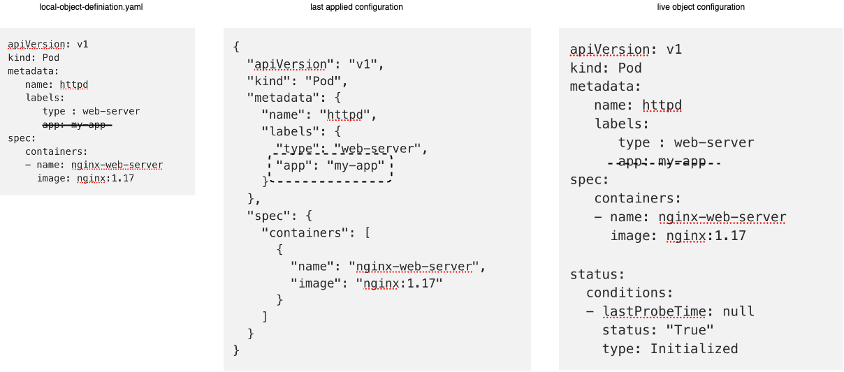

So if a field is present in the live configuration and not present in the local or the last applied configuration, then it will be left as it is.

But if a field is missing from the local field and it is present in the last applied configuration, so that means that in the previous step or wherever the last time we ran the program in that particular field was there and it is now being removed.

So the last applied configuration helps us to figure out, what fields have been removed from the local file, so that field is then removed from the live configuration.

So we saw the three sets of files and we know that the local file is stored in our local system. The live object configuration is stored in the Kubernetes memory, but where is the JSON file that has the last applied configuration stored?

It’s stored in the live object configuration on the Kubernetes cluster itself as an annotation, named last applied configuration:

apiVersion: v1  
kind: Pod  
metadata:  
 name: httpd  
 labels:  
 type : web-server  
 app: my-app  
 annotations:  
 kubectl.kubernetes.io/last-applied-configuration:  
 {"apiVersion": "v1","kind": "Pod","metadata": {"name": "httpd", "labels": {"type": "web-server","app": "my-app"}},"spec": {"containers": [{"name": "nginx-web-server","image": "nginx:1.17"  
}]}}  
spec:  
 containers:  
 - name: nginx-web-server  
 image: nginx:1.17status:  
 conditions:  
 - lastProbeTime: null  
 status: "True"  
 type: Initialized

So that is the only applied when we use the kubectl apply command, the kubectl create or replace command does not store the last applied configuration like this.